Revelation 6 ⎯ The Beginning of the Tribulation
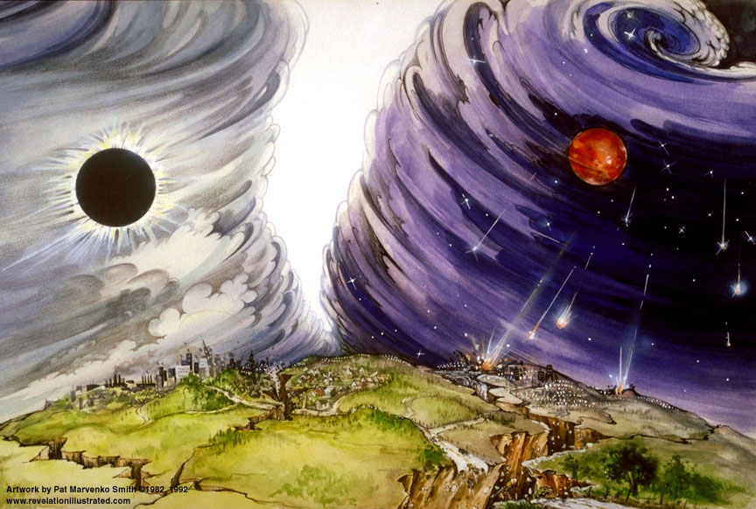
Luke 21:20-22 "But when you see Jerusalem surrounded by armies, then recognize that her desolation is near. ²¹ "Then those who are in Judea must flee to the mountains, and those who are in the midst of the city must leave, and those who are in the country must not enter the city; ²²because these are days of vengeance, so that all things which are written will be fulfilled.

1
White
6
Signs
5
Martyrs
4
Ashen
3
Black
2
Red
Earthquake, hail
Euphrates dried
Earth in darkness
Sun scorches
Rivers to blood
Sores
Sea to blood
1/3 Earth
1/3 Sea
1/3 Rivers
1st Woe, Locusts
1/3 Heavens
3rd Woe, 7 Bowls
2nd Woe, 1/3 Men Die
7
Wrath
The Lamb
opens the
seals.
Angels sound
the trumpets.
God sends the
bowls out, full
of the wrath of God.
Tribulation
Great Tribulation
compressed

End Times Confederacies
Pentecost, “Things to Come”, p.340 ff
(see “Other Verses & Notes”)
- 7 Nations led by Antichrist (starts with 10)
- Northern led by Gog
- Southern
- Eastern

- Armies of Heaven led by Christ

The beginning of birth pangs.
1
White
Revelation 6 |  | Matthew 24 | Other Verses & Notes
Rev 6:1 And I saw when the Lamb broke one of the seven seals, and I heard one of the four living creatures saying as with a voice of thunder, "Come."[Go!] ²And I looked, and behold, a white horse, and he who sat on it had a bow; and a crown was given to him; and he went out conquering, and to conquer. |  | Matt 24:3 And as He was sitting on the Mount of Olives, the disciples came to Him privately, saying, "Tell us, when will these things be, and what will be the sign of Your coming, and of the end of the age?" ⁴And Jesus answered and said to them, "See to it that no one misleads you. ⁵"For many will come in My name, saying, 'I am the Christ,' and will mislead many.  - 4 horsemen of the Apocalypse  - Bow with no arrows – victory by covenants and agreement.  - Crown – ‘stephanos’, a victor’s crown as in winning; not ‘diadem’, a sovereign’s crown. | Daniel 9:26-27 "Then after the sixty-two weeks the Messiah will be cut off and have nothing, and the people of the prince who is to come will destroy the city and the sanctuary [70 A.D.]. And its end will come with a flood; even to the end there will be war; desolations are determined. ²⁷ "And he will make a firm covenant with the many for one week [beginning of Tribulation], but in the middle of the week he will put a stop to sacrifice and grain offering; and on the wing of abominations will come one who makes desolate, even until a complete destruction, one that is decreed, is poured out on the one who makes desolate."
³And when He broke the second seal, I heard the second living creature saying, "Come." [Go!] ⁴And another, a red horse, went out; and to him who sat on it, it was granted to take peace from the earth, and that men should slay one another; and a great sword was given to him.  2  Red |  | ⁶"And you will be hearing of wars and rumors of wars; see that you are not frightened, for those things must take place, but that is not yet the end. ⁷"For nation will rise against nation, and kingdom against kingdom, … | Note: the Armageddon campaign begins when Israel is at peace, thus during the first 3 ½ yrs. of the Tribulation.  Ezekiel 38:10-12 'Thus says the Lord God, "It will come about on that day, that thoughts will come into your [Gog – Northern confederacy] mind, and you will devise an evil plan, 11and you will say, 'I will go up against the land of unwalled villages. I will go against those who are at rest, that live securely, all of them living without walls, and having no bars or gates, 12to capture spoil and to seize plunder, to turn your hand against the waste places which are now inhabited, and against the people who are gathered from the nations, who have acquired cattle and goods, who live at the center of the world.'  Ezekiel 38:16 and you will come up against My people Israel like a cloud to cover the land. It shall come about in the last days that I will bring you against My land, so that the nations may know Me when I am sanctified through you before their eyes, O Gog."  Ezekiel 38:18-22 "And it will come about on that day, when Gog comes against the land of Israel," declares the Lord God, "that My fury will mount up in My anger. 19"And in My zeal and in My blazing wrath I declare that on that day there will surely be a great earthquake in the land of Israel. 20"…; the mountains also will be thrown down, the steep pathways will collapse, and every wall will fall to the ground. 21"And I shall call for a sword against him on all My mountains," declares the Lord God. "Every man's sword will be against his brother. 22"And with pestilence and with blood I shall enter into judgment with him; and I shall rain on him, and on his troops, and on the many peoples who are with him, a torrential rain, with hailstones, fire, and brimstone.  Daniel 11:40-12:1 "And at the end time the king of the South will collide with him [the antichrist], and the king of the North will storm against him with chariots, with horsemen, and with many ships; and he will enter countries, overflow them, and pass through. ⁴¹"He will also enter the Beautiful Land, and many countries will fall; but these will be rescued out of his hand: Edom, Moab and the foremost of the sons of Ammon. ⁴²"Then he will stretch out his hand against other countries, and the land of Egypt will not escape. ⁴³"But he will gain control over the hidden treasures of gold and silver, and over all the precious things of Egypt; and Libyans and Ethiopians will follow at his heels “ ⁴⁴ "But rumors from the East and from the North will disturb him, and he will go forth with great wrath to destroy and annihilate many.  ⁴⁵And he will pitch the tents of his royal pavilion between the seas and the beautiful Holy Mountain; yet he will come to his end, and no one will help him.  Daniel 12:1-2 "Now at that time Michael, the great prince who stands guard over the sons of your people, will arise. And there will be a time of distress such as never occurred since there was a nation until that time; and at that time your people, everyone who is found written in the book, will be rescued. ² "Many of those who sleep in the dust of the ground will awake, these to everlasting life, but the others to disgrace and everlasting contempt.  Stars:  Isaiah 14:12-15 "How you have fallen from heaven, O star of the morning, son of the dawn! You have been cut down to the earth, You who have weakened the nations! ¹³ "But you said in your heart, 'I will ascend to heaven; …' ¹⁵ "Nevertheless you will be thrust down to Sheol, To the recesses of the pit.  Revelation 12:9 And the great dragon was thrown down, the serpent of old who is called the devil and Satan, who deceives the whole world; he was thrown down to the earth, and his angels were thrown down with him.
⁵And when He broke the third seal, I heard the third living creature saying, "Come." [Go!] And I looked, and behold, a black horse; and he who sat on it had a pair of scales in his hand. ⁶And I heard as it were a voice in the center of the four living creatures saying, "A quart of wheat for a denarius, and three quarts of barley for a denarius; and do not harm the oil and the wine."  4  Ashen  3  Black |  | ⁷…and in various places there will be famines and earthquakes.⁸"But all these things are merely the beginning of birth pangs.
⁷And when He broke the fourth seal, I heard the voice of the fourth living creature saying, "Come." [Go!] ⁸And I looked, and behold, an ashen horse; and he who sat on it had the name Death; and Hades was following with him. And authority was given to them over a fourth of the earth, to kill with sword and with famine and with pestilence and by the wild beasts of the earth. |  | 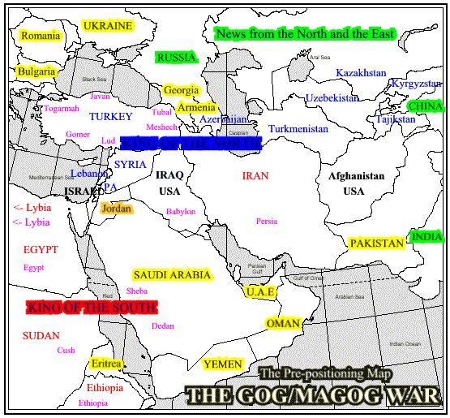
Midpoint of the 7 Year Tribulation
⁹And when He broke the fifth seal, I saw underneath the altar the souls of those who had been slain because of the word of God, and because of the testimony which they had maintained; ¹⁰and they cried out with a loud voice, saying, "How long, O Lord, holy and true, wilt Thou refrain from judging and avenging our blood on those who dwell on the earth?" ¹¹And there was given to each of them a white robe; and they were told that they should rest for a little while longer, until the number of their fellow servants and their brethren who were to be killed even as they had been, should be completed also.  5  Martyrs | ⁹"Then they will deliver you to tribulation, and will kill you, and you will be hated by all nations on account of My name.¹⁰"And at that time many will fall away and will deliver up one another and hate one another. ¹¹"And many false prophets will arise, and will mislead many.¹²"And because lawlessness is increased, most people's love will grow cold. ¹³"But the one who endures to the end, he shall be saved. ¹⁴"And this gospel of the kingdom shall be preached in the whole world for a witness to all the nations, and then the end shall come.  Revelation 14:6 And I saw another angel flying in midheaven, having an eternal gospel to preach to those who live on the earth, and to every nation and tribe and tongue and people;
¹²And I looked when He broke the sixth seal, and there was a great earthquake; and the sun became black as sackcloth made of hair, and the whole moon became like blood; ¹³and the stars of the sky fell to the earth, as a fig tree casts its unripe figs when shaken by a great wind. ¹⁴And the sky was split apart like a scroll when it is rolled up; and every mountain and island were moved out of their places.  6  Signs | ¹⁵"Therefore when you see the abomination of desolation which was spoken of through Daniel the prophet, standing in the holy place (let the reader understand), ¹⁶then let those who are in Judea flee to the mountains; ¹⁷let him who is on the housetop not go down to get the things out that are in his house; ¹⁸and let him who is in the field not turn back to get his cloak. ¹⁹"But woe to those who are with child and to those who nurse babes in those days! ²⁰"But pray that your flight may not be in the winter, or on a Sabbath; ²¹for then there will be a great tribulation, such as has not occurred since the beginning of the world until now, nor ever shall.  ²⁹"But immediately after the tribulation of those days the sun will be darkened, and the moon will not give its light, and THE STARS WILL FALL from the sky, and the powers of the heavens will be shaken,
¹⁵And the kings of the earth and the great men and the commanders and the rich and the strong and every slave and free man, hid themselves in the caves and among the rocks of the mountains; ¹⁶and they said to the mountains and to the rocks, "Fall on us and hide us from the presence of Him who sits on the throne, and from the wrath of the Lamb; ¹⁷for the great day of their wrath has come; and who is able to stand?" | ³²"Now learn the parable from the fig tree: when its branch has already become tender, and puts forth its leaves, you know that summer is near; ³³even so you too, when you see all these things, recognize that He is near, right at the door. ³⁴"Truly I say to you, this generation will not pass away until all these things take place.  J.V. McGee states:  - Great Tribulation begins and ends with these signs:  Joel 2:31 "The sun will be turned into darkness, And the moon into blood, Before the great and awesome day of the Lord comes.  Joel 3 – Armageddon

Timeline Review:

Rapture of the Church
- Apostasy of the church
- Rapture of the Church (true believers)
- Judgment seat of Christ (Bema seat) ⎯ of the Church saints
- Three of the 10 nations taken over by a strong ruler
- Strong ruler ascends to lead the 7 nation confederacy
- Treaty between the strong leader and Israel

The Tribulation begins
- Scroll with 7 seals, Lion of Judah/Root of David/Lamb is the only one worthy to open it
- 6 seal judgments begin
- Northern and Southern confederacies attack Israel, defeated by God

The Great Tribulation begins at 5th seal (Rev 6:12-17)
- Abomination of Desolation
- Wrath of the Lamb – Rev 6:16-17 (Day of the Lord)
- Parenthetic 1 - 144,000 sons of Israel sealed as servants of the Lord
- Parenthetic 1 - Great multitude of Gentiles standing before the Lamb
- 7th seal opened giving 7 trumpet judgments
- Silence in heaven for ½ hour

Chapter 7: 144,000 Sons of Israel sealed with a mark on their foreheads; multitude from all tribes and nations before the throne dressed in white.
7
Trumpets

Chapters 8 & 9:

