Revelation 10 & 11⎯ The Little Book/“Prophesy Again”/Ready to Cleanse Israel
Daniel 12:5-9 Then I, Daniel, looked and behold, two others were standing, one on this bank of the river, and the other on that bank of the river. 6And one said to the man dressed in linen [Gabriel], who was above the waters of the river, "How long will it be until the end of these wonders?" 7And I heard the man dressed in linen, who was above the waters of the river, as he raised his right hand and his left toward heaven, and swore by Him who lives forever that it would be for a time, times, and half a time; and as soon as they finish shattering the power of the holy people, all these events will be completed. 8As for me, I heard but could not understand; so I said, "My lord, what will be the outcome of these events?" 9And he said, "Go your way, Daniel, for these words are concealed and sealed up until the end time.

1
White
6
Signs
5
Martyrs
4
Ashen
3
Black
2
Red
Earthquake, hail
Euphrates dried
Earth in darkness
Sun scorches
Rivers to blood
Sores
Sea to blood
1/3 Earth
1/3 Sea
1/3 Rivers
1st Woe, Locusts
1/3 Heavens
3rd Woe, 7 Bowls
2nd Woe, 1/3 Men Die
7
Wrath
The Lamb
opens the
seals.
Angels sound
the trumpets.
God sends the
bowls out, full
of the wrath of
God.
Tribulation
Great Tribulation
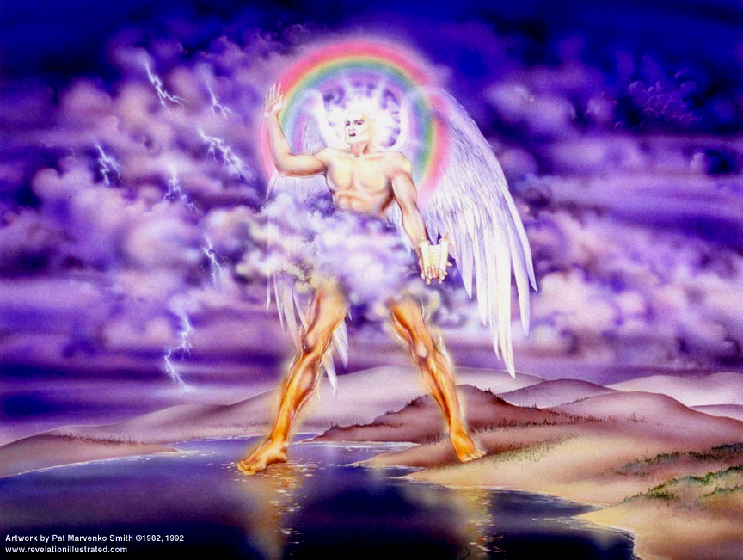

Parenthetical Interlude (see the Benware Chapter Chart)
Revelation 10 & 11 |  | Bible References | Notes
Note that there is a parenthetical interlude between seals 6 and 7. Likewise there is now an interlude between trumpets 6 and 7; and we’ll see the same between the 6th and 7th bowls. God is giving us a chance to catch our breaths.

¹And I saw another strong angel coming down out of heaven, clothed with a cloud; and the rainbow was upon his head, and his face was like the sun, and his feet like pillars of fire; ²and he had in his hand a little book which was open. And he placed his right foot on the sea and his left on the land; ³and he cried out with a loud voice, as when a lion roars; and when he had cried out, the seven peals of thunder uttered their voices. | Leviticus 25:23 'The land, moreover, shall not be sold permanently, for the land is Mine; for you are but aliens and sojourners with Me.  Job 37:5 "God thunders with His voice wondrously, Doing great things which we cannot comprehend.  Jeremiah 25:29-31 "For behold, I am beginning to work calamity in this city which is called by My name, and shall you be completely free from punishment? You will not be free from punishment; for I am summoning a sword against all the inhabitants of the earth," declares the LORD of hosts.' ³⁰ "Therefore you shall prophesy against them all these words, and you shall say to them, 'The LORD will roar from on high And utter His voice from His holy habitation; He will roar mightily against His fold. He will shout like those who tread the grapes, Against all the inhabitants of the earth. ³¹ 'A clamor has come to the end of the earth, Because the LORD has a controversy with the nations. He is entering into judgment with all flesh; As for the wicked, He has given them to the sword,' declares the LORD."  When does a lion roar? |  |  | - “another” – same kind as before  - Strong angel =  - Christ (DeHaan, Ironside)  - Not Christ (McGee, Walvoord.)  (Either way, you are in good company  - Not Christ:  - John did not fall down and worship  - Christ’s voice comes from heaven, vs. 4  - The angel swore by God in heaven, vs. 6  - Appearance:  - Rainbow – God keeps His covenants  - Face like the sun – coming from the presence of Christ  - Feet like pillars of fire – judgment angel  - Little book – biblaridion  - It is open  - It is the title deed of the earth!!  - It is the Scroll of Redemption and contains the terms for redeeming and avenging
⁴And when the seven peals of thunder had spoken, I was about to write; and I heard a voice from heaven saying, "Seal up the things which the seven peals of thunder have spoken, and do not write them." | 2 Cor. 12:2-4 I know a man in Christ who fourteen years ago… ⁴was caught up into Paradise, and heard inexpressible words, which a man is not permitted to speak.  Revelation 22:10 And he said to me, "Do not seal up the words of the prophecy of this book, for the time is near. |  |  | - “seven peals of thunder” – God?  - “Seal up…” – Christ?  Daniel 12:9 He said, "Go your way, Daniel, for these words are concealed and sealed up until the end time.  Evidently this was a message for John only.
⁵And the angel whom I saw standing on the sea and on the land lifted up his right hand to heaven, ⁶and swore by Him who lives forever and ever, who created heaven and the things in it, and the earth and the things in it, and the sea and the things in it, that there shall be delay no longer, ⁷but in the days of the voice of the seventh angel, when he is about to sound, then the mystery of God is finished, as He preached to His servants the prophets. | Rev. 11:15 And the seventh angel sounded; and there arose loud voices in heaven, saying, "The kingdom of the world has become the kingdom of our Lord, and of His Christ; and He will reign forever and ever."  Col. 2:2 that their hearts may be encouraged, having been knit together in love, and attaining to all the wealth that comes from the full assurance of understanding, resulting in a true knowledge of God's mystery, that is, Christ Himself, |  |  | - “Mystery of God is finished” – all prophesies come to fruition!  Jeremiah 31:34 "And they shall not teach again, each man his neighbor and each man his brother, saying, 'Know the Lord,' for they shall all know Me, from the least of them to the greatest of them," declares the Lord, "for I will forgive their iniquity, and their sin I will remember no more."  This seems to indicate that when the 7th trumpet sounds we are at the conclusion of the Great Tribulation, and the mystery of God. He has a lot to reveal to us yet!
⁸And the voice which I heard from heaven, I heard again speaking with me, and saying, "Go, take the book which is open in the hand of the angel who stands on the sea and on the land." ⁹And I went to the angel, telling him to give me the little book. And he said to me, "Take it, and eat it; and it will make your stomach bitter, but in your mouth it will be sweet as honey." ¹⁰And I took the little book out of the angel's hand and ate it, and it was in my mouth sweet as honey; and when I had eaten it, my stomach was made bitter. | Jeremiah 15:16 Thy words were found and I ate them, And Thy words became for me a joy and the delight of my heart; For I have been called by Thy name, O Lord God of hosts.  Ezekiel 2:8-3:3 "Now you, son of man, listen to what I am speaking to you; do not be rebellious like that rebellious house. Open your mouth and eat what I am giving you." ⁹Then I looked, behold, a hand was extended to me; and lo, a scroll was in it. ¹⁰When He spread it out before me, it was written on the front and back; and written on it were lamentations, mourning and woe. ^{3:1}Then He said to me, "Son of man, eat what you find; eat this scroll, and go, speak to the house of Israel." ²So I opened my mouth, and He fed me this scroll. ³And He said to me, "Son of man, feed your stomach, and fill your body with this scroll which I am giving you." Then I ate it, and it was sweet as honey in my mouth. |  |  | - Eating the little book has a typical meaning, to receive the Word of God with faith.  - God always warns of judgment, e.g.,  Genesis 18:16-17 Then the men rose up from there, and looked down toward Sodom; and Abraham was walking with them to send them off. ¹⁷ The LORD said, "Shall I hide from Abraham what I am about to do,  - Bitter – the Word to unbelievers  John 3:18 "He who believes in Him is not judged; he who does not believe has been judged already, because he has not believed in the name of the only begotten Son of God.  - Sweet – the Word to Believers  Psalm 119:103 How sweet are Thy words to my taste! Yes, sweeter than honey to my mouth
¹¹And they said to me, "You must prophesy again concerning many peoples and nations and tongues and kings."

Rev 11:1And there was given me a measuring rod like a staff; and someone said, "Rise and measure the temple of God, and the altar, and those who worship in it. ²"And leave out the court which is outside the temple, and do not measure it, for it has been given to the nations; and they will tread under foot the holy city for forty-two months. | Ezekiel 36:22-28 "Therefore say to the house of Israel, 'Thus says the Lord God, "It is not for your sake, O house of Israel, that I am about to act, but for My holy name, which you have profaned among the nations where you went… ²⁴ "For I will take you from the nations, gather you from all the lands and bring you into your own land. ²⁵ "Then I will sprinkle clean water on you, and you will be clean; I will cleanse you from all your filthiness and from all your idols. … ²⁸ "You will live in the land that I gave to your forefathers; so you will be My people, and I will be your God. |  |  | - Most difficult chapter in Revelation – Take as literally as possible  Chapter 11’s focus is Israel and God’s faithfulness in fulfilling His Covenants.  - Temple destroyed in 70 AD.  - Revelation written ~ 92 AD.  - No temple when John wrote  - To measure → judgment or construction/possession  Why leave out the court?  - 42 months = 3 ½ yrs, the Great Tribulation
³"And I will grant authority to my two witnesses [Greek - martys], and they will prophesy [preach] for twelve hundred and sixty days, clothed in sackcloth." ⁴These are the two olive trees and the two lampstands that stand before the Lord of the earth.  - Identity?  - Duty?  - Attitude?  - Time period?  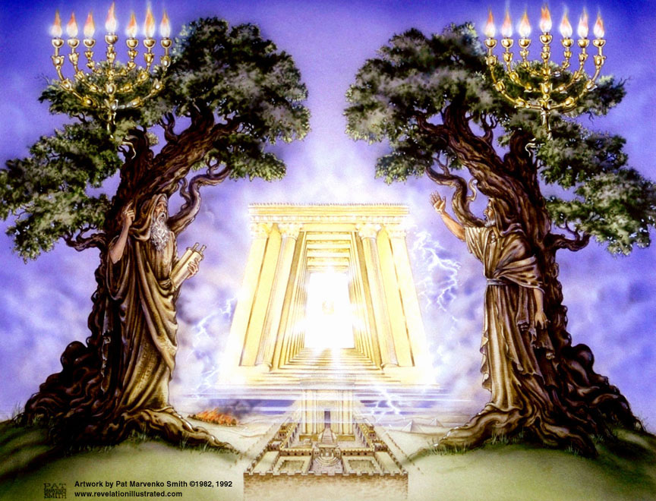 | Deut. 17:6 "On the evidence of two witnesses or three witnesses, he who is to die shall be put to death; he shall not be put to death on the evidence of one witness. [Also Matt. 18:16]  MacArthur’: analysis on “who”:  Zech. 4:5-6 So the angel who was speaking with me answered and said to me, "Do you not know what these [golden lampstand and bowls] are?" And I said, "No, my lord." ⁶Then he answered and said to me, "This is the word of the Lord to Zerubbabel saying, 'Not by might nor by power, but by My Spirit,' says the Lord of hosts.  Zech. 4:12-14 And I answered the second time and said to him, "What are the two olive branches which are beside the two golden pipes, which empty the golden oil from themselves?" ¹³So he answered me saying, "Do you not know what these are?" And I said, "No, my lord." ¹⁴Then he said, "These are the two anointed ones, who are standing by the Lord of the whole earth." [branches supplying oil (Holy Spirit]) to the lampstand – Israel]  Deut. 18:15 "The Lord your God will raise up for you a prophet like me [Moses] from among you, from your countrymen, you shall listen to him.  Malachi 4:5 "Behold, I am going to send you Elijah the prophet before the coming of the great and terrible day of the Lord.  John 1:21 And they asked him, "What then? Are you Elijah?" And he said, "I am not." "Are you the Prophet?" And he answered, "No."  Matthew 17:2-3 And He was transfigured before them; and His face shone like the sun, and His garments became as white as light. ³And behold, Moses and Elijah appeared to them, talking with Him.  Moses represents The LAW, Elijah the Prophets. |  |  | - Sackcloth - prophets used it when prophesying judgment – humility, sadness, sorrow  - Two witnesses, empowered by the Holy Spirit, are not identified and best left that way. However…  Others’ analysis on “who”:  Hebrews 9:27 And inasmuch as it is appointed for men to die once and after this comes judgment,  2 Kings 2:11 … And Elijah went up by a whirlwind to heaven.  Hebrews 11:5 By faith Enoch was taken up so that he should not see death; …  However:  a. Enoch was a gentile.  b. Everyone resurrected so far have died twice:  John 11:43 And when He had said these things, He cried out with a loud voice, "Lazarus, come forth."  McGee thought the two witnesses might be Elijah and John the Baptist.
⁵And if anyone desires to harm them, fire proceeds out of their mouth and devours their enemies; and if anyone would desire to harm them, in this manner he must be killed. ⁶These have the power to shut up the sky, in order that rain may not fall during the days of their prophesying; and they have power over the waters to turn them into blood, and to smite the earth with every plague, as often as they desire. | Exodus 7:19 Then the Lord said to Moses, "Say to Aaron, 'Take your staff and stretch out your hand over the waters of Egypt, … that they may become blood; ...' "  2 Kings 1:10 And Elijah answered and said to the captain of fifty, "If I am a man of God, let fire come down from heaven and consume you and your fifty." Then fire came down from heaven and consumed him and his fifty.  1 Kings 17:1 Now Elijah the Tishbite, who was of the settlers of Gilead, said to Ahab, "As the Lord, the God of Israel lives, before whom I stand, surely there shall be neither dew nor rain these years, except by my word." |  |  | - Protection?  - Power?  Moses’ Plagues:  Plague of Blood: Ex. 7:14–25  Plague of Frogs: Ex. 7:25–8:11  Plague of Lice: Ex. 8:16–19  Plague of Flies: Ex. 8:20–32  Plague of Livestock Death: Ex. 9:1–7  Plague of Boils: Ex. 9:8–12  Plague of Hail: Ex. 9:13–35  Plague of Locusts: Ex. 10:1–20  Plague of Darkness: Ex. 10:21–29  Firstborn Death: Ex. 11:1–12:36
⁷And when they have finished their testimony, the beast that comes up out of the abyss will make war with them, and overcome them and kill them. ⁸And their dead bodies will lie in the street of the great city which mystically is called Sodom and Egypt, where also their Lord was crucified. ⁹And those from the peoples and tribes and tongues and nations will look at their dead bodies for three and a half days, and will not permit their dead bodies to be laid in a tomb. ¹⁰And those who dwell on the earth will rejoice over them and make merry; and they will send gifts to one another, because these two prophets tormented those who dwell on the earth. | Rev. 17:8 "The beast that you saw was and is not, and is about to come up out of the abyss and to go to destruction. And those who dwell on the earth will wonder, whose name has not been written in the book of life from the foundation of the world, when they see the beast, that he was and is not and will come.  Isaiah 30:9-11 For this is a rebellious people, false sons, Sons who refuse to listen To the instruction of the Lord; ¹⁰Who say to the seers, "You must not see visions"; And to the prophets, "You must not prophesy to us what is right, Speak to us pleasant words, Prophesy illusions. ¹¹Get out of the way, turn aside from the path, Let us hear no more about the Holy One of Israel." |  |  | Beast – the Antichrist  - Death!  - “Satanic Christmas”
¹¹And after the three and a half days the breath of life from God came into them, and they stood on their feet; and great fear fell upon those who were beholding them. ¹²And they heard a loud voice from heaven saying to them, "Come up here." And they went up into heaven in the cloud, and their enemies beheld them. ¹³And in that hour there was a great earthquake, and a tenth of the city fell; and seven thousand people were killed in the earthquake, and the rest were terrified and gave glory to the God of heaven. | Two possible responses:  A. Rev. 14:7 and he said with a loud voice, "Fear God, and give Him glory, …"  or…  B. Rev. 16:9 And men were scorched with fierce heat; and they blasphemed the name of God who has the power over these plagues; and they did not repent, so as to give Him glory. |  |  | - Resurrection!  Luke 16:31 "But he said to him, 'If they do not listen to Moses and the Prophets, they will not be persuaded even if someone rises from the dead.'"  Literally “seven thousand names of men”… an idiom indicating men of prominence.  - “the rest” – remaining Jews; “all Israel will be saved”
¹⁴The second woe is past; behold, the third woe is coming quickly. ¹⁵And the seventh angel sounded; and there arose loud voices in heaven, saying, "The kingdom of the world has become the kingdom of our Lord, and of His Christ; and He will reign forever and ever." ¹⁶And the twenty-four elders, who sit on their thrones before God, fell on their faces and worshiped God, ¹⁷saying, "We give Thee thanks, O Lord God, the Almighty, who art and who wast, because Thou hast taken Thy great power and hast begun to reign. ¹⁸"And the nations were enraged [orgizo – made angry], and Thy wrath [orge - anger] came, and the time came for the dead to be judged, and the time to give their reward to Thy bond-servants the prophets and to the saints and to those who fear Thy name, the small and the great, and to destroy those who destroy the earth." | Isaiah 2:2-3 Now it will come about that In the last days The mountain of the house of the LORD Will be established as the chief of the mountains, And will be raised above the hills; And all the nations will stream to it. ³ And many peoples will come and say, "Come, let us go up to the mountain of the LORD, To the house of the God of Jacob; That He may teach us concerning His ways And that we may walk in His paths." For the law will go forth from Zion And the word of the LORD from Jerusalem.  Rev. 20:4 … I saw the souls of those who had been beheaded because of the testimony of Jesus and because of the word of God, and those who had not worshiped the beast or his image, and had not received the mark upon their forehead and upon their hand; and they came to life and reigned with Christ for a thousand years.  Daniel 12:11-13 "And from the time that the regular sacrifice is abolished, and the abomination of desolation is set up, there will be 1,290 days. ¹²"How blessed is he who keeps waiting and attains to the 1,335 days! ¹³"But as for you, go your way to the end; then you will enter into rest and rise again for your allotted portion at the end of the age [days]." |  |  | - Full results of the 7th trumpet in Rev 16.  Rev. 4:10 Glory to Creator  Rev. 5:9 Glory to Redeemer  Rev 11:17 Glory to… it drops "who is to come  King  Psalm 2:1-9 Why are the nations in an uproar, And the peoples devising a vain thing? ²The kings of the earth take their stand, And the rulers take counsel together Against the Lord and against His Anointed…'Thou shalt break them with a rod of iron, thou shalt shatter them like earthenware.' "  - Resurrection of the OT Saints and the Tribulation Saints at the end of the Great Tribulation  Revelation 15:1 Then I saw another sign in heaven, great and marvelous, seven angels who had seven plagues, which are the last, because in them the wrath of God is finished.
¹⁹And the temple of God which is in heaven was opened; and the ark of His covenant appeared in His temple, and there were flashes of lightning and sounds and peals of thunder and an earthquake and a great hailstorm. |  |  |  | Joel 3:12 Let the nations be aroused And come up to the valley of Jehoshaphat, For there I will sit to judge All the surrounding nations.

