Tori Marie | Victoria Marie Reynolds
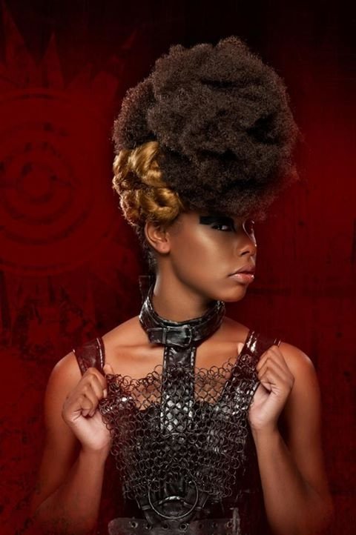 | Runway, Commercial, Print modeling. Hosting and Acting assignments.  Body Structure: Height: 5' 9"  Weight: 130 lbs  Hair: Black  Eyes: Brown  Shoe: 8.5  Dress: 4  skills  Runway Modeling, Acting, Basketball, Track, Dance, Cheerleading
EXPERIENCE:
Charity Fashion Show-Take The Time Foundation Huntsville AL(Model)Girls Run The World: An Evening of Fashion; WE>AIDS Charity Benefit – Sigma Gamma Rho Sorority, Inc-Kappa Iota Chapter-AAMU(Model)Rip the Runway Atlanta GA(Model)WeDoFashion Atlanta(Model) Black & White Hair/Fashion Show Atlanta(Model) 2012,ACTING-Played Innocent Little Girl in Bobby Pin Diaries for Moldingheartz Play Company, F.A.M.E fashion show Huntsville AL(Model) WeDoFashion Atlanta GA(Model) Hosted Jazz Before Christmas Radar Red Carpet
MUA: Colleen Gagnon, Bare Essentials, Demi Howell
PHOTOGRAPHER: Aaron Lacey, O Jay Rice
MEASUREMENT:
Bust: 33 ½” CF to side waist: 8 ½
Waist: 25 ¾” add 3/8” to waist/short intersection CF Length (torso): 14
Hips: 37” CB Length (torso): 15
Arm Length: 25” Shoe size: 8 ½ -9
Crotch depth: 10 ¾” Hip front to side seam: 10 ½

