Film
Safety First Principal Tu Do Cameraworks Raquel Hagman
Back Court Supporting MTC Miami Talent
Boxes Supporting North Broward Pictures Liz Peterson
Paracosm Principal Ungerman Productions Bianca Ungerman
Sweet Dreams Principal Metis Studios Zach Sherman
Hanny’s House of Orphans Principal Metis Studios Zach Sherman
To Be or Not to Be Principal Regency Victor Rivera

Television
The Raven (Pilot Presentation) Principal Rinky Dink Productions David Haines
Just My Luck (Pilot Presentation) Principal Metis Studios Liz Peterson
WSAS Kids News (Web) Anchor (Principal) 407 Productions Jackie Gorora

Infomercial/Voiceover
Murder by Moonlight Trailer Supporting Amazon Studios Vincent Zandri
Don’t Mute the Youth PSA Principal National Youth Rights Assoc. Kelley Briceno
Maine Arts Camp Industrial Principal Kristofer Kauff Maine Arts Camp
Miami Children’s Hospital Principal N2 Productions Neil Nunez
Mrs. Pinklemeyer Principal Independent Production Jennifer Kelman
MP3 How-To-Video Series Principal Library of Classics Hilary Pushkin

Theatre
13: The Musical Evan Arts Garage Mark Kirschenbaum
Broadway Rocks! Senior Performer Florida Regional Tour Rome Saladino
You’re a Good Man, Charlie… Charlie Brown Showtime Arts Theatre Sara Perry-Greenberg

Training
Multi-Camera Intensive Carol Goldwasser, CSA Los Angeles, CA
Cold Read Comedy Intensive Harriet Greenspan, CSA Los Angeles, CA
Comedy Intensive Howard Meltzer, CSA Los Angeles, CA
Sitcom Auditioning Dana Gergely, CSA Los Angeles, CA
Sense Memory Intensive Ty Harman, CSA Los Angeles, CA
Single Camera Scene Study Allen Hooper, CSA Los Angeles, CA
Multi-Camera Acting Wendy Ann Faraone Los Angeles, CA
Character Analysis Jason La Padura, CSA Los Angeles, CA
Scene Study Lyndsey Baldasare, CSA Los Angeles, CA
Audition Technique Geralyn Flood, CSA Los Angeles, CA
Commercial Auditioning Terry Berland Los Angeles, CA
Single-Camera Scene Study Lesly Kahn Los Angeles, CA
Scene Study Helen Anzalone Los Angeles, CA
Audition Technique Joshua LeBar Los Angeles, CA
Improvisation Ezra Weisz Los Angeles, CA
Stanislavsky & Method Acting Mark Kirschenbaum Miami, FL
Sketch Comedy Kristofer Kauff Los Angeles, CA

Special Skills
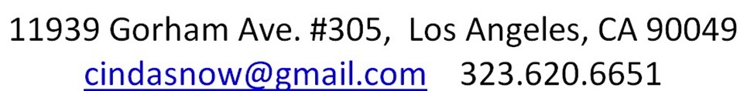

Singing, Drums & Percussion, Improv, Conversational Spanish, Honor Student, Swimming, Biking, Photography
Manager:

