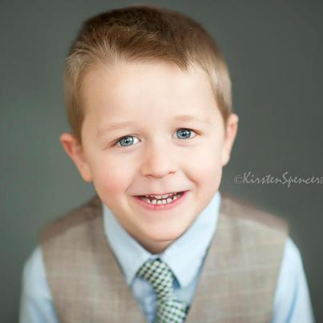

GARRETT WAYNE RUNYAN
63 Adams St
Orange, MA 01364
brandyrunyan@gmail.com
(254) 541-9151
Parents: Stephen & Brandy Runyan

Child actor aged 6. Possesses fun and bubbly personality and eager attitude towards working with co-actors & actresses.

PERSONAL INFORMATION
DATE OF BIRTH: 04/03/2007
HAIR: Dirty Blonde
EYES: Blue
HEIGHT: 3’, 8”
WEIGHT: 43lbs
GENDER: Male

ACTING EXPERIENCE
(Music Video) “Window” by Joen, featuring Prince Charles –PB Dolla Entertainment (April 2013)
(Music Video) “Ronan”, Emerson Student Film- Directed by Stephanie Kiser (May 2013)

PRINT
Black Diamond Quarterly Magazine: Summer 2013, Rising Stars Spread-Black Diamond PR (July 2013)

EDUCATION
Kindergarten (Homeschooled)

ADDITIONAL SKILLS
*Ability to memorize lines quickly and accurately
*Creative imagination
*Enjoys character development

ADDITIONAL PHOTOS AVAILABLE
See online WebComp: https://talentsoup.com/webcomp/19478d

