High School Debate Tournament 4 – January 20th, 2018

Where: Suffolk University (20 Somerset Street, Boston, MA 02108)
Who: All BDL High Schools and Brooke Charter, Everett, Somerville, and Lexington

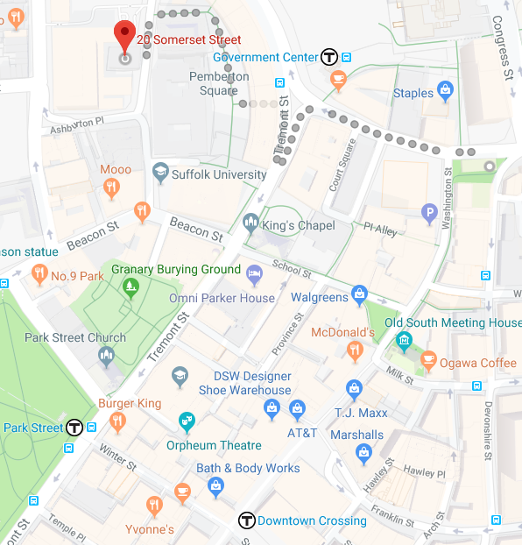
Transportation:
Parking:
Parking is available at the 100 Cambridge Street garage or at the Courthouse Garage for $12.

Directions by MBTA:
Take the Green or Blue lines to Government Center, and walk to the right of Center Plaza, up Somerset Street, the building is on the right.

Take the Orange Line to State and walk west on Court Street, then turn right and walk north on Cambridge Street, and make a left on Somerset Street, the building is on the right.

Take the Red Line to Park Street, walk northeast on Tremont Street, turn left on Beacon Street, turn right on Somerset Street, the building is on the left.

Emergency Contact Information: Roger Nix, Tournament Director, cell: 508-395-7228
Rane Baldwin, Tournament Assistant, cell: 620-245-2119

Schedule:
DOORS OPEN AT 7:00  COACHES ARRIVE BY 7:30  7:30 – 8:00 | Arrival, Registration, Breakfast  & Judge Training  REGISTRATION DEADLINE AT 8:00!
8:15 – 10:15 | Round 1
10:15 – 12:15 | Round 2
12:15 – 1:00 | Lunch
1:00 – 3:00 | Round 3
3:00 – 5:00 | Round 4
5:00 – 5:30 | Dinner
5:30 – 6:00 | Awards Ceremony
6:00 – 8:00 | Finals – Debate en Español, JV, and Varsity Only (No Novice Finals)

Registration Information

Preregistration Deadline: Friday, January 12th – 12:00pm
Registration Deadline: Thursday, January 18th – 8:00pm

Tournament Day: Create an account on Tabroom.com, and then link it to your team. Then you will be able to register for and track the tournament online to know where you need to be and when!

Parents

What time will they be done? On Saturday, all students debate the first four rounds, and then only the students who have won advance to a final round. That means that many students are finished with their part of the debate after 6pm when the Awards Ceremony ends, but we do encourage students to stay and watch elimination rounds to help improve as debaters and to cheer on teammates and friends. The entire tournament ends as soon as the final round concludes, usually by 8:30-9pm.

Tracking My Student: If you register for an account on Tabroom.com, you will be able to track your student’s rounds and get text or email updates if the tournament is running behind schedule. You are also welcome to ask at the volunteer table to find out if the tournament is running on time and to find the rooms where your student is debating. You will just need to know your child’s name and school to ask their location.

Am I Allowed to Watch the Debates? We love to have families come and watch their students debate. You are welcome to sit in on any round provided that you ask the other team and the judge if they mind and as long as you are silent during the debate (communicating with the students or creating any noise disruption could interrupt the debate and could be counted as a team cheating in the activity). With permission from both teams, you may also take pictures or video of your student’s debate.

Do You Need Volunteers? Both the Boston Debate League and our team are always in need of volunteers. In the past parents have helped out as team chaperones, as volunteer judges at tournaments, and as volunteers helping in setup and other tasks at the tournament. Please let the coaches or BDL volunteer staff know if you are able to volunteer!

