
Sheboygan North High School and the SNH Debate Team are excited to welcome you to the Sheboygan North Raider Rumble 2015! We are offering three rounds of both Novice Switch Side and Varsity Switch Side Debate and five rounds of Public Forum and Lincoln-Douglas! Below I have all the necessary information you will need, and as most information is on www.tabroom.com this invite will be kept brief to the essentials.

In addition to the tournament, and to keep things on the lighter side, we will be offering an ugly Christmas Sweater contest. Feel free to find and wear your ugliest sweater to win sweet prizes. Rules will be available on tabroom.com and at the tournament. Stay tuned for details.

Registration:
Registering for the tournament will occur on Tabroom linked above and is open between 11/09/15 until 12/10/15 at 5:00 PM. Judging registration is until the same time. Drops will be allowed until 12/11/15 at 5:00 PM, but you will be on the hook for any judge commitments and/or fees from the dropped teams after the Thursday deadline.

On the morning of the tournament, you are required to call/text in any judge and student changes and an estimated ETA between 7-7:45. My contact number is 920-627-2399. Texting works best. I will send a confirmation text back to you.

Checks can be made available to Sheboygan North Debate Team. Payments can be mailed ahead of time to:
Attn: Anton Shircel, Debate Coach
Sheboygan North High School
1042 School Ave
Sheboygan, WI 53083
Entry Fees:
VSS or NSS @ $25 per team
PF @ $25 per team
L­D @ $15 per student
Hired Judges @ $150

Event Details:
VSS/NSS: There will be only Varsity Switch Side available at this tournament and will follow an 8 minute prep time rule. Novice Switch Side will have 5 minutes. Both divisions will only have three rounds.

Public Forum: PF will have 5 rounds and have the normal flip for sides format with 2 minutes of prep time. Also so that it is clear. Final Focus is 2 minutes.

Lincoln Douglas: This division will also hold 5 rounds with the standard 4 minute prep.
Judge Requirements:​
One for every 1 or 2 Policy teams entered. Two for every 3 or 4 Policy teams.
One for every 1 or 2 L­Der’s. Two for every 3 or 4 L­Der’s etc.
One for every 1 or 2 PF teams Two for every 3 or 4 PF teams. etc.
Schedule:
Policy | LD/PF | Upon Arrival:  Students Should Report to Commons Area  Judges Lounge: Rm 151  Tab: IIMC
Rd 1- 8:30 | Rd 1 – 8:30
Rd 1- 8:30 | Rd 2 – 9:30
Rd 2 – 10:30 | Rd 3 – 10:30
Rd 2 – 10:30 | Rd 4 – 11:30
Lunch in the Commons Area
Rd 3 – 1:00 | Rd 5 – 1:00
Awards - 3:30 in Lunchroom

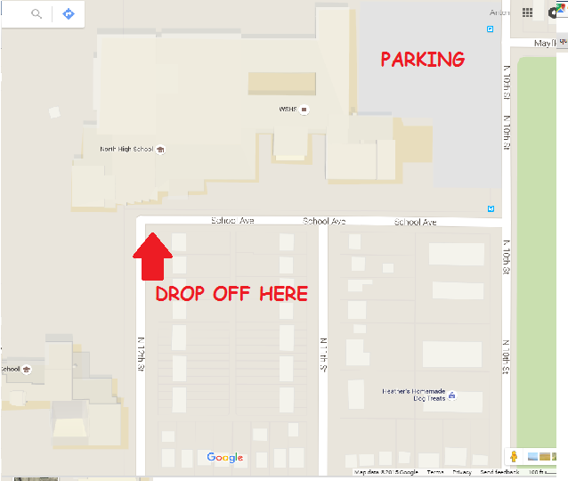
Location and Parking:
The address is 1042 School Ave, Sheboygan, WI 53083. Please use the Commons entrance on the corner of N. 12st St. and School Ave. There is parking for the buses in the East Lot off of N. 10th St. There is also limited parking on/off of School Ave for vans and smaller vehicles.

Food:
Students can buy food from the concessions during the morning and lunch time. The current menu planned is pizza. Judges/coaches will receive a meal ticket to use at the concessions.

There will also be refreshments available in the Judge’s Lounge.

