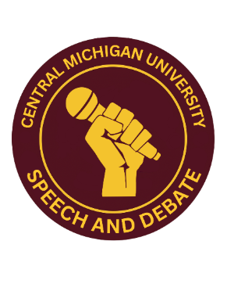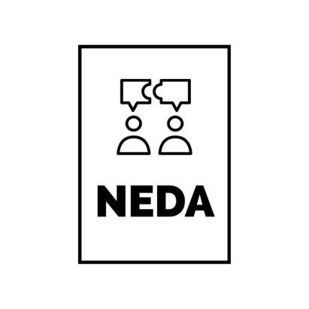
On behalf of the Central Michigan University Debate Team, I’m happy to invite you to the 2026 NEDA Fall Educational Opener debate tournament to be held at Central Michigan University, Friday and Saturday, September 25th and 26th!
We are experimenting with a completely REVAMPED approach to the formats that we are hosting this year at NEDA-sponsored tournaments! We will be hosting formats that are consistent with other national forensics organizations such as Pi Kappa Delta and Phi Rho Pi.
This year's tournament will include College Public Forum and IPDA!
We’re looking forward to exploring this year’s College Public Forum topic: Resolved: The International Criminal Court does more harm than good.
In addition, we are holding introductory debate lectures before the start of the tournament. Including lectures on the fundamentals of argumentation, as well as format-specific lectures, presented by coaches
We’re looking forward to seeing you in Mount Pleasant in September!
Sincerely,
Dr. Ryan Corso-Gonzales
Assistant Professor/Director of Forensics
Central Michigan University
Tournament Schedule:

Friday September 25th
1:00 pm- 2:00 pm: Tournament Check-In
2:00 pm – 3:00 pm: Argumentation Lecture by
3:00 pm – 4:00 pm: Format-specific introductions by
4:00 pm- 5:00 pm: Round 1
5:15 pm – 6:15 pm: Dinner
6:15 pm – 7:15 pm: Round 2
7:30 pm – 9:00 pm: Round 3

Saturday, September 26th
9:00 am- 10:00 am: Round 4
10:15 am – 11:15 am: Round 5
11:30 am – 12:30 pm: Round 6
12:30 pm – 1:30 pm: Lunch
Breaks announced
1:30 pm- 2:30 pm: Quarter Finals
2:45 pm- 3:45 pm: Semi-finals
4:00 pm – 5:00 pm: Finals
5:15 pm: Awards start ASAP

TOURNAMENT RULES:
- Teams will be competing in College Public Forum and IPDA divisions.
- Depending on the number of teams, Varsity and Novice teams might face each other in rounds; teams will be separated by division for awards and final rounds.
- Individuals competing in IPDA will have their topic presented to them at the round start time on the schedule and then be given 30 minutes to strike topics with their opponents and prepare their speech.
- IPDA debaters can use computers/devices to research before the round but should not be researching once the debate has started.
- Coaches may assist debaters during the 30-minute prep time process.

Awards
- Team awards will be given to the top 5 teams in each division.
- Speaker awards will be given to the top 10 individual debaters in each division.
- Sweepstakes Awards will be given to the top 3 programs for both novice and varsity divisions.

ENTRIES:
- Please enter team info on TabRoom.com.
- All entries are due by 11 pm Monday, September 21st, 2026.
- (If you don’t have exact final entries, please at least email a rough head count).
- When entering team information, please indicate whether each debater is a Novice.
- NEDA novice status = fewer than 6 previous tournaments at any level (including high school).
- Any dropped entries after 11:59 pm on Wednesday, September 23rd, will be fined a $40 penalty.
- Please limit your entry to one maverick per division for College Public Forum.

REGISTRATION:
- Registration will be in Moore Hall Room 209, beginning at 1:00 pm on Friday.
- Registration fees:
- Teams/pairs in College Public Forum: $50 per entry.
- IPDA: $30 per entry.
- If registration fees are a barrier to your team’s participation, please let us know, and we can make arrangements to resolve that problem.
- Each judge provided by a school ‘covers’ two team entries.
- There will be a $50.00 ‘judge fee’ for each uncovered team.

Directions:
The tournament will function primarily out of Moore Hall and Anspach.

Address: W Campus Dr, Mount Pleasant, MI 48858

Parking: Parking will be available in Lot 33S.

Nearby Hotels:
There are several hotels in Mt. Pleasant, including one hotel located on campus associated with the University.

Courtyard by Marriott Mt. Pleasant at Central Michigan University
2400 East Campus Dr, Mt Pleasant, MI 48858
(989) 773-1444

