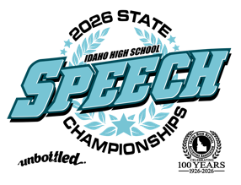
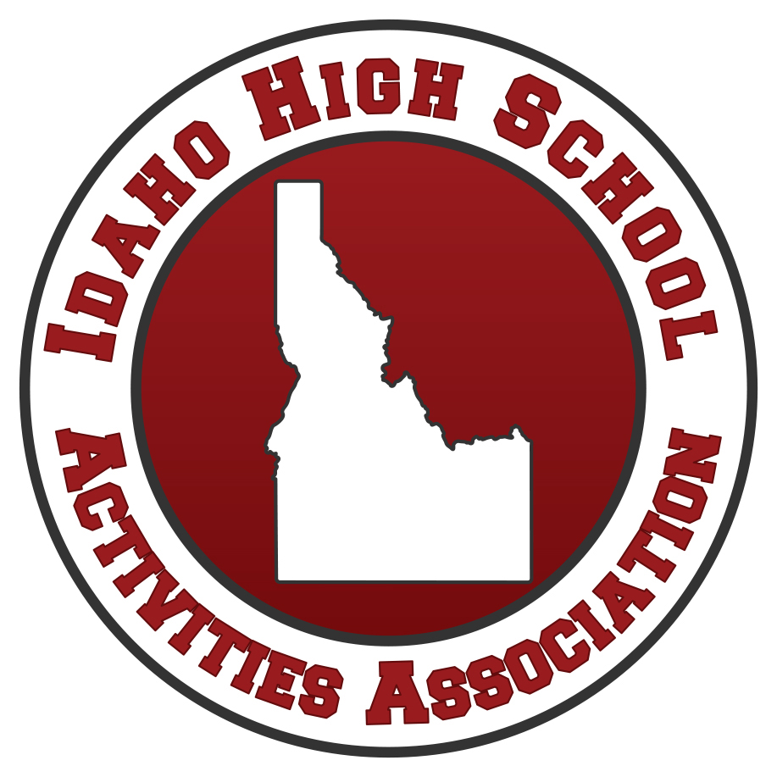
Idaho High School Activities Association

2026 STATE SPEECH TOURNAMENT
Pocatello High School
April 10-11, 2026

Pattern A – TBD
Pattern B – TBD

Friday, April 10
11:00 am - 11:30 am Judge Registration / Team Packet Pick up
11:30 am - 12:00 am Judges & Coaches Meeting
11:30 am - 12:00 pm Welcome Assembly
12:15 pm - 1:00 pm Novice Judge Clinic
12:15 pm - 2:15 pm Round I A Draw Events + Other designated A events
2:15 pm – 3:45 pm Round I B Designated B events
3:45 pm – 5:45 pm Round II A Draw Events + Other designated A events
5:45 pm – 7:15 pm Round II B Designated B events
7:15 pm - 9:15 pm Round III A Draw Events + Other designated A events

Saturday, April 11
8:00 am Judges/Coaches Report to Tournament Desk
8:30 am – 10:30 am Round III B Designated B Events
10:30 am – 11:00 am Prep for Break Rounds
11:15 am – 1:15 pm Semifinals A Draw Events + Other designated A Events
1:15 pm – 3:00 pm Semifinals B Designated B Events
3:00 pm – 5:00 pm Finals A Draw Events + Other designated A Events
5:00 pm – 6:30 pm Finals B Designated B Events
7:00 pm Awards

