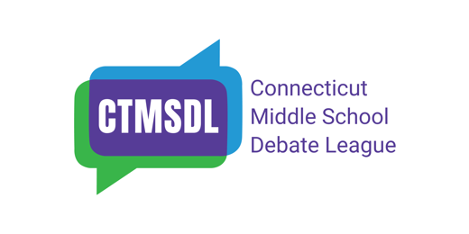
Tournament, Saturday, February 28, 2026, 8:00 am — 4:30 pm
Timothy Edwards Middle School, 100 Arnold Way, South Windsor, CT 06074
Sponsored by The English Speaking Union, Greenwich Branch
On behalf of Timothy Edwards Middle School and Coach John Smith-Horn, the CTMSDL invites you to our third event of the 2025--2026 season.
Novice and Open Level debaters will have 3 rounds of extemporaneous debate. It is up to coaches to decide which category (novice or open) is appropriate for each of their teams. Most novice teams that competed in November and December should register as open!
Please review the June 2024 Handbook.
Coaches should register on Tabroom.com for the event CTMSDLfeb28 by 10 am Thursday, February 26. That’s the deadline to purchase Tabroom entries. You may edit your teams up until 9:00 am on Feb 28. Instructions on using Tabroom can be found here. There is no cap on the number of teams a school may enter.
Coaches must register one judge per every 2 teams entered. Coaches should make sure their judges understand the information in the Judges’ Instructions and the Handbook prior to the event. Observers are welcome.
Schedule
Arrival, Coaches check-in, lunch ticket sales | 8:00 – 9:00 (DO NOT BE EARLY )
Welcome – Auditorium | 9:00
Workshops: Debaters (optional), New Judges, Exper Judges | 9:30 – 10:30
Open & Novice R1 | 10:45 – 12:00
Lunch | 12:00 – 12:45
Open & Novice R2 | 1:00 – 2:30
Open & Novice R3 | 2:45– 4:00
Games (optional) – Auditorium | After R3
Awards | 4:15
BAKE SALE 8-10:45 am & 2-3 pm! Cash only. Debaters may buy pizza and drink tickets when they arrive. Pizza is $2 per slice and drinks are $1. BYO water bottles. Breakfast and lunch will be provided for judges. Questions or comments? Please email Jen Posner at jen.posner@ctmsdebate.org. CTMSDL sweatshirts for sale all day. Cash or Venmo.

