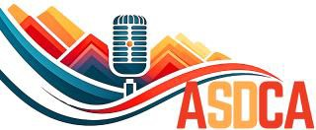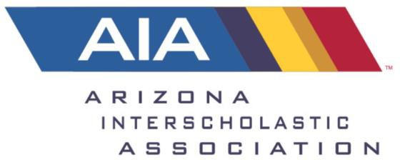

2026 State Tournament Congressional Docket Division 1
At the 2024 Spring Conference “A Proposal to have Online Voting for Congressional Docket Order” was approved.

Tournament directors are required to randomly select a docket order prior to competition. The purpose is to reduce large school advantage in dictating the docket order on their own.

Congress Session 1 the docket order will be as follows:
Bill 1 - A Bill to Reschedule Veterans Day and Protect Voting
Bill 2 - A Bill to Abolish Medical Patents
Bill 3 - A Bill to Streamline the Development of Green Infrastructure
Bill 4 - The Gerrymandering Removal Act

Congress Session 2 the docket order will be as follows:

Bill 5 – A Bill to Decriminalize the Possession of Controlled Substances
Bill 6 – A Bill to Abolish School Resource Officer (SRO) Presence in Schools
Bill 7 – A Bill to Abolish Animal Cruelty in the Beauty Industry
Bill 8 – A Bill to End Mandated Reporter Status for Educators

Congress Session 1
Bill 1 - A Bill to Reschedule Veterans Day and Protect Voting

1  2  3  4  5  6  7  8  9  10  11  12  13  14  15  16  17  18  19  20  21  22  23  24  25  26  27  28 | BE IT ENACTED BY THE CONGRESS HERE ASSEMBLED THAT:  SECTION 1. Veterans Day and Election Day are hereby rescheduled from their current dates to the second Monday in November. Several states are encouraged to enact laws requiring employers in non-essential sectors to provide paid leave to employees on Veterans Day/Election Day.  SECTION 2. This legislation shall take effect beginning in fiscal year 2027. All laws or parts of laws in conflict with this legislation are hereby declared null and void.
Introduced for Congressional Debate by Mountain View High School
Bill 2 - A Bill to Abolish Medical Patents

BE IT ENACTED BY THE CONGRESS HERE ASSEMBLED THAT:
SECTION 1. All medical patents shall hereby be nullified. The U.S. Patent and Trademark Office shall be restricted from issuing any and all medical patents in the future. The National Institutes of Health (NIH) shall be allocated an additional 70 billion dollars per year to finance the research and development done by the pharmaceutical industry.
SECTION 2. Medical patents shall be defined as patents on any medication, medical device, or medical process that prevent other competitors from producing similar medications, devices, or processes.
SECTION 3. The U.S. Patent and Trademark Office, the Department of Commerce, and the Department of Health and Human Services shall oversee the enforcement of this legislation.
SECTION 4. This legislation will take effect on July 1, 2026.
SECTION 5. All laws in conflict with this legislation are hereby declared null and void.
Introduced for Congressional Debate by Hamilton High School.

Bill 3 - A Bill to Streamline the Development of Green Infrastructure
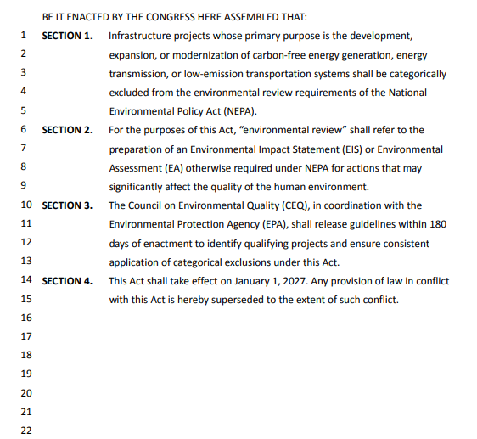
Introduced for Congressional Debate by Brophy College Prep.

Bill 4 - The Gerrymandering Removal Act

1  2  3  4  5  6  7  8  9  10  11  12  13  14  15  16  17  18  19  20  212223 | BE IT ENACTED BY THE CONGRESS HERE ASSEMBLED THAT:  SECTION 1. To avoid the prospect of gerrymandering, the drawing of congressional and state legislative district boundaries shall be handed over to the Department of Interior, who shall submit maps for each state every eight years.  SECTION 2. The Department of Interior shall adhere to the following principles when drawing district boundaries:  - Districts shall be contiguous and compact.  - Districts shall respect existing political subdivisions, such as counties and municipalities, and maintain communities of interest where possible.  - Districts shall not be drawn for the purpose of favoring or disfavoring any political party or incumbent candidate.  SECTION 3. Each state, regardless of political majority, shall create a commission consisting of an equal number of members affiliated with the two largest political parties to vote on whether to pass the proposed redistricting plan.  - Members shall be selected through a transparent, random, and publicly verifiable process administered by the state’s judicial branch.  - Members shall vote on whether or not to pass the federal government's redistricting plan, passed with a 2/3 majority.  - If the plan isn’t passed, the elected commission and Department of Interior must work together to create and pass a new redistricting map in under 6 months.  SECTION 4. This legislation shall go into effect in FY 2027.  SECTION 5. All laws in conflict with this legislation are hereby declared null and void.
Introduced for Congressional Debate by Arizona College Prep High School.

Congress Session 2

Bill 5 - A Bill to Decriminalize the Possession of Controlled Substances

BE IT ENACTED BY THE CONGRESS HERE ASSEMBLED THAT:
Section 1. This bill will eliminate all existing penalties for those found in possession of currently labeled controlled substances, regardless of intent to distribute.
Section 2. Controlled substances are defined as all substances whose manufacture, importation, possession, use, or distribution is currently restricted according to federal law.
Section 3. This legislation shall be overseen by the Justice Department, in cooperation with all federal and local law enforcement agencies.
SECTION 4. This legislation will take effect on July 1, 2026.
Section 5. All laws in conflict with this legislation are hereby declared null and void.

Introduced for Congressional Debate by Chandler High School

Bill 6 - A Bill to Abolish School Resource Officer (SRO) Presence in Schools

BE IT ENACTED BY THE CONGRESS HERE ASSEMBLED THAT:
SECTION 1. The permanent stationing of School Resource Officers (SROs) in all K-12 public schools is hereby abolished. No funds, whether federal, state, or local, shall be allocated for the hiring, training, or deployment of law enforcement officers within educational institutions. All existing SRO funding will hereby be redirected towards juvenile restorative justice programs.
SECTION 2. School Resource Officer (SRO) shall be hereby defined as any law enforcement officer, whether directly employed by a police department or contracted by a school district, whose primary duty is maintaining security within a K-12 school.
SECTION 3. The Department of Education and the Department of Justice shall oversee the enforcement of this legislation.
- Any school district found in violation of this act shall be subject to a loss of 15% of its federal education funding annually.
SECTION 4. This legislation will take effect on January 1st, 2027. All laws in conflict with this legislation are hereby declared null and void.
Introduced for Congressional Debate by Hamilton High School.

Bill 7 –
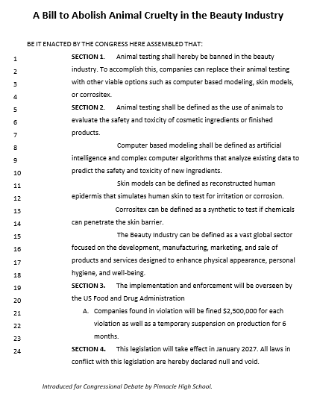
Bill 8 –
