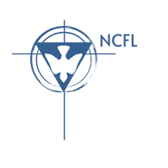
NCFL-Pensacola
PATRIOT PARLANCE
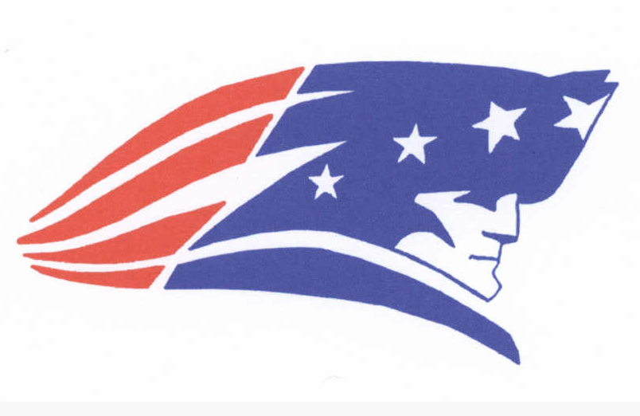
Legislative Docket
101. Sovereign Respect and Venezuela Operations Act
102. A Bill to Expand Funding for Mental Health Services in Schools
103. A Bill to Hasten the Transition to Nuclear Energy
104. A Resolution to Abolish trying Children as Adults
105. R.I.S.E A Bill to Reform Indonesia’s Sea-Trade Economy
106. A Bill to Sanction Qatar
107. A Bill to Support the Sustainability of the Panama Canal
108. A Bill to subsidize the U.S. Electric Vehicle Industry
109. A Bill to Provide for Sibling Groups in Foster Care

Sovereign Respect and Venezuela Operations Act

BE IT ENACTED BY THE CONGRESS HERE ASSEMBLED THAT:
Section 1. The United States shall immediately cease any ongoing unilateral military, intelligence, or law-enforcement operation aimed at seizing, detaining, or transporting the sitting President of Venezuela outside Venezuelan territory, and shall initiate diplomatic steps to return the President of Venezuela to Venezuelan jurisdiction while pursuing any allegations through lawful multilateral processes.
Section 2. A. “Sovereign respect” is defined as adherence to the territorial integrity, political independence, and equality of states as reflected in the Charter of the United Nations and customary international law.​
B. “Unilateral operation” is defined as any action undertaken by the United States without prior authorization from Congress and without an explicit mandate from a competent international body such as the United Nations Security Council or the Organization of American States.​
C. “Sitting President of Venezuela” refers to the individual currently exercising the office of head of state and government of the Bolivarian Republic of Venezuela under its internal constitutional order, regardless of U.S. political recognition.
Section 3. A. The Department of State shall lead diplomatic efforts to negotiate the safe and orderly return of the President of Venezuela to Venezuelan jurisdiction, including coordination with regional and international organizations and with Venezuelan authorities.​
B. The Department of Defense, the Intelligence Community, and the Department of Justice are prohibited from obligating or expending funds to plan, support, or conduct any unilateral operation to capture, detain, or transfer the sitting President of Venezuela, except where Congress has expressly authorized such action through subsequent legislation.​
C. The Department of Justice shall pursue any criminal allegations against the President of Venezuela, or other senior Venezuelan officials, through extradition requests, cooperation with international tribunals, or other lawful mutual legal assistance mechanisms that respect Venezuelan sovereignty and international law.​
D. The Inspectors General of the Department of State, Department of Defense, and Department of Justice shall jointly report to Congress within 180 days on any past or ongoing U.S. operations involving the apprehension or extraterritorial transfer of the President of Venezuela, including legal justifications and compliance with this Act.
SECTION 4. This legislation will take effect on July 1, 2026.
All laws in conflict with this legislation are hereby declared null and void.
Introduced for Congressional Debate by Ashton Carter, Pensacola High School.

A Bill to Expand Funding for Mental Health Services in Schools

BE IT ENACTED BY THE CONGRESS HERE ASSEMBLED THAT:
SECTION 1. The federal government shall allocate $10 billion annually to fund mental health services in K-12 public schools across the United States.
SECTION 2. “Mental health services” shall include access to school psychologists, counselors, social workers, and mental health education programs.
“Public schools” refer to all primary and secondary schools receiving federal education funding.
SECTION 3. The Department of Education and the Department of Health and Human Services shall oversee implementation and ensure proper allocation of funds.
SECTION 4. This legislation will take effect on January 1, 2027.
All laws in conflict with this legislation are hereby declared null and void.

A Bill to Hasten the Transition to Nuclear Energy

BE IT ENACTED BY THE CONGRESS HERE ASSEMBLED THAT:
SECTION 1. The United States shall hereby designate $450 billion annually for the next 30 years for the purpose of building a total of 6 petawatt hours of annual electrical generation capacity in nuclear fission reactors. In addition, a one-time fund of $25 billion will be designated for the purpose of constructing a deep geological repository for transuranic waste capable of 6 storing a minimum of 50 years of waste at the maximum waste production rate of the fission reactors.
SECTION 2. For the purposes of this act:
A. Nuclear fission reactor shall be defined as an electrical generation facility that utilizes the controlled fission of uranium molecules to produce electricity.
B. Deep geological repository shall be defined as a storage facility for the purpose of securely containing waste underground for a minimum period of 1,000 years.
SECTION 3. This legislation shall be overseen and enforced by the Department of Energy.
SECTION 4. This legislation will take effect in fiscal year 2027.
All laws in conflict with this legislation are hereby declared null and void.
A Resolution to Abolish Trying Children as Adults in the Criminal Justice System
WHEREAS, The United States is one of the few countries in the world where children can be tried as adults and sentenced to life in prison without the possibility of parole; and
WHEREAS, Neuroscience and psychological research consistently show that adolescent brains are still developing, particularly in areas related to impulse control, decision-making, and understanding long-term consequences; and
WHEREAS, The U.S. Supreme Court has recognized that children are categorically less culpable than adults due to their diminished capacity for judgment and maturity in Roper v. Simmons (2005) and Graham v. Florida (2010); and
WHEREAS, Research indicates that children tried as adults face higher rates of abuse, violence, and isolation in adult correctional facilities, which can lead to greater recidivism and hinder rehabilitation; and
WHEREAS, The goal of the criminal justice system should be rehabilitation and reintegration of offenders into society, which is more achievable through the juvenile justice system than through adult court processes; now, therefore, be it
RESOLVED, That the Congress here assembled should abolish the practice of trying children as adults, and instead, ensure that minors who commit criminal offenses are adjudicated in the juvenile justice system, where they can receive age-appropriate treatment, rehabilitation, and support for their reintegration into society.

R.I.S.E.A Bill to Reform Indonesia’s Sea-Trade Economy

BE IT ENACTED BY CONGRESS HERE ASSMBLED THAT:
Section 1. The United States will establish a free trade agreement with Indonesia and invest 4 billion dollars with the goals of fostering trade with the U.S., economic development, and protecting already existing trade relations.
Section 2. Free trade agreement shall be defined as an agreement which lifts restrictions on the trade and movement of goods, services, and investment.
Section 3. The Department of State and Commerce will establish the framework for a deal which will protect and foster American business. The Department of Commerce will additionally allocate investment in Indonesia in sectors that will benefit the local economy and American business interests
Section 4. This legislation will take effect immediately after passage.
All laws in conflict with this legislation are hereby declared null and void.
A Bill to Sanction Qatar

BE IT ENACTED BY THE CONGRESS HERE ASSEMBLED THAT:
SECTION 1. The United States Federal Government shall sanction Qatar by limiting all forms of trade conducted with Qatar until improvements are made regarding human rights.
SECTION 2. Improvements include but are not limited to providing safe working conditions, eliminating gender segregation, and terminating persecution of the LGBTQ+ community. Sanctions are defined as economic and trade restrictions placed on a country. Human rights are rights inherent to all human beings, regardless of race, sex, nationality, ethnicity, language, religion, or any other protected status ensuring the protection of these rights.
SECTION 3. The Department of State and the Department of Commerce will oversee enforcement of this legislation.
A. The Department of State will provide reports every six months to check if requirements are met in order to lift sanctions.
SECTION 4. This legislation will take effect on January 1, 2026.
All laws in conflict with this legislation are hereby declared null and void.
A Bill to Support the Sustainability of the Panama Canal

BE IT ENACTED BY THE CONGRESS HERE ASSEMBLED THAT:
SECTION 1. The United States will provide financial aid to the Republic of Panama to enhance the sustainability of the Panama Canal through infrastructure upgrades and environmental protection initiatives.
SECTION 2. A. Environmental Protection Initiatives shall be defined as programs designed to restore ecosystems surrounding the Panama Canal, reduce pollution, and mitigate the effects of climate change.
B. Infrastructure Upgrades shall be defined as any improvements to the physical and digital infrastructure that support the Panama Canal’s operations and sustainability.
SECTION 3. The United States Agency for International Development (USAID) in conjunction with the Department of State will oversee the implementation of this legislation.
A. The funding for this initiative shall be capped at $500 million over a five year.
SECTION 4. This legislation will take effect on January 1, 2028.
All laws in conflict with this legislation are hereby declared null and void.
A Bill to Subsidize the U.S. Electric Vehicle Industry

BE IT ENACTED BY THE CONGRESS HERE ASSEMBLED THAT:
SECTION 1. The federal government shall provide a subsidy of $5 billion to support the growth of the U.S. electric vehicle industry. Such subsidies will address concerns about declines in industry demand resulting from the elimination of national tax credits and the unavailability of funds from the National Electric Vehicle Infrastructure program.
SECTION 2. The U.S. electric vehicle industry shall include, but is not limited to, manufacturers, battery suppliers, and infrastructure development within the United States.
SECTION 3. The Department of Energy shall work in conjunction with the Department of Transportation to administer the subsidy program.
A. Annual reports to Congress on industry progress and adoption rates will be devised.
B. With the release of such reports, adjustments to subsidy allocation and total funding shall be made accordingly
SECTION 4. This legislation will take effect in fiscal year 2027.
All laws in conflict with this legislation are hereby declared null and voi
A Bill to Provide Homes for Sibling Groups in Foster Care
BE IT ENACTED BY THE CONGRESS HERE ASSEMBLED THAT:
Section 1. This Congress hereby authorizes a fund of $100,000,000 to address or assist in resolving the shortage of appropriate foster homes for children, to develop resources to keep sibling groups together, and to provide for a system of checks and balances to ensure a child’s ongoing safety and well-being, by providing for the placement of a foster child in cottage family homes and making a child so placed eligible for foster care maintenance payments.
Section 2. The term ‘cottage family home’ means a home—
“(i) that is operated by a public or private child care agency licensed or approved by the State in which the home is situated as an agency that meets the standards established for the licensing or approval;
“(ii) that is able to serve as a resource to facilitate sibling groups being placed together where daily contact and interaction strengthens family ties;
“(ii) that is in a single-family style residence with no more than 2 children per bedroom unless it is in the best interest of the children; and
“(iv) in which the children are under the care of live-in parents that use the reasonable and prudent parent standard and provide 24-hour substitute care of children placed away from their parents or other caretakers.
Section 3. The Department of Health and Human Services shall oversee enforcement of this legislation.
SECTION 4. This legislation will take effect January 1, 2027. All laws in conflict with this legislation are hereby declared null and void

