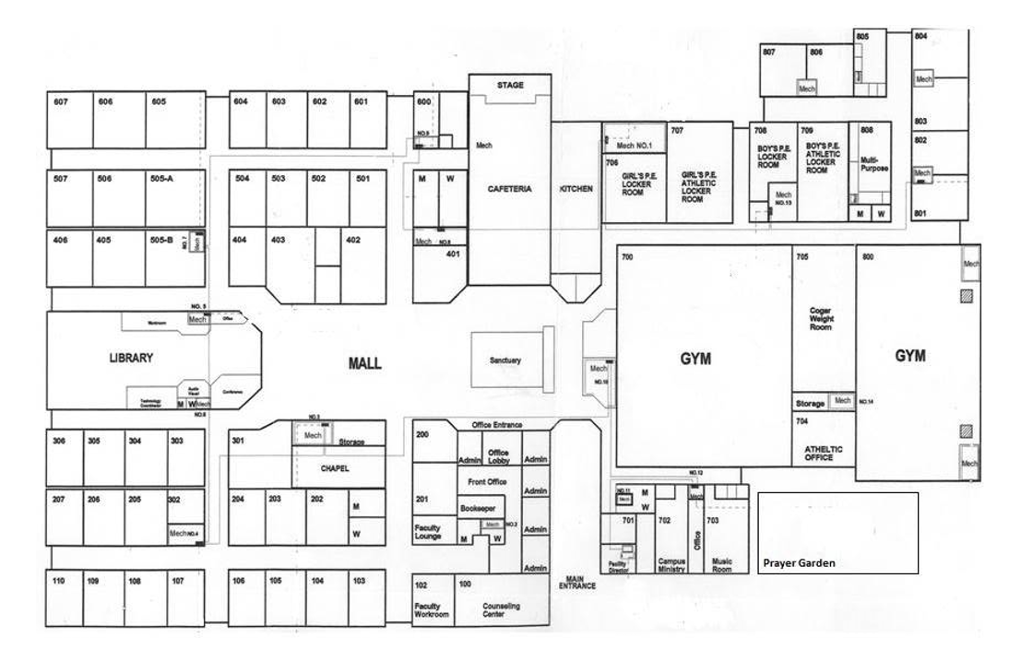
All parking for Friday, January 16, will be on the left side of the building. Our basketball team uses the front lot for VIP parking. See map below:

Good to park!
No Parking- Friday 1/6
Faculty Entrance
Front of school
No Parking- Friday 1/6

