Florida Sunshine NSDA District Tournament

Debate and Individual Events, Saturday, January 31, 2026
Paul R. Wharton High School
20150 Bruce B Downs Blvd, Tampa, FL 33647

Congressional Debate Saturday, February 7, 2026
Suncoast Polytechnical High School
4650 Beneva Road Sarasota, FL 34233

Jym Froelich, District Chair 941.786.5000
james.froelich@sarasotacountyschools.net

Event:
NSDA District Tournament for Debate and Individual Events
Debate Events offered: Lincoln-Douglas, Policy, and Public Forum
Individual Events offered: Dramatic Interpretation, Duo Interpretation, Humorous Interpretation, Informative Speaking, International Extemporaneous Speaking, Original Oratory, Program Oral Interpretation, and US Extemporaneous Speaking

NSDA District Tournament for Congressional Debate
Events offered: HSE, SEN

Non-Qualifier Congressional Debate
Events offered: NQ CON

Participation in the District Tournament is a prerequisite for schools that wish to compete in the online Last-Chance Qualifier in April.

Entries: Fully paid NSDA member schools may NOT enter more than their entry limit per NSDA (see chart posted below). REMINDER: Students must be members of NSDA (25 points on record, fees paid, and website registration) to compete and to have membership and degrees counted toward their schools.

Congressional Debate requires at least six (6) schools and ten (10) students entered to seat a Senate. We must have at least sixteen (16) students entered to seat a House.

Schools are limited to four (4) entries per Debate and Individual Event category, and are further restricted to a total number of entries based on the team’s aggregate NSDA strength score. These entry limits are imposed automatically by tabroom.

Rules and conventions for all event categories can be found on the NSDA website in the High School Unified Manual. Each school's NSDA coach of record must attend the entire tournament with students. The District tournament is a championship/national qualifying tournament. If a coach cannot attend the tournament, do not register the team. If a coach becomes unavailable after the close of registration, contact the District Chair to drop the school’s entries. The Non-Qual Congress is limited to sixty (60) total entries and open to schools and students regardless of whether they are entering the District Congressional Debate Tournament. Non-Qual Congress registration appears as a separate tournament on Tabroom but the Congress Qualifying Events (House/Senate) will run concurrently with the Non-Qual Chamber at Suncoast Polytech.

Double Entry: A student who competes in more than one event at NSDA Districts MUST submit, before the start of the tournament, a Single-Entry Letter of Intent form to indicate the event in which they will compete at Nationals. Students may not compete in two Congressional Debate events. Students may not compete in two Debate event categories either.

Fees:
- The Florida Sunshine fee (school fee) is $25 per school. It must be paid separately by check or in cash. This fee covers the school for both qualifier tournaments. If a school is only competing in the Congress Qualifier on 2/7, they may pay the fee at morning registration then, otherwise, the fee is due when the team checks-in the morning of the 1/31 Debate/IE Qualifier.
- Student entry fees are $30 per student. This means for partnered events like DUO, PFD, and CX, the entry fee is $60.
- Host/meal fees for students and judges are $10. Head coaches’ meals are complimentary. Coaches must order ALL meals for students and judges on the “Meals” tab. Vegetarian options may also be specified on the “Meals” tab.
- All checks should be payable to FGCCFL, as the League account handles both FGCCFL and NSDA business. Schools will pay at registration on Saturday morning. Please plan to bring cash or check to the tournament. PayPal is an acceptable method of payment when utilizing the Friends and Family option.

Judge Quotas:

1:4 for Individual Event Entries.

1:2 for Debate Event Entries, except for Policy (CX) Debate, which requires coverage at a 1:1 ratio.

1:4 for Congressional Debate. Coaches must NOT place themselves in the judge pool as they will be used as Parliamentarians.

Judge Requirements: The District Committee requires that schools supply TRAINED (NSDA Level 1 Congressional Debate (for Congressional Debate) and Multicultural Competence (all events)) judges for a national qualifying tournament. We cannot run the tournament without judges. All judging will be conducted via online balloting. Judges must bring and utilize a reliable, fully charged laptop and enter their feedback on the ballots. Coaches must NOT place themselves in the judge pool as they will be used in tab staff, other official functions of the tournament, and elimination round panels.

Tabulation Rules:

Two judges and one Parliamentarian per chamber will be used in all Congressional Debate sessions (HSE, SEN, and NQ CON).

All events other than Congress will have one judge per preliminary round, and will utilize three (3) judge panels for elimination rounds.

All events other than Congress will have at least four (4) preliminary rounds.

IE Events will only have elimination rounds if the event category has 8 or more entries. Where there are 8 or more entries, at least 25% of the entries will break to at least one elimination round, and elimination rounds will always have at least four (4) competitors. The number of elimination rounds and what metrics are used to determine advancements all follow the NSDA High School Manual.

All Debate Events will have at least one elimination round. Debate entries that have one (1) or zero (0) losses at the end of the preliminary rounds will advance to a single elimination bracket. Winners of elimination rounds will advance until the three (3) qualifying entries and two (2) alternates are determined.

Congress Legislation: Participating schools are required to submit at least one (1) piece of legislation for qualifying chambers and may submit up to four (4). To encourage participation and preparation collaboration the Non Qualifying Chamber will be utilizing the same docket released for both qualifying Congressional events.
- Email legislation to Jym Froelich at <james.froelich@sarasotacountyschools.net>. Please upload legislation to tabroom as a redundancy.
- Designate each item as intended for the Senate or House.
- All legislation must be submitted in NSDA Congressional Debate format and must be the original work of the participating student(s). The current NSDA templates and guidelines are available on the NSDA website and have been loaded to tabroom. Legislation that does not follow NSDA formatting requirements or is unsuitable for district-level debate WILL NOT be considered. The legislation deadline is Wednesday, January 21.

Dates:
12 December 2025: Registration opens at http://floridasunshine.tabroom.com
Non-Qual registration opens at http://floridasunshinenq.tabroom.com
21 January 2026: Legislation is due (emailed to District Chair).
24 January 2026: Finalize all DEB/IE entries on Tabroom including students, real judge names, judge conflicts, and meal orders. This is the LAST day to enter NSDA points to determine eligibility to compete. Tabroom access will close at 9:00 p.m.
31 January 2026: Finalize all Congress entries on Tabroom including students, real judge names, judge conflicts, and meal orders. This is the LAST day to enter NSDA points to determine eligibility to compete. Tabroom access will close at 9:00 p.m.

Tech Reminders: Per NSDA rules, laptops, tablets, and cell phones are permitted. Electronic device use must comply with the “Current Guidelines for Use of Internet-Enabled Devices in Debate Events.” Devices must be silenced and run on their batteries. Students may not use their devices to gain help from coaches, other students, or any other person or generative AI, such that it would prevent the speech from being the original work of the competitor. Devices are prohibited in all other events except that a cell phone (silenced, in airplane mode, and placed on a desk or lectern) may be used for timing. If a prohibited use of a device is reported in any session the student/students will be automatically disqualified.

The burden of knowledge for tech rules or event rules falls to each coach in the district. Please be sure you, your students, and judges know the NSDA rules.

Tabbing Information for the NSDA District Tournament can be found on pages 76-92 of the NSDA Unified Manual: <https://www.speechanddebate.org/high-school-unified-manual/>. The NSDA Tournament Code of Conduct for all students, coaches, and adults will be in effect.

Required Forms: Coaches MUST print the School Consent Form and the Single-Entry Letters of Intent. Make sure they are signed by the coach. Bring them with you to registration.

- Single-entry letter of intent can be accessed here: https://www.speechanddebate.org/district-tournament-single-entry-letter-of-intent/
- Student of the Year nomination form can be accessed here: https://www.speechanddebate.org/student-of-the-year-nomination-form/
- Coach of the Year nomination form can be accessed here: https://www.speechanddebate.org/high-school-coach-of-the-year-nomination-form/

Site Specific Instructions for 1/31 Debate/IE Qualifier:

WHARTON CAMPUS MAP

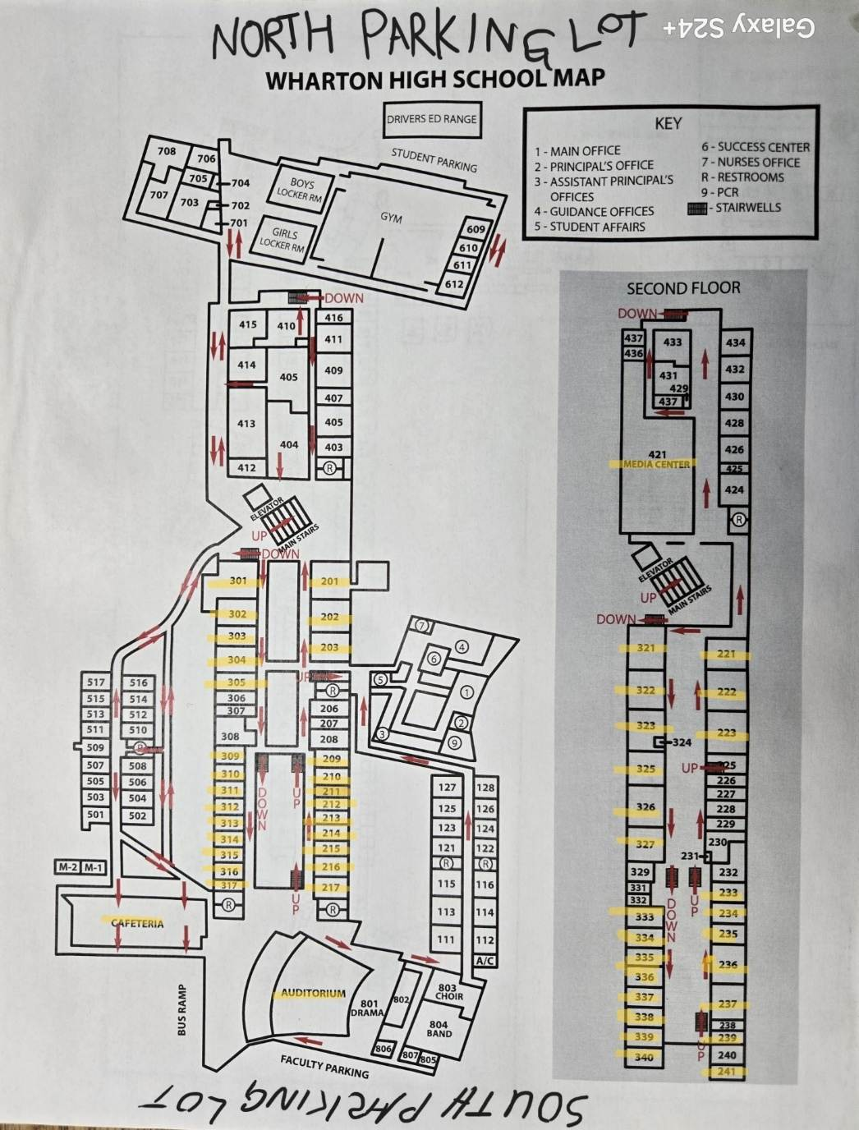

Site Specific Instructions for 2/7 Congress Qualifier:

Arrival Instructions
All guests should park in the NE Student Parking lot (Red Arrow on map). Overflow parking in SE Staff Parking lot (Blue Arrow on map). Students will be housed in the Junior and Senior Quads. Judges and Coaches will report to the Media Center. The Tab Staff and Morning Registration will also be in the Media Center.

DIRECTIONS to Suncoast Polytechnical High School at 4650 Beneva Road ~ Sarasota, FL ~ 34233:

FROM the North Follow I-75 S (Naples). Exit 207 toward SR 758/Bee Ridge Rd. Right onto SR 758/Bee Ridge Rd. Continue for 2.9 mi, then left onto S. Beneva Rd. Stay in the right lane, continue for 0.9 mi, and turn right into the Bus Loop/Student Parking. Park in the Student Parking lot. SPHS is the building with yellow columns.

FROM the South Follow I-75 N toward Tampa. Take Exit 207 toward SR 758/Bee Ridge Rd. Left onto SR 758/Bee Ridge Rd. Continue for 2.9 mi, then left onto S. Beneva Rd. Stay in the right lane, continue for 0.9 mi, and turn right into the Bus Loop/Student Parking. Park in the Student Parking lot. SPHS is the building with yellow columns.

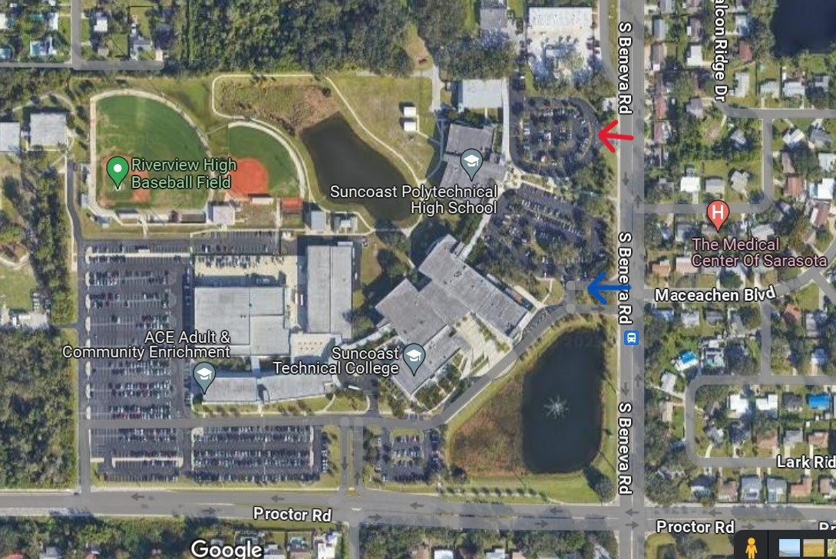

Entry Allotments (per NSDA) for HSE/SEN/NQ Entry Slots (As of 13 January 2026)

IF YOUR SCHOOL IS NOT LISTED, YOU ARE NOT CURRENTLY SHOWING AS AN ACTIVE CHAPTER.
If your school has zero slots, you will need to add members and degrees before being eligible to participate.

School | HSE | SEN | NQ
Academy of the Holy Names | 2 | 2 | *
Admiral Farragut Academy | 4 | 2 | *
Alonso High School | 4 | 2 | *
Carrollwood Day School | 6 | 2 | *
Chipley High School | 2 | 2 | *
Citrus High School | 2 | 2 | *
Crestview High School | 2 | 2 | *
Cristo Rey Tampa | 2 | 2 | *
Fort Walton Beach High School | 4 | 2 | *
Gulf Breeze High School | 4 | 2 | *
HB Plant High School | 3 | 2 | *
Imagine School at North Port | 2 | 2 | *
Land O’ Lakes High School | 2 | 2 | *
Maclay School | 2 | 2 | *
Newsome High School | 6 | 2 | *
Niceville High School | 4 | 2 | *
North Port High School | 2 | 2 | *
Osceola Fundamental High | 3 | 2 | *
Pace High School | 4 | 2 | *
Pasco High School | 4 | 2 | *
Paul R Wharton High School | 3 | 2 | *
Pensacola High School | 3 | 2 | *
Pine View School | 8 | 2 | *
Plant City High School | 2 | 2 | *
Robinson High School | 8 | 2 | *
Sarasota High School | 4 | 2 | *
Sarasota Military Academy | 2 | 2 | *
South Walton High School | 3 | 2 | *
Southeast High School | 2 | 2 | *
St Petersburg High School | 2 | 2 | *
Strawberry Crest High School | 10 | 2 | *
Sumner High School | 2 | 2 | *
Suncoast Polytechnical | 2 | 2 | *
Tampa Jesuit | 2 | 2 | *
Weeki Wachee High School | 2 | 2 | *

* The Non-Qual Congress is limited to sixty (60) total entries and open to schools and students regardless of whether they are entering the District Congressional Debate Tournament.

The Florida Sunshine NSDA District Tournament is committed to providing a safer, more inclusive speech and debate competition. To that end, we will offer a Belonging and Inclusion Station as a tournament resource to provide interpersonal support to anyone who feels that an element of the tournament has excluded them. The BIS will also provide safeguards to any concerns about behavior that violates our harassment and discrimination policy.

Anyone seeking interpersonal support or needing to raise concerns regarding harassment and discrimination may visit our Belonging and Inclusion Advocate, Jym Froelich, in the tabroom.

TENTATIVE SCHEDULE

Saturday, January 31, 2026, Debate and Individual Events - Wharton

7:15-7:45 Tournament Day Registration

7:45-8:15 Announcements

8:30 Round 1 (All Events)

10:30 Round 2 (All Events)

11:45 – 1:00 Lunch

12:45 Debate Round 3

1:15 IE Round 3

2:15 Debate Round 4

3:00 Speech Round 4

4:00 Debate Semis

4:45 Speech Semis

6:00 Debate Finals

6:30 Speech Finals

ASAP Awards

Saturday, February 7, 2026, Congressional Debate – Suncoast Polytech

7:15-7:45 Tournament Day Registration

7:45-8:15 Announcements

8:30 Session 1 (HSE, SEN and NQ CON)

11:00 - 12:45 Lunch (HSE to take lunch early)

11:45 HSE Session 2

1:00 SEN + NQ CON Session 2

2:45 HSE Finals

ASAP Awards

