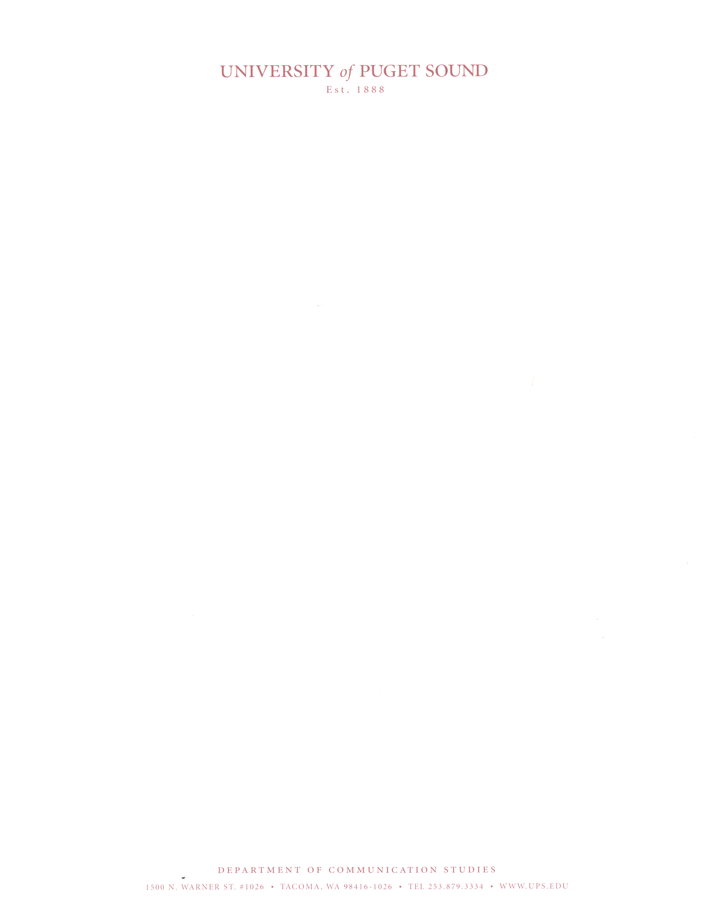
Dear Director of Forensics and Program Coaches,

The University of Puget Sound invites you and your students to participate in the 91st Puget Sound High School Tournament, January 9th-10^{h}, 2026.

We are thrilled to host you and your students this coming year. We continue to receive a number of Tournament of Champion bids in Semi-Finals LD, Semi-Finals Silver Public Forum, and Finals Gold Public Forum. We continue to be a bid tournament for Individual Events.

In accordance the Washington Interscholastic Activities Association (WIAA) will not be able to entries from unaffiliated or club program students. If the Washington High Schools do compete against students who are not affiliated with a school, they risk significant punishment. All students must be representing the school they attend and registered as members of that school with the knowledge of the school.

All Individual Events will occur on Saturday only. All Congress will occur on Friday only. Debate events will span Friday and Saturday.

The tournament will be held in-person on the campus of the University of Puget Sound. All tabulation and balloting will occur via www.tabroom.com. You must register on this site. All judges must also have accounts with linked email addresses for use with online balloting. Please insure all judges are ready to use the online system. If you have difficulties registering, please contact dbuescher@pugetsound.edu. Invoices will also be available through tabroom.com. If you have not used the site in the past, you will need to sign up.

All judges must have met one of the following qualifications to judge at the Puget Sound tournament. 1) Judges must complete the free online NSDA Adjudicating Speech and Debate training module (https://nfhslearn.com/courses/adjudicating-speech-and-debate) or 2) judges must have judged at a minimum of two prior tournaments. Coaches/directors must certify the two-tournament minimum in the qualifications portion of the judge entry via tabroom. Judges that do not meet one of these two requirements will not be allowed to judge and will not count toward judging commitment. We realize this is an extra burden for judges, but it is essential judges have the necessary training to provide effective educationally focused feedback for students.

Below, please find: General Information, Entry Fees, Tournament Schedule, Registration information, Puget Sound Program and Scholarship Information.

We hope you will join us in January for a friendly and competitive tournament experience that celebrates the University of Puget Sound's commitment to excellence in forensics education.

Sincerely,

Derek Buescher, Phd Matt Coleman, JD
Director of Forensics Debate Coach
Tournament Director
General Information
Please note that coaches and administrators are responsible for knowing the rules of entry for this tournament.

Registration:

You must register on-line at www.tabroom.com. Only in the most extraordinary of circumstances we will accept other forms of registration.
- Entry Deadline: Tuesday, January 6, 5:00 PM Pacific Time.
- Drop Deadline: Thursday, January 8, 12:00 PM Pacific Time. After this deadline, fees will be calculated and all drops will be charged full entry fees.
- If necessary, you may email changes to your registration via tabroom.com. Please email changes as soon as you know them, but check www.tabroom.com first to see if you can enter the changes yourself.
- Confirmation of registration will be online. All of your information should be available on www.tabroom.com. Please do not wait until Friday morning when ballots are being distributed to make changes except in unusual circumstances.
- Tabroom.com invoices are not official invoices until we have posted that they are correct. Please do not use these invoices to make payments until we notify programs they have been processed and are ready for use as tabroom.com is may be incorrect with its calculations. It is the responsibility of coaches/directors to file appropriate payment to their accounting offices even if purchasing orders are used.

Entry Information:
All events will be live and in-person events.
- Lincoln-Douglas Debate:
  - An L-D entry is defined as a single individual prepared to debate both sides.
  - All L-D rounds will be double-flighted.
- Public Forum Debate:
  - All public forum debates will be double-flighted.
  - No one person, or "maverick" teams are allowed except in limited basis in the event a partner is ill, e.g. for not more than 2 rounds. Maverick teams are not permitted in elimination debates.
- Congressional Debate:
  - Entries will be Open (any student) and Novice. If entries are high enough we may divide into multiple chambers as necessary. We will use the spring docket of congress bills from WSFA.
- Worlds Debate:
  - A Worlds Debate team can consist of 3-5 students with up to three students debating each round.
  - The tournament will use a mix of limited prep (impromptu) topics and pre-prepared topics. Prepared topics will be draw from the WSFA topics released in December (or Spring topics).
- Individual Events:
  - Students may be triple entered, but are responsible for making all of their rounds on time.
  - Students may enter only one duo interpretation.
- Students may enter only one kind of debate or congress.

Divisions for all events:
- Novice division is for all first-year students and students with no prior experience. After three trophies, students should move up a division
- Junior division is for all second-year students and students with no prior experience. After three trophies, students should move up a division.
- Open division is open to all students regardless of years of experience or awards won in debate.
- If a debate team is composed of partners of different experience levels, the team should enter the division of the more experienced partner.
- We reserve the right to collapse a division of congressional debate, public forum, or LD if there are fewer than six schools entered or insufficient number of entries to run a successful division.
- We will use MPJ in Open Lincoln Douglas Debate. Preferences will likely be released Thursday evening.

Patterns
- Individual Events: Informative, Extemporaneous, Dramatic Interpretation, Dual Interpretation, Oratory, Impromptu, Humorous Interpretation, Programmed Oral Interpretation, Editorial Commentary, Spoken Word Poetry
- SPAR Debate: Will run concurrently with Individual Events. Participants of SPAR may not double enter with IEs
- Debate: Public Forum, Lincoln Douglas, Congress, and Worlds

Matching:
- Individual events (including SPAR): will be prematched, with drops processed as we receive them. Not reporting your drops is not the fault of the tournament directors.
- Public Forum, L-D Debate, and Worlds: Rounds I and II of all debates will be prematched; please report drops promptly. All subsequent debates will be matched “high-low” within brackets unless events are too small to power match in which case all six rounds will be random matches. We will use MPJ for open LD only.

Awards:
- Awards will be presented to the first-third place finishers in each individual event. In debate events, awards will be given to octo-finalists through first place. In congress top presiding officers and judge’s choice will receive awards in each chamber.
- The Charles T. Battin Award will be presented to the top open division all-around competitor in the tournament.
- It is the responsibility of schools to be present at awards to pick up awards and certificates.
- School sweepstakes awards will be presented to the top 3 squads based on the following formula:

L-D Debate/PF/Worlds Congress IE/SPAR
First Place 10 pts 10 pts 5 pts
Second Place 8 pts 8 pts 4 pts
Third/Quarters 6 pts 4 pts 3 pts
Finalist/Octos 3 pts 2 pts 2 pts

This is not an open tab room tournament.

Individual Event Rules

EDITORIAL COMMENTARY: A scripted speech which is intended to be an analysis of a news event rather that a running synopsis of news. Speakers will read their manuscript from a seated position. The script should be timed to end between 1:45 and 2:00. Any speaker ending before 1:45 or after 2:00 shall be ranked one score lower. There is only open division for this event.

INFORMATVE: A speech that is designed to be informative in nature. Visual aids and note cards are permitted, but are not required. Time: ten minutes (10) maximum, with thirty seconds (30) grace. Novices may use notes

DRAMATIC INTERP: One or more cuttings from a published play, prose, poetry, TV, or radio script, which is serious in nature. The presentation is MEMORIZED. Time: ten minutes maximum with 30 seconds grace. Novices may use scripts.

DUAL INTERP: A cutting from a published play, prose, poetry, TV, or radio script, which may be either humorous or serious in nature. The selection must be memorized but given without props or costumes. Time: ten minutes (10) maximum with 30 seconds grace. Novices may use a script.

EXTEMPORANEOUS: Thirty minutes before speaking time, each speaker will select a topic from a choice of three. Questions will be based on current events. Speaker will be expected to organize and analyze material relevant to the subject area and answer the chosen question. One note card for novices only is permitted. Time: seven minutes (7) maximum, with thirty seconds (30) grace.

ORATORY: An original speech designed to persuade—that is, to change or reinforce an existing belief, to eulogize, to cause agreement with speaker’s position, or to motivate to action. Notes may be used in Novice Oratory. Time: ten minutes (10) maximum, with 30 seconds grace.

IMPROMPTU: Student will enter the room and be given a choice of two-three topics. The student will choose a topic and have six minutes to prepare and speak on the chosen topic. Time may be used in any manner the speaker chooses (example-2 minutes prep and 4 speaking or 4 minutes prep and 2 minutes speaking). Time: six minutes (6) maximum, with thirty seconds (30) grace.

HUMOROUS INTERP: One or more cuttings from a published play, prose, poetry, TV, or radio script, which is humorous in nature. The presentation is MEMORIZED in open, but novices may use scripts. Time: ten minutes with 30 seconds grace.

PROGRAMMED ORAL INTERP: At least one cutting of prose and one cutting of poetry and/or drama linked thematically. We will follow WSFA rules. Time: ten minutes maximum with thirty seconds grace.

SPOKEN WORD POETRY: Students will write and perform original poetry. Original Spoken Word Poetry is poetry written for performance to express ideas, experience, or emotion through the creative arrangement of words according to their sound, their rhythm, their meaning. The maximum time limit is 5 minutes with a 30-second grace period. The delivery must be memorized, and no book or script may be used. No more than 150 words of the original poetry may be direct quotation from any other speech or writing, and such quotations must be identified in a printed copy of the speech. An introduction is permitted, but not required

Entry Fees
All fees will be handled at the fee collection times; you do NOT need to send your school fee in advance. Fees will be assessed as of 12:00 p.m. on Thursday, January 8th. Drops after that time do not reduce fees as we hire judges and buy trophies based on your original entry numbers. Make checks payable to University of Puget Sound Forensics. Please email in drops and changes early; the fewer drops that are reported at registration, the more likely we are to start on time.

Purchase Orders: We ask that you avoid the use of purchase orders. If you select to use a purchase order then the director of your program is responsible for processing the necessary forms from registration with your schools accounting agents.

School/Squad fees: $60.00/school or squad
Worlds Debate $35.00/per team
Lincoln Douglas $30.00/per debater
Public Forum $35.00/per team
Congress Slot $25.00/per contestant
Individual Events $12.00/per entry (not person)
SPAR Debate $15.00/per entry
Uncovered LD Debater $125.00/per debater
Uncovered Public Forum $125.00/per team
Uncovered Worlds Team $125.00/per team
Uncovered Congress Slot $75.00/per student
Uncovered IE Slot $25.00/per slot
No Show Judges $200.00/per no show
Missed Ballot Fee $40.00/per missed ballot

Judges:
All ballots will be submitted electronically via tabroom, so please ensure judges have accounts ahead of time. Because forensics is an educational activity, we believe that a coach-judge who will provide competent critiques for competitors should accompany all entries. We require all judges take the NFHS judging course found here: https://nfhslearn.com/courses/adjudicating-speech-and-debate or to have their coach certify that they have judged in

Judges may only judge 1 type of debate but may also cover speech. We do appreciate it when debate judges can cover other events in a pinch, and LD judges are required to judge PF and/or Worlds if needed.

Members of the Puget Sound Forensics Team are not available for hire as they are needed to run the tournament. Students who have not graduated from high school may NOT judge regardless of division.

- Each LD, PF, or Congress Judge covers up to 3 entries.
- Each IE/SPAR Judge covers up to 5 entries
- Judges cannot cover concurrent events: Worlds, Public Forum, LD, and Congress, but may be asked to judge across formats.
- Judging Penalties: Each no-show judges not reported by 10:00 p.m. Thursday, January 8th will cost the school a $200.00 penalty and the appropriate fees for uncovered entries. Ballots assigned to judges from your school that are not picked up by ten minutes after a round is scheduled to begin will incur a $40 fee to cover a hired judge payment.

Tentative Tournament Schedule
January 9-10, 2026

IE Pattern: Expository, Extemporaneous, Dramatic Interpretation, Duo Interpretation, Oratory, Impromptu, Humorous Interpretation, Programmed Oral Interpretation, Editorial Commentary, SPAR

Tentative Schedule

Friday January 9—Debate Friday January 9--Congress
8:00-10:00—Debate 1 10:30-1:00—Round 1
10:00-12:00—Debate 2 2:00-4:30—Round 2
12:00-12:30—Lunch 5:30-8:00—Round 3
12:30-2:30—Debate 3
3:00-5:00—Debate 4
5:30-7:30—Debate 5

Saturday January 10
8:00-9:45—IE 1
10:00-11:55—Debate 6
11:45-1:30—IE 2
1:30-3:30—Debate Elim 1
3:30-5:15—IE 3
5:00-6:15—Debate Elim 2
6:00-7:30—IE Finals
7:00-8:15—Debate Elim 3
8:30-9:45 –Debate Elim 4 (if necessary)
8:30 PM--Awards
Tournament Speech Statement
This tournament affirms the importance of all tournament participants' cooperation in creating an educational and competitive environment that is fair, humane and responsible while, at the same time, encouraging debates that are devoted to full and robust argument about a diverse range of ideas. Specifically, this tournament affirms that:
- Judges and students are encouraged to talk about the expectations that they have for creating a debate that focuses on ideas instead of personal attacks.
- Debaters are encouraged to communicate with respect and to avoid the perception of attacking each other or the judge.
- Judges are encouraged to communicate with respect and avoid the perception of attacking or devaluing students.
- Debaters and judges are encouraged to reject discourse that devalues other members of our community based on their race, age, gender, gender orientation, class, sexual or religious orientation, or any reason that is not directly related to the arguments that they present.
- Students and judges are encouraged to communicate with each other when they observe instances of verbally aggressive attacks rather than silently watching something occur to which they object.
- Judges are encouraged to reward courteous and respectful behavior toward the judge and other competitors in awarding speaker points.
If serious and/or repeated demeaning speech materially or substantially disrupts the opportunity for debaters to compete fairly or the judge to evaluate fairly, judges are encouraged to dock speaker points.

Puget Sound Program Information

As a premier Northwest Liberal Arts college, the University of Puget Sound is dedicated to developing a community of learning and preparing students for the challenges of the contemporary world, holding self-expression as an institutional core value.

The Puget Sound Forensics/Debate program is always seeking interested students regardless of their high school experience level and welcomes inquiries from any student. The program currently focuses on a debate format designed in collaboration with Puget Sound Director of Forensics, Dr. Derek Buescher. The format (CARD) highlights the importance of advocacy, research, and debate through a competitive debate style grounded in evidence while maintaining an accessible and enriching educational experience. CARD offers the ability to continue debate in a competitive college environment while balancing the co-curricular activity with the demands of a college education and experience.

In addition to offering a prototypical collegiate debate experience, Puget Sound Debate also seeks to enrich the campus and regional community through public advocacy and continues to build relationships through global enrichment, notably with Chinese Universities.

Puget Sound Debate offers scholarships to incoming students through a scholarship application process. The form to apply for the forensics scholarship can be found here: https://admission.pugetsound.edu/register/forensics. The scholarship deadline is January 15., the same date as regular decision applications are due. The website indicates that typical awards range between $2000-$5000, but we have some flexibility with those figures.

Please feel free to pass along my contact information (dbuescher@pugetsound.edu) to any student you think would be interested or, if you wish, please feel free to contact me with names and emails of students you would recommend.

The University of Puget Sound offers unparalleled academic opportunities in a 97-acre residential campus of 1900 undergraduate students in the heart of Tacoma’s North End district. As Western Washington’s only national small independent college the University has been selected as one of 40 colleges that change lives. Additional information about the University of Puget Sound can be found at https://www.pugetsound.edu.

I look forward to hearing more about your students and their future plans. If you or your students would like to talk more about Puget Sound and the Puget Sound Forensics program, please reach out to me at dbuescher@pugetsound.edu.

