
Millard West Order of Bills--December 6th

- A Bill to KISS Invasive Species Goodbye – Marian

- A Resolution to Amend the Constitution to Abolish the U.S. Senate – Lincoln Southeast

- A Bill to Lower College Tuition by Reallocating Institutional Profits – Millard West

- A Resolution to Amend the Constitution To Rescind Executive Action – Lincoln Southwest

- A Bill to Ban Imported Tobacco and Nicotine Products – Elkhorn South

- A BILL TO END NON-CRIMINAL DETENTION – Norfolk

- A Bill to Slam the Brakes on Autonomous Vehicles – Lincoln East

- A Resolution to Provide Literacy Programs in Homeless Shelters – Hastings

- A Bill to Abolish the Death Penalty – Millard South

- A Resolution to Inoculate Tuberculosis – Lincoln East

- A Bill to Put Health First – Lincoln Southwest

- A Resolution to Make Minimum Wage a Living Wage - Hastings

Table of Contents:
1.A Bill to KISS Invasive Species Goodbye – Marian (p. 3)

2.A Resolution to Amend the Constitution to Abolish the U.S. Senate –Lincoln Southeast (p. 4)
3.A Bill to Lower College Tuition by Reallocating Institutional Profits – Millard West (p. 5)

4. A Resolution To Amend The Constitution To Rescind Executive Action –Lincoln Southwest (p. 6)

5.A Bill to Ban Imported Tobacco and Nicotine Products – Elkhorn South (p. 7)

6. A BILL TO END NON-CRIMINAL DETENTION - Norfolk (p. 8)

7. A Bill to Slam the Brakes on Autonomous Vehicles – Lincoln East (p. 9)
8. A Resolution to Provide Literacy Programs in Homeless Shelters – Hastings (p. 10)

9. A Bill to Abolish the Death Penalty – Millard South (p. 11)

10. A Resolution to Inoculate Tuberculosis – Lincoln East (p. 12)

11.A Bill to Put Health First – Lincoln Southwest (p. 13)

12. A Resolution to Make Minimum Wage a Living Wage – Hastings (p. 14)

1. A Bill to KISS Invasive Species Goodbye

- BE IT ENACTED BY THE CONGRESS HERE ASSEMBLED THAT:
- SECTION 1. Congress will launch the Killing Invasive Species Scheme (KISS) with the purpose of
- stopping the spread of invasive species in the United States.
- A. The United States Department of the Interior (DOI) will use Cyprinid herpesvirus 3 to
- kill Cyprinus carpio in the Mississippi Watershed, Lake Erie, and Lake Michigan, and for
- research purposes.
- B. The DOI will use pseudorabies virus (PRV) and aerial shooting to kill feral Sus scrofa
- across the United States.
- C. The DOI will pay people who catch and kill feral Gallus gallus (chickens) in Hawaii $1
- per chicken. The dead chickens shall be delivered to any Hawaii Department of Land
- and Natural Resources (DLNR) office for Compensation. The chicken carcasses
- may be collected by the DLNR for disposal or returned to the killer.
- D. The DOI will start ground baiting Myocastor coypus.
- SECTION 2.
- A. Cyprinid herpesvirus 3 will be defined as “a species of virus causing a viral disease
- that is very contagious to Cyprinus carpio and Cyprinus rubrofuscus.”
- B. Pseudorabies virus (PRV) will be defined as “a species of virus causing a viral
- disease that is very contagious to Sus scrofa, also known as feral pigs”
- C. Invasive carp will be defined as “Cyprinus carpio and Cyprinus rubrofuscus”.
- D. Feral Sus scrofa, or feral pigs, will be defined as “any swine born, living, or has lived
- in the wild and the offspring of these swine.”
- E. Aerial shooting is the practice of a trained shooter shooting feral pigs from a
- helicopter in areas where the density of feral pigs is high.
- F. Gallus gallus, or commonly known as feral chickens, will be defined as “any chicken
- in Hawaii not in captivity and not owned by anyone.”
- G. Myocastor coypus, or commonly known as nutria, will be defined as “a large semi
- aquatic rodent resembling a beaver”.
- H. Ground baiting will be defined as “preparing zinc phosphide baits outside burrows as
- needed to catch nutria.”
- SECTION 3. The United States Department of Interior will oversee the enforcement and
- implementation of this bill.
- SECTION 4. Congress will allot $100 million to the Department of the Interior for this project and it will
- be evaluated yearly to determine if more money needs to be allocated. The funding of this bill will
- come from the funding of the United States Governmental Survey.
- SECTION 5. A. This bill will go into effect at the beginning of the 2026 fiscal year.
- SECTION 6. All laws in conflict with this legislation are hereby declared null and void.

Introduced by Marian High School

2. A Resolution to Amend the Constitution to Abolish the U.S. Senate
1  2  3  4  5  6  7  8  9  10  11  12 | RESOLVED, By two-thirds of the Congress here assembled, that the following article is proposed as an amendment to the Constitution of the United States, which shall be valid to all intents and purposes as part of the Constitution when ratified by the legislatures of three-fourths of the several states within seven years from the date of its submission by the Congress:  ARTICLE --  SECTION 1: The Senate is hereby abolished. All powers of the Senate described in Article 1 will be transferred to the House of Representatives.  SECTION 2: The Congress shall have power to enforce this article by appropriate legislation.
Introduced for Congressional Debate by Lincoln Southeast.

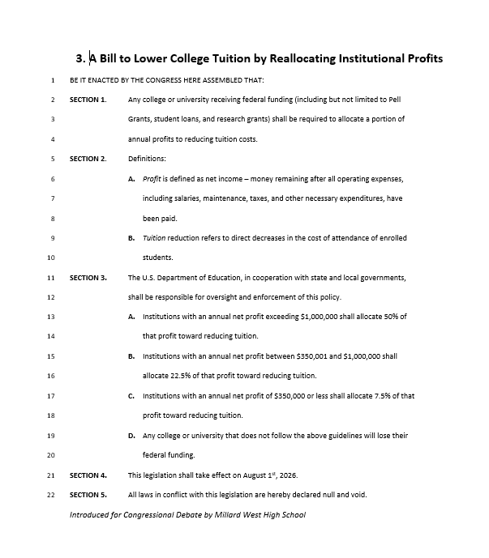

4. A Resolution To Amend The

Constitution To Rescind Executive Action
1 RESOLVED, By two-thirds of the Congress here assembled, that the
2 following article is proposed as an amendment to the Constitution of the
3 United States, which shall be valid to all intents and purposes as part of the
4 Constitution when ratified by the legislatures of three-fourths of the several
5 states within seven years from the date of its submission by the Congress:
6 ARTICLE --
7 SECTION 1: The President of the United States shall have no authority to
8 issue executive orders, directives, or proclamations that have
9 the force of law. All executive actions requiring the force of law
10 shall be enacted through legislation passed by Congress and
11 signed into law by the President, consistent with the legislative
12 powers granted under Article 1 of the Constitution.
13 SECTION 2: Any existing executive orders, directives, or proclamations
14 that have the force of law shall be rendered null and void upon
15 the ratification of this amendment unless reenacted through
16 legislation by Congress.
17 SECTION 3: Congress shall have the power to enforce this article by
18 appropriate legislation.
19 SECTION 4: This legislation will take effect immediately and all laws in

20. conflict with this resolution are hereby declared null and void.
Submitted By Lincoln Southwest

5. A Bill to Ban Imported Tobacco and Nicotine Products
1  2  3  4  5  6  7  8 |  | BE IT ENACTED BY THE CONGRESS HERE ASSEMBLED THAT:  SECTION 1. Any product containing Tobacco or Nicotine can no longer be imported into the country. Punishments for the crime will be subject to seizure of paraphernalia as well as a $1000 fine for every item being brought into the country.  SECTION 2. “product” does not include any Fruits or Vegetables that may have trace amounts of Nicotine in them.  SECTION 3. This legislation will take effect on January 1st, 2026. All laws in conflict with this legislation are hereby declared null and void.
Submitted by Elkhorn South

6. A BILL TO END NON-CRIMINAL DETENTION

1  2  3  4  5  6  7  8  9  10  11  12  13  14  15  16  17  18 | BE BE IT ENACTED BY THE STUDENT CONGRESS HERE ASSEMBLED THAT:  SECTION 1. All federal, state, and local government agencies are prohibited from detaining individuals unless the individual is being held with pending criminal charges.  SECTION 2. Any agency that receives funding from any tax revenue is responsible for complying with this legislation.  SECTION 3. The US Department of Justice will be responsible for responding to any alleged, illegal detentions.  A. Federal agencies found in non-compliance with this law will have 30 calendar days to release detained individuals. After 30 days, agencies will lose 50% of federal funding. After 45 days, agencies will lose 75% of federal funding. After 60 days, agencies will lose 100% of federal funding.  B. State and local government agencies will lose federal funding, including any and all grants, after 30 days. After 60 days, state and local agencies will lose the ability to levy taxes.  SECTION 4. This bill will go into effect upon passage.  SECTION 5. All laws that are in conflict with this policy shall hereby be declared null and void.
Submitted by Norfolk High School

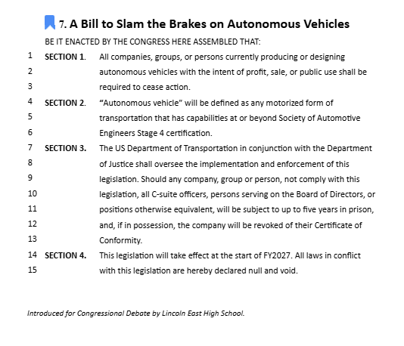

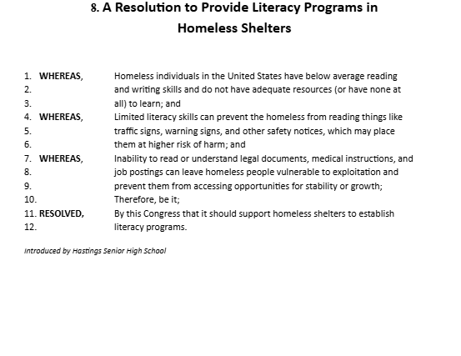

9. A Bill to Abolish the Death Penalty

- BE IT ENACTED BY THE CONGRESS HERE ASSEMBLED THAT:
- SECTION 1. The death penalty will now be considered cruel and unusual
- punishment and will be banned to use in state sanctioned prisons.
- SECTION 2. The death penalty will be defined as the state-sanctioned killing of
- a person as punishment for a crime
- SECTION 3. The DOJ will oversee the implementation and enforcement of this
- bill.
- SECTION 4. This bill will be implemented at the start of the next fiscal year.
- SECTION 5. All laws in conflict with this legislation are hereby declared null
- and void.

Introduced by Millard South High School

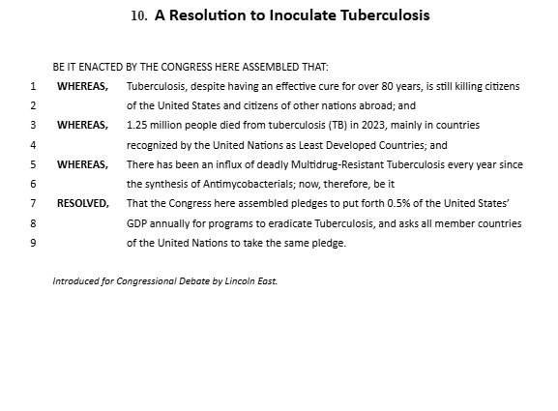

11. A Bill to Put Health First
BE IT ENACTED BY THE CONGRESS HERE ASSEMBLED THAT:
1 Section 1
2 (a) All prescription medications prescribed by a licensed healthcare provider
3 shall be made available at no cost to any individual residing in the United
4 states.
5 (b) Pharmacies and healthcare providers dispensing prescription drugs under
6 this bill will be reimbursed directly by the federal government. Reimbursement
7 rates will be based on the average cost of medications.
8 Section 2
9 (a) The government shall establish a Prescription Drug Fund to finance the cost
10 providing free prescription drugs. The fund will be sourced from:
11 ● An annual levy on pharmaceutical companies with annual revenues
12 capped at a specified threshold.
13 ● A proposed increase in the deferral income tax rate for individuals
14 with high incomes.
15 (b) The U.S. Department of Health and Human Services (HHS) will administer the
16 fund, ensuring that the funds are allocated efficiently and timely to pharmacies,
17 healthcare providers, and manufactures as needed.
18 Section 3 This bill shall take effect immediately and will be fully implemented by
19 January 1, 2027.
20 Section 4 All laws in conflict with this legislation are hereby declared null and void.
Introduced for Congressional Debate by Lincoln Southwest High School.

12. A Resolution to Make Minimum Wage a Living Wage

- WHEREAS, A full time minimum wage job no longer provides income sufficient to
- escape poverty; and
- WHEREAS, The federal minimum wage has remained stagnant at $7.25 since 2009,
- failing to keep pace with inflation and the rising cost of living; and
- WHEREAS, Millions of workers, particularly in minority groups, earn the federal
- minimum wage. The federal minimum wage is currently considered a
- poverty wage, meaning it is not sufficient to cover basic living needs like
- food, housing, and transportation; therefore, be it
- RESOLVED, By this Congress that the federal minimum wage shall be raised to $17
- per hour, and indexed to inflation thereafter, to ensure that minimum wage
- work provides a livable income.

Submitted by Hastings Senior High School

