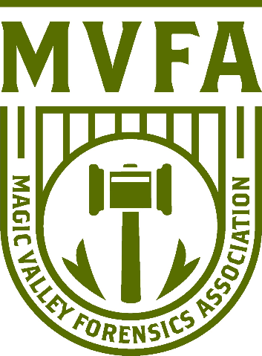

2025 Rim2Rim

Presented by the
Magic Valley Forensics Association

Dear Debate & Speech Coaches:
The Magic Valley Forensics Association cordially invites you to attend the 2025 Rim2Rim at Twin Falls High School.
Friday, December 12th and Saturday, December 13th
Students may double enter in speech events (students may not double enter into two draw events- Retold, Extemp, Radio, Improv Comedy, or Panel). There will be a stand-alone Friday session of Congress for debate-only competitors. Awards will be given based on preliminary results of the Friday Congress session. There will be finals rounds in all other events.

Speech Events:
Duo Interpretation
Humorous Interpretation
Dramatic Interpretation
Informative Speaking
Original Oratory
Communication Analysis
After Dinner Speaking
Panel
Program Oral Interpretation
Impromptu
Retold
Extemporaneous
Sales
Radio Speaking
Improv Comedy

Debate Events:
Novice/Open Lincoln Douglas
Novice/Open Public Forum
Open World Schools (depends on entries)
Open Congress
Friday Congress (no speech cross entry)

According to Idaho's definition, the novice division will be restricted to students in their first year of competition.

Registration: The deadline is 4:00 p.m. (MST) on Wednesday, December 10, 2024. We will be using Tabroom.com; please upload your entries online and make sure your judges have linked Tabroom accounts.
Congress: We will be using the November NSDA docket and student submitted legislation. Each school can submit two pieces of student legislation. Pieces must be emailed to kklahman@kimberly.edu by Friday, November 21nd to be included in the packet. Once all bills are submitted, we will set aside some of the docket for finals, but the legislation order will be set in round. The docket will be sent out ASAP on Friday.
Improv Comedy: We will be hosting a new draw event made by a TFHS senior, Richard Roper.
Topics drawn/prepared in the contest room. Each speaker will be designated three topics from which to choose and may use a total of 6 minutes of preparation and then 4 minutes of speaking. The contestant may take notes during the preparation time, but they may not refer to the notes during the presentation. Topics will be comedic events for one round, abstract prompts for one round, and celebrities for one round. In the final rounds, the contestant will receive one comedic event, one celebrity, and one abstract prompt to choose from. Since this event is based on acting and performing, a maximum of 3 characters per round is allowed but not required.
Limits & Conflicts: Speech events will occur in one division of open competition. When double entering students, keep in mind the campus is large, and students are required to make it to rounds within the time window or risk forfeiting. To ensure the tournament runs on time, no exceptions can be made.
Public Forum will offer open and novice divisions. LD will offer open and novice divisions. Due to consistently low entries, the JV division has been be removed. World Schools Debate will occur in one division with two set rounds and two impromptu rounds. Congress will be offered in open division and will have both a Friday offering with a single session, and a Saturday offering with two sessions and finals. Congress students do not have to compete on both days. On Saturday, students may enter only one type of debate in either division or congress, but not both. Friday Congress awards will be based on the one prelim round.
Drops and changes must be finalized by the deadline of Wednesday, December 10th at 4:00 PM. After that a penalty fee of $25.00 is incurred for drops.
Judges: This tournament will continue its tradition of ensuring judges are fed and comfortable. Of course, the judge’s lounge will have refreshments and meals. We will hold a judge meeting concurrent with the opening ceremony for students. Judges will be using electronic ballots and are expected to accept all ballots assigned to them. Additionally, school judges are expected to be available throughout the tournament.
Oral critiques will not be tolerated. Please discuss this with your judges prior to the tournament.
There are tournament judges for hire for $75. If you need help in covering your judge requirements, please contact Andy Orr Aorr@csi.edu.
Dining & Concessions: Twin Falls High School will have concessions. There are also fast food restaurants like Subway, Sonic, Dutch, McDonalds within walking distance if you permit your students to do so.

Additionally, UberEats and DoorDash both deliver to the high school. Regular delivery is also available from the following restaurants:
- Jimmy Johns 208-733-5338
- Dominos 208-734-3960
- Pizza Hut 208-734-9063

Locations: Student drop-off location will be announced soon, but plan on dropping off by the Roper Auditorium on the corner of Madrona and Filer. Do not arrive prior to 3:00pm on Friday.
The opening ceremony will be held in the auditorium, and awards will be in the gym. After the opening ceremony, we will move the students to the cafeteria and judges to the teacher’s lounge.
All postings will be made electronically.

All students should remain in the cafeteria between rounds and are expected to show respect toward TFHS facilities as well as all students, faculty, and staff.

** No competitor may enter a room prior to the assigned judge or they will be dropped from the tournament.

Hotels: We have reserved a block of rooms and have a group rate at three local hotels. Rooms must be booked by December 1st to receive the rate.

  - Hampton Inn: $112
  - Holiday Inn Express: $115 standards $135 Suites (fully renovated June 2025)
  - Quality Inn: $85 standards $95 suites

For these three hotels call Tami Goedhart, Director of Sales, 208-733-2098

Other hotels are located near campus on Blue Lakes Boulevard or Pole Line Road.

  - Best Western 208-736-8000
  - Red Lion 208-734-5000
  - Sure Stay 208-734-5801
  - La Quinta 208-736-9600
  - Fairfield 208-734-8444

Schedule: This year we will be offering a traditional schedule with speech on Friday (plus a bonus congress round on Friday) and debate on Saturday. There will be one awards ceremony on Saturday only.

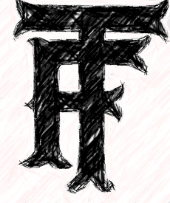
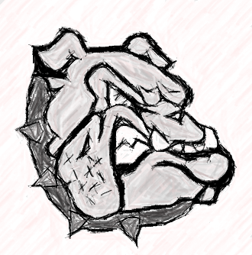
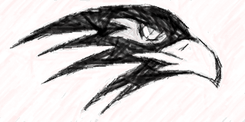
2025 Rim2Rim

Friday, December 12, 2025:

3:00 – Registration: Roper Auditorium

4:00 – Speech Round 1

5:30 – Speech Round 2

7:00 – Speech Round 3

8:30 – Speech Finals

For Coaches:
- Reasonable ending on Saturday
- Group rates at 3 hotels
- Inexpensive entry & event fees
- Lower judge requirements

For Students:
- Friday Congress
- East/West Competition
- Experimental IE
- Concessions

Saturday, December 13, 2025:

Registration 8:00 AM

Congress

8:30-11:30 – Session 1

12:00-3:00 – Session 2

3:30-6:30 – Super

7:00 – Awards

Public Forum
(flights)

8:30-10:30 – Round 1

10:30-12:30 – Round 2

1:00-3:00 – Round 3

3:00-5:00 – Round 4

5:30 – Gold/Silver

7:00 – Awards

Lincoln-Douglas
(flights)

8:30-10:30 – Round 1

10:30-12:30 – Round 2

1:00-3:00 – Round 3

3:00-5:00 – Round 4

5:30 – Gold/Silver

7:00 – Awards

Worlds Schools

8:30-10:00 – Round 1
(prepared)

10:00 – 12:30 – Round 2
(impromptu)

1:00 – 2:30 – Round 3
(prepared)

2:30 – 5:00 – Round 4
(impromptu)

5:30 – Gold/Silver
(prepared)

7:00 – Awards

