Coppell Debate Boosters
Electronic Payment Information
*Coaches do not have access. Please forward receipt to a coach for proper recording.
Zelle:
Email - cisddbc@gmail.com
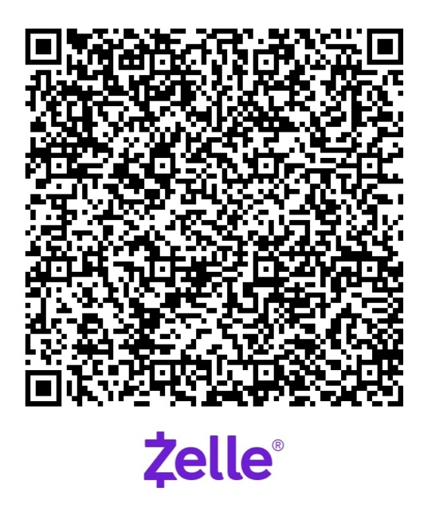

PayPal:
Email - cisddbc@gmail.com


