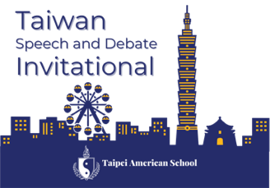

Dear Colleagues,

The Taipei American School Speech and Debate team is excited to invite you to attend the 3rd Annual Taiwan Speech & Debate Invitational on October 9-11, 2026, hosted at our campus in Taipei, Taiwan.

We are excited to offer you and your students not only an outstanding tournament experience, but also a unique cultural opportunity to explore parts of our beautiful island and engage with the growing international speech and debate community.

Please note some important tournament information:
- The Taiwan Speech and Debate Invitational will be an in-person tournament.
- Schools from around the world are invited to attend. In 2024 and 2025, we have hosted over 30 schools from around the world, including schools joining from the United States, Vietnam, mainland China, Singapore, and Indonesia. We look forward to growing these numbers in 2026!
- The tournament will run Friday through Sunday. We encourage teams to arrive by Wednesday evening to provide sufficient time to get settled and adjust to the time difference before the tour day on Thursday, October 8th. We have selected this weekend as 10/10 is Taiwan’s National Day, a national holiday, and Monday, October 12th is a holiday in the United States, making return travel easier for visiting teams.
- We are proud to offer competition in Congressional Debate, Policy Debate, Public Forum Debate, and World Schools Debate, as well as Extemp, Impromptu, Oratory, Informative, and Interp. We have the capacity to offer competition in Lincoln-Douglas Debate and divide the interp category into independent disciplines if there is significant interest. Please email williamsc@tas.edu.tw if you have interest in adding these events.
- Our World Schools Debate division is hosted in partnership with the Taiwan Schools Debate Challenge. Teams registered through Tabroom will have their information shared with TSDC.
- The tournament will offer six preliminary rounds in Public Forum, Policy, and World Schools Debate, four preliminary rounds in all speech events, and three preliminary sessions in Congressional Debate. In debate, we will break all winning records up to a full Octafinal. If entries warrant it, we will add a double-octafinal to the schedule. In speech, we will advance the greatest number of students reasonable (around a third of the field).
- We will offer novice divisions in both Policy Debate and Public Forum Debate.
- We have been designated by the TOC as a finals bid tournament in Policy, Public Forum, and World Schools, and a Top-6 bid tournament in Congressional Debate.
- If speech interest warrants it, we plan to apply for NIETOC bid status for our 2026 tournament.

In recent years, international speech and debate has expanded significantly and we are excited to share that exciting growth with you at our tournament. In addition to teams from Taiwan, we anticipate hosting teams from China, Vietnam, Singapore, Indonesia, Korea, Japan, and the U.S. at our 2026 Invitational and hope to add more tournaments to that list. In our increasingly globalized world, we believe there is great value in students making connections with their peers around the globe and look forward to fostering those connections with you in-person this fall in the beautiful city of Taipei, Taiwan.

Please do not hesitate to reach out with any questions. We can’t wait to welcome you to Taiwan!

All the best,
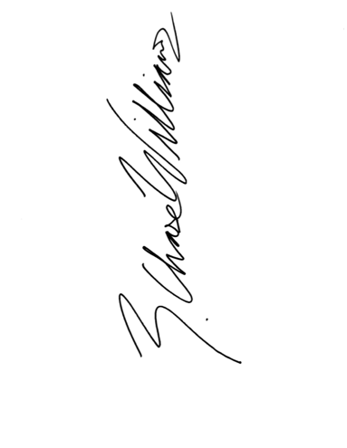
Chase Williams
Director of Speech and Debate
Taipei American School

