CATHEDRAL PREPARATORY SCHOOL
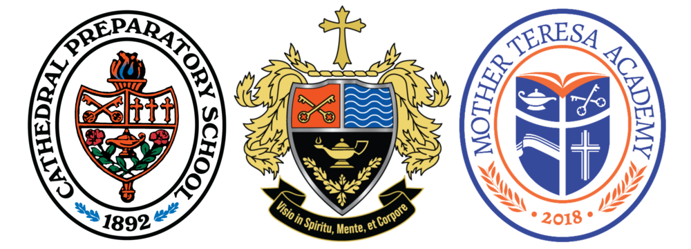

Dear Coaches:
The men and women of Cathedral Preparatory School are excited to invite you to compete in the first Speech and Debate Tournament of the season on Wednesday, November 5, 2025. We will be providing opportunities for students to compete in Debate, Speech, and Congress.
Competitors — Upon arrival, please use the south entrance located at 250 West 10ᵗʰ Street to enter the school. Check-in and student lounge will be in our Student Life Center.
Food and refreshments will be available for purchase — including Porky’s Pizza for $2 per slice, along with additional snacks and beverages. Food and beverages will be provided for Coaches, staff, and judges.
Registration is via Tabroom and must be completed by 4:00 p.m. on November 3, 2025.
If you have any questions or concerns, please contact:
- Susan Peebles — susan.peebles@ncfl.org – CFL of Erie Director
- Bob Hall — hallr@fairviewschools.org – CFL of Erie Board Member
- Jon Pintea — jon.pintea@cathedralprep.com – Site Host
- Jarod Lazor — jarod.lazor@cathedralprep.com – Site Host

We look forward to seeing you at Cathedral Prep!

