Idaho High School Activities Association

2025 State Drama Tournament

Manager: Shaun Nichols Host: Jorden Cammack

Thunder Ridge High School

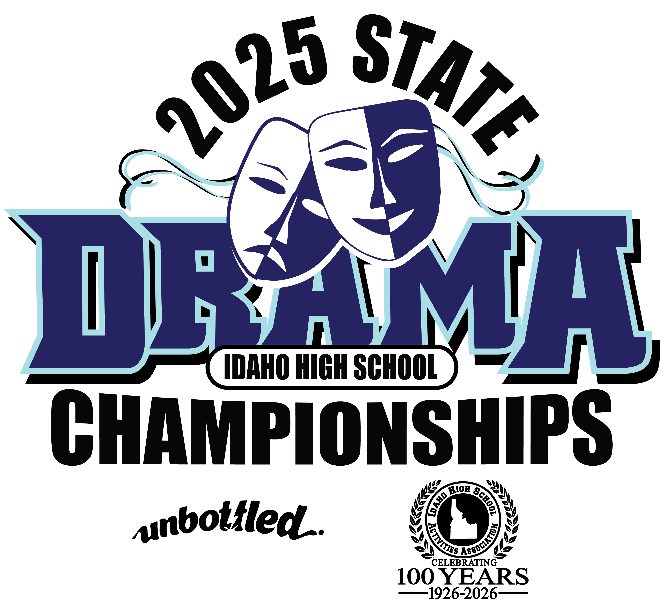

Friday, December 5
11:00 - 11:40 School Check-in / Judge Registration / Tech Set-up
11:45 - 12:00 Judges & Coaches Meeting
12:15 - 12:45 Welcome Assembly - Students, Coaches, Judges
1:00 - 2:45 Rd I A Ensembles, Originals / Tech – Costume and Properties
1:00 Makeup Application Begins
2:45 - 4:00 Rd I B Solos, Pantomime
4:00 - 5:45 Rd II A Ensembles, Originals / Tech - Makeup and Scene Design
5:45 – 7:00 Rd II B Solos, Pantomime
6:45 – 7:00 Ballot Review – Technical Theatre**
7:00 Posting - Tech Theatre Finals
**If we are using coaches to judge the final round, we may need to move ballot review to 7:00.

Saturday, December 6
7:00 Building Open
7:45 Judges/Coaches Check In
8:00 – 9:45 Rd III A Ensembles, Originals / Tech Finals – Costume, Props, Scene Design
9:15 Makeup Application Begins
9:45 - 11:00 Rd III B Solos, Pantomime
11:30 Ballot Review
12:00 Posting Acting Semifinals
12:15 - 2:15 Semifinals All Acting Events / Tech Finals – Makeup
2:45 Posting Acting Finals
3:00 - 4:30 Acting Events Finals
5:00 Awards

