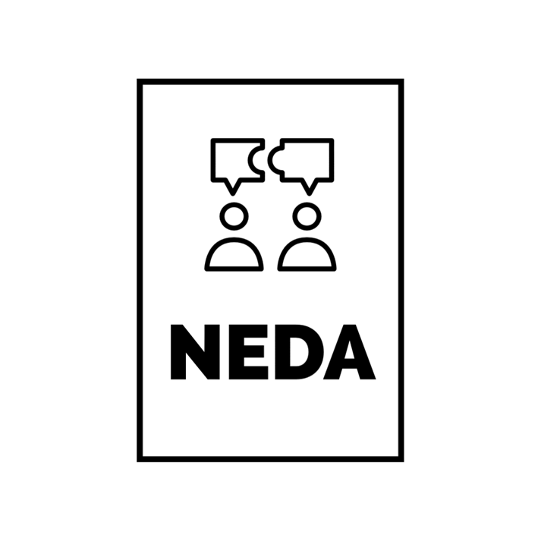
On behalf of the Wayne State University Debate Team, I’m happy to invite you to the 2025 NEDA Motor City Invitational debate tournament to be held at Wayne State University Friday and Saturday, October 24 – October 25!
We’re looking forward to exploring this year’s NEDA Resolution: Capitalism has failed in crossfire/public forum and Resolved: The U.S should significantly reform its capitalist system for policy. The tournament will also include a ‘Rapidfire’ division debating a variety of resolutions. In addition, we have reduced our entry fees (we know it’s tough out there)!
We’re looking forward to seeing you in the Motor City in October!
Sincerely,
Ronald J. Stevenson, Ph.D.
Director of Forensics / Associate Professor
Department of Communication
Wayne State University

Rapidfire
Friday Oct 24
Rd. 1 – 4pm
Rd. 2 – 5pm
Rd. 3 – 6pm

Saturday Oct 25
Rd. 4 – 9am
Rd. 5 – 10am
Rd. 6 – 11am
Lunch – Noon -1pm
Semifinals – 1:30pm
Finals – 3:00pm

Awards 4:30pm in Manoogian 91

Public Forum/Crossfire
Friday Oct 24
Rd. 1 – 4pm
Rd. 2 – 5pm
Rd. 3 – 6pm

Saturday Oct 25
Rd. 4 – 9am
Rd. 5 – 10am
Rd. 6 – 11am
Lunch – Noon -1pm
Semifinals – 1:30pm
Finals – 3:00pm

Awards 4:30pm in Manoogian 91

Policy
Friday Oct 24
Rd. 1 – 4pm
Rd. 2 – 5:30pm

Saturday Oct 25
Rd. 3 – 8:30am
Rd. 4 – 10am
Lunch – 11:30-12:30
Rd. 5 – 12:30-2:00pm
Finals – 2:15-4:00pm

Awards 4:30pm in Manoogian 91

TOURNAMENT RULES:
- Teams will be competing in Policy, Public Forum/Crossfire, and Rapidfire divisions
  - Depending on the number of teams, Varsity and Novice teams might face each other in rounds; teams will be separated by division for awards and final rounds
- Awards
  - Team awards will be given to the top 5 teams in each division
  - Speaker awards will be given to the top 5 individual debaters in each division
  - Sweepstakes Awards will be given to the top 3 teams.
- Individuals competing in Rapidfire will have their topic announced at the round start time on the schedule and then be given 20 minutes to prepare their speech.
  - Rapidfire debaters are able to use computers/devices to research before the round but should not be conducting research once the debate has started.
  - Coaches may assist debaters during the 20-minute prep time process
ENTRIES:
  - Please enter team info on TabRoom.com
- All entries are due by 11pm Monday, October 20, 2024.
  - (If you don’t have exact final entries, please at least email a rough head count)
- When entering team information, please indicate whether each debater is a Novice
  - NEDA novice status = fewer than 6 previous tournaments at any level (including high school)
- Any dropped entries after 11:59p on Wednesday, October 22, will be fined a $40 penalty
- Please limit your entry to one maverick per division for both crossfire and policy

REGISTRATION:
- Registration will be in the lobby Manoogian Hall beginning at 3:30 Friday
- Registration fees:
  - Teams/pairs in policy and public forum/crossfire: $50 per entry
  - Rapidfire: $30 per entry.
  - If registration fees are a barrier to your team’s participation, please let us know and we can make arrangements to resolve that problem.
  - There will be a $50.00 ‘judge fee’ for each uncovered team
    - Each judge provided by a school ‘covers’ two team entries

Directions:

I-75 (from the south)
- Take I-75 north and exit at Warren. Go to the light and turn left.
- Proceed on Warren for about 2 miles until you pass Anthony Wayne Drive. Turn right at the next light onto service drive (Manoogian Hall will be immediately to your right) and past the building and enter the parking structure on your right.

Parking:
Parking structure 2 is located next to Manoogian Hall. Street parking is also available, but please be mindful of your meter as the parking police aggressively enforce them.

Nearby Hotels:

There are a number of hotels downtown, however, those generally tend to be pretty expensive. If you stay in Warren, Dearborn, Allen Park, or Southfield, those hotels will be about a 15–20 minute drive to the campus and are much more reasonably priced.

Avid Hotel
11570 E ELEVEN MILE ROAD,
Warren, MI, 4808
Phone: (586) 300-4200

Holiday Inn Express & Suites
Address: 30000 Van Dyke Ave,
Warren, MI 48093
Phone: (586) 573-7600

WoodSpring Suites Detroit Madison Heights
Address: 32400 Stephenson Highway,
Madison Heights, MI, 48071
Phone: (248) 607-6230

