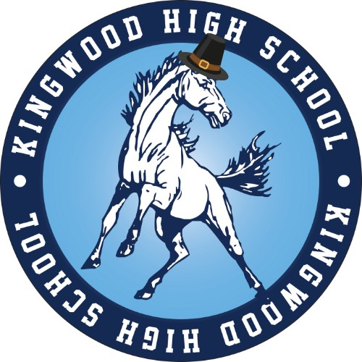
Kingwood High School’s
Mustang Fall Classic

TFA Qualifier & NIETOC Bid Tournament
November 7-8, 2025

Tournament Directors:
Joseph Genovese, KHS Associate Principal
Dillon Rogers, AHS Director of Speech and Debate - John.Rogers@humbleisd.net
______________________________________________________________________

The Kingwood High School Speech & Debate Booster Club and Team are proud to invite you back for our 3rd annual Kingwood Mustang Fall Classic! We will be offering all TFA State-Qualifying events, plus Poetry, Prose, Impromptu. Additionally, as a NIETOC Bid Tournament, we will be awarding bids in DX, IX, DI, HI, DUO, DUET, OO, INFO, and POI. We can’t wait to provide a great tournament experience to you again this year!

Please register on Tabroom by October 31, 2025 @ 11:59PM.
Kingwood High School’s
Mustang Fall Classic

Friday, November 7, 2025
3:30 CX , LD, PFD, NLD, NPF Round I
WSD Round I (Prepared)
Congress Prelims
5:30 CX, LD, PFD, NLD, NPF Round II
WSD Round II (Prepared)
7:00 Congress Finals
7:30 CX, LD, PFD, NLD, NPF Round III
WSD Round III (Impromptu)

Saturday, November 8, 2025
7:30 Extemp Draw (Auditorium)
8:00 Section A Prelims (DX, FX, NX, DI, DUET, IMP)
9:30 Section B Prelims (OO, INFO, POI, HI, DUO, OI)
11:00 LD, PFD, NLD, NPF Round IV
CX, WSD Semis
12:30 Extemp Draw
1:00 Section A&B Semis
2:30 Debate Elim 1
CX, WSD Finals
4:00 Extemp Draw
4:30 Section A&B Finals
6:00 Debate Elim 2
7:30 Debate Elim 3
General Information
- Location: Our 2025 Kingwood Mustang Fall Classic will be hosted at Atascocita High School, located at 13300 Will Clayton Pkwy, Humble, TX 77346.
- Arrival: Please review the important arrival information below. Mr. Rogers will send out a more detailed arrival email the week of the tournament.
  - All tournament attendees will be required to pass through our district’s Evolve weapons detection system.
  - We can welcome you on campus at Atascocita High School beginning at 12:00PM.
  - Please do not attempt to enter the campus between 2:45PM and 3:05PM. AHS dismissal traffic is extremely heavy, and we need to clear AHS students out of the building.
- Parking: Mr. Rogers will send out a more detailed arrival email, including a color-coded map, the week of the tournament.
- Payments:
a. Please make checks payable to:
KHS Speech & Debate Booster Club
ATTN: Joseph Genovese
2701 Kingwood Dr., Kingwood, TX 77339”
b. If needed, a W-9 is available in PDF format on our tabroom.com site.
- Concessions: Concessions will be provided for students in the cafeteria by the Kingwood High School Speech and Debate Club. Concessions will include drinks, candy, snacks, baked goods, and simple meal items (nachos/pizza/etc.).
- Ballots: Tabroom.com will be utilized to push ballots & pairings, so ensure that your teams and judges have linked accounts.
- Entries: No independent entries will be accepted. All entries must be associated with an institution and have an adult sponsor/coach present during the tournament.
- Judging: Each school must have a coach/sponsor/judge available for all tournament times/rounds to provide support for the tournament and judge as needed. Each school is required to have at least one judge registered on Tabroom, and that judge must be available to judge as needed by the tournament.
- Deadlines:
  - Registration Deadline – October 31, 2025 @ 11:59PM
    - Fees will be frozen at the registration deadline.
- Debate:
  - Power-Matching will be lag-powered in all Debate events beginning Round 3.
  - Brackets will be broken in all debate events.
- Debate Topics:
  - Policy Debate
    - Resolved: The United States federal government should significantly increase its exploration and/or development of the Arctic.
  - Lincoln-Douglas
    - Resolved: The United States ought to rewild substantial tracts of land.
  - Public Forum
    - Resolved: The United States federal government should require technology companies to provide lawful access to encrypted communications.
  - Congressional Debate
    - Prelims: 22, 21, 24, 23, 25
    - Finals: 28, 29, 26, 27, 30
  - World Schools
    - Round 1: This House would regulate artificial intelligence as a public utility.
    - Round 2: This House would regulate artificial intelligence as a public utility.
    - Round 3: IMPROMPTU
    - Semis: This House believes that hacktivism is a legitimate tool of resistance. Info Slide: Hacktivism refers to the use of cyberattacks and hacking techniques to advance political, social, or ideological causes.
    - Finals: IMPROMPTU
- Speech Categories:
  - Domestic Extemp
    - Round 1: The Economy
    - Round 2: The Trump Administration
    - Finals: Elections 2028
  - International Extemp
    - Round 1: The Americas
    - Round 2: Europe
    - Round 3: Africa and Southwest Asia
  - Impromptu
    - Round 1: Choices and Consequences
    - Round 2: Growing Up in 2025
    - Finals: The Internet Made Me Think

