Massachusetts Speech and Debate League
2025 Novice Tournament
Legislation Docket

Welcome to Sharon High School, and welcome to the 2025 Novice Tournament in Congressional Debate! Enclosed, please find the following legislation and special information.

Legislative Items for Debate:

- Demonstration Debate / First Item: A Bill to Stop Arms Sales to Saudi Arabia to Protect Yemeni Lives (Natick HS)
- A Bill to Extend Social Security (Sen. Mollor, Catholic Memorial)
- A Resolution to Amend the Constitution to Lower the Voting Age to 16 (MSDL)
- A Bill to Ban Cell Phones in Classrooms (MSDL)

Welcome, Novice Congressional Debaters!

We’re thrilled you’re here for your first tournament! Our goal is to create a fun, supportive, and educational experience. Dive in, take notes, learn from others, and give it your all. We can’t wait to see you shine today and at our next event in two weeks at Xaverian Brothers High School!

To Our Experienced Students:

Thank you for serving as judges and demonstrating strong debate skills for our novices. Your leadership and modeling are invaluable, and we’re grateful for your contributions today.

Happy prepping, and best of luck!

Best regards,

Joe Bowden
MSDL Chair of Congress

Memes to Warm Up for the Season By

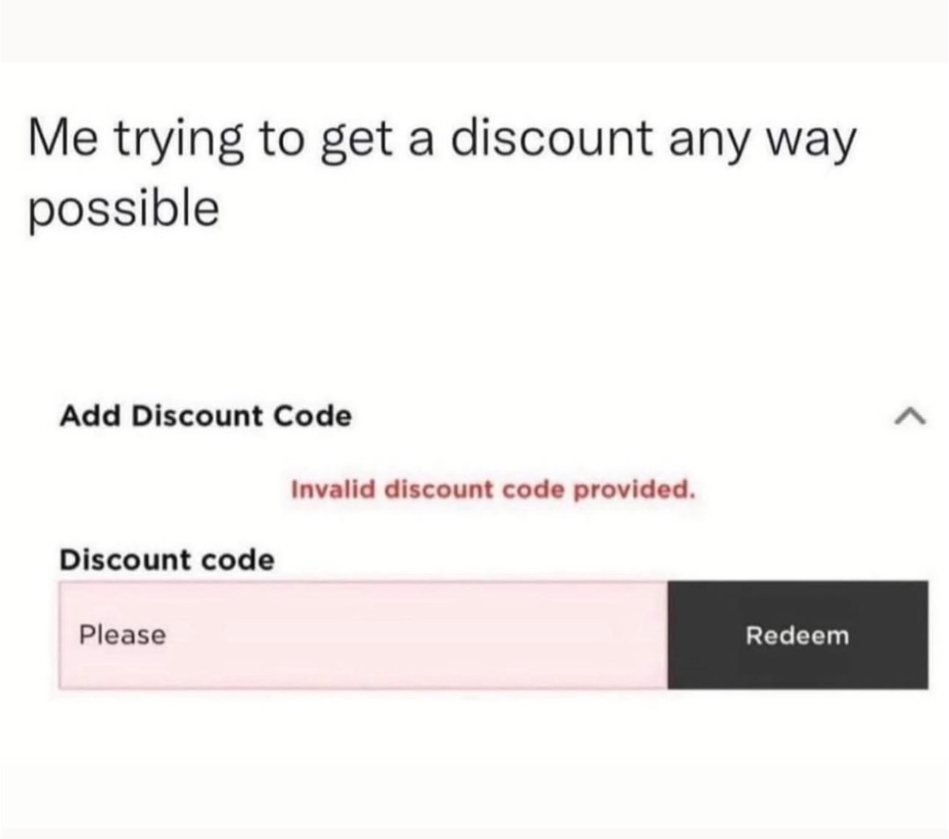 | 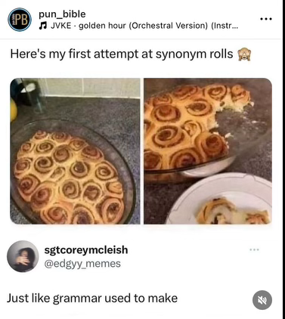
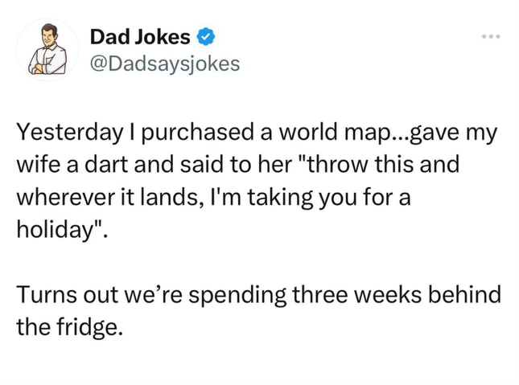 | 

