How to create an account on tabroom.com
- Go to tabroom.com
- Click “Sign Up” in the upper right corner.
- Create an account under your email address.
- Non-required fields
  - Phone number - allows you to receive text alerts during tournaments. NSDA/tabroom.com will never call you or sell your number to another organization.
  - Provider - helps the text alert system work better.
  - City and state are not that important.
  - Time Zone - select Los Angeles. If this is not set properly, you will probably not receive text alerts.
- Once the account is created, you will see a box to “confirm your email”.
  - Don’t enter your email address in this box.
  - Go to your email inbox - there will be an email with a code.
  - Either click the link to confirm or go back to the page on tabroom.com and enter the code into the box.
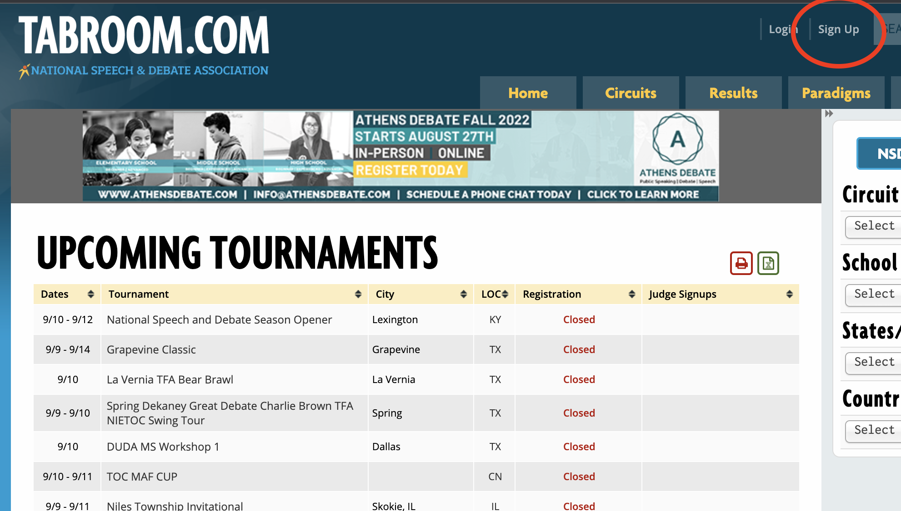
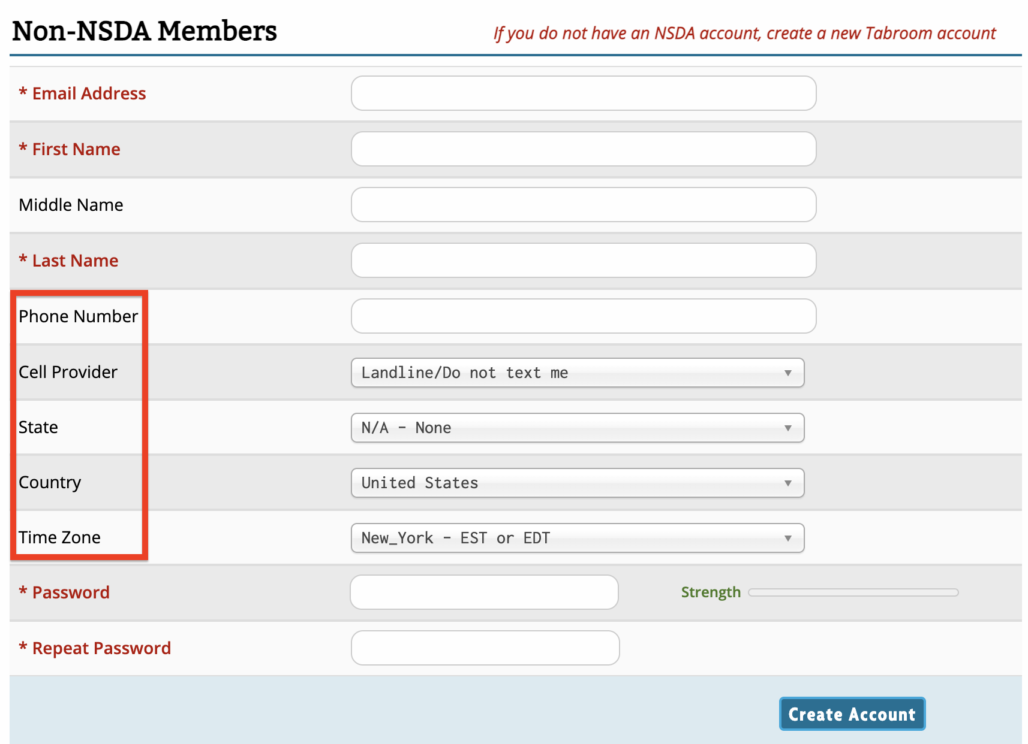
- Give the coach of your school the email address for your account - they will link you to the school.

