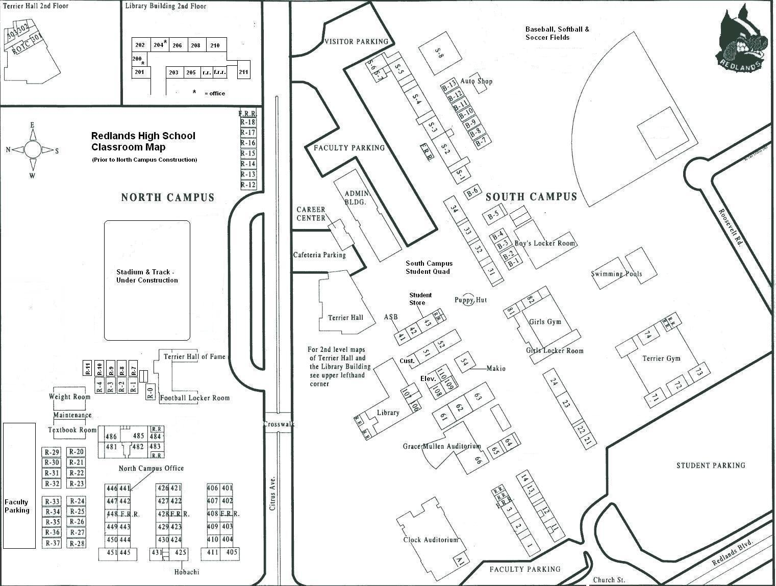
ADMINISTRATION
BUILDING
CLOCK
AUDITORIUM
DODGE STADIUM
TERRIER GYM
VISITOR ENTRY DOOR
VISITOR PARKING
STUDENT ENTRY GATE
STUDENT ENTRY GATE
STUDENT ENTRY GATE
STUDENT ENTRY GATE

