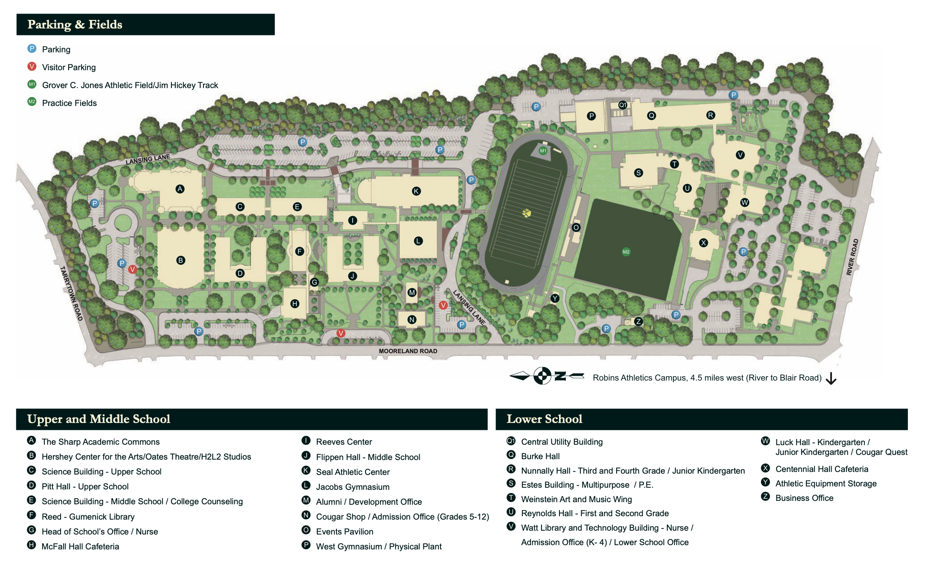
All debate rounds will be held in Pitt Hall (D), North Science (C), South Science (E), and Sharp Academic Commons (A)
Student lounge is in McFall (H)- feel free to use the tables outside of the building too!
Judge Lounge is in Reed- Gumenick Library (F)

