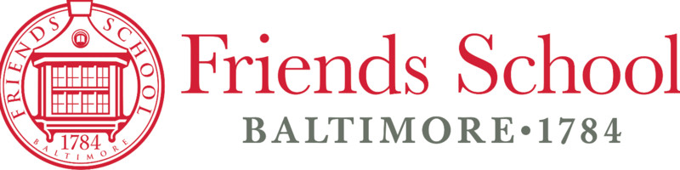

Quaker Classic – Friends School of Baltimore
Date: Monday, May 12, 2025
Time: Evening (exact times TBD)
Location: Friends School of Baltimore
Eligibility: Friends School of Baltimore students only
Event: Public Forum Debate
Rounds: 2–3 rounds (no elimination)
Entry Fee: None
Judge Requirement: None (but help is welcome)
Registration Deadline: End of day on May 12
Contact: Mr. Henschen – thenchen@friendsbalt.org
Welcome/Intro
Thisis a low-stakes, in-house Public Forum scrimmage open only to PF debaters from the Friends School of Baltimore. This is not a public/nat circuit tournament. It's just here to get more live practice before summer. We'll debate theJanuary 2025 NSDA PF Topic + run a short series of rounds (2–3 depending on time & turnout).
This is supposed to be simple and stress-free. There’s no cost, no outside registration, and above all else no pressure. If you’ve debated this year, or if you just want to try PF before next season, it will be a great way to end the year with a coule more speeches under your belt.
Topic
Resolved: The African Union should grant diplomatic recognition to the Republic of Somaliland as an independent state.
What to Expect
- Pairings and ballots will run through Tabroom (here lol).
- Rounds will be scheduled + run during the evening.
- Judges can be teachers, students, or volunteers. We won’t have strict judging policies.
- Registration will stay open until the night of the tournament. Pls just sign up if you’re interested.
If you have any questions, email Mr. H. Otherwise, we’ll see you there.

