Falcon First Docket 2025

All taken from https://utahdebatecoaches.org/congress-legislation/
From last year and this.

Session 1
Voting Rights
Repeal Patriot Act
Enhance School Security
Abolish the Death Penalty

Session 2
Expand the Mutual Defense Treaty
Judges Managing Immigration Process
Driving Age
Unbiased International Aid

Session 3
Remove Turkey from NATO
School Start Times
Discourage Trade War with China
Leave NATO
Repeal Alien Enemies Act

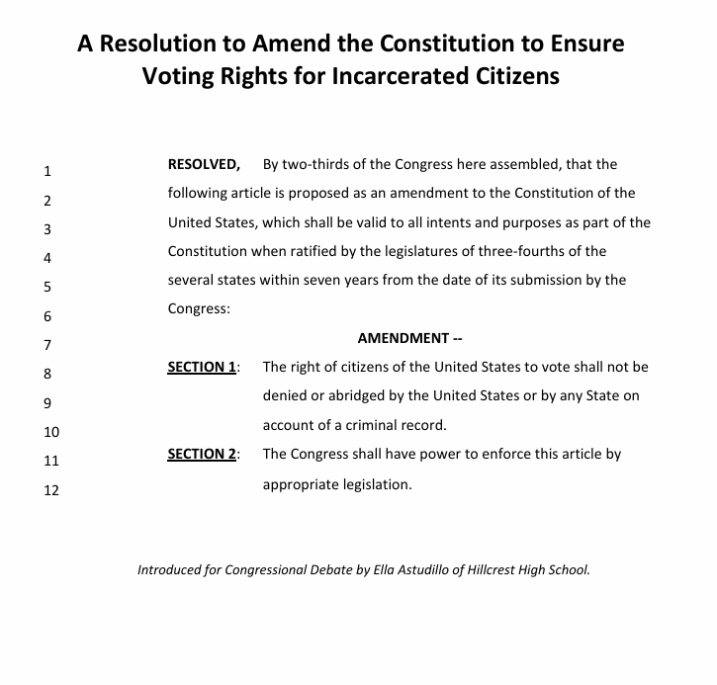

A Bill to Repeal the USA PATRIOT Act

1  2  3  4  5  6  7  8  9  10  11  12  13 | BE IT ENACTED BY THE CONGRESS HERE ASSEMBLED THAT:  SECTION 1. The Uniting and Strengthening America by Providing Appropriate Tools Required to Intercept and Obstruct Terrorism (USA PATRIOT Act) is hereby repealed in its entirety.  SECTION 2. Any amendments to existing laws or Acts made by the USA PATRIOT Act shall be nullified, and such laws shall be restored to their pre-amendment form as if those changes were never enacted.  SECTION 3. The Department of Justice shall oversee the enforcement of this repeal.  - Any existing authorities or agencies acting under powers granted solely by the USA PATRIOT Act shall cease those activities and provide public documentation of terminated programs within 180 days of this bill’s effective date.  SECTION 4. This legislation will take effect on December 1st, 2025. All laws in conflict with this legislation are hereby declared null and void.
Introduced for Congressional Debate by Keith Grondahl of Clearfield High School.

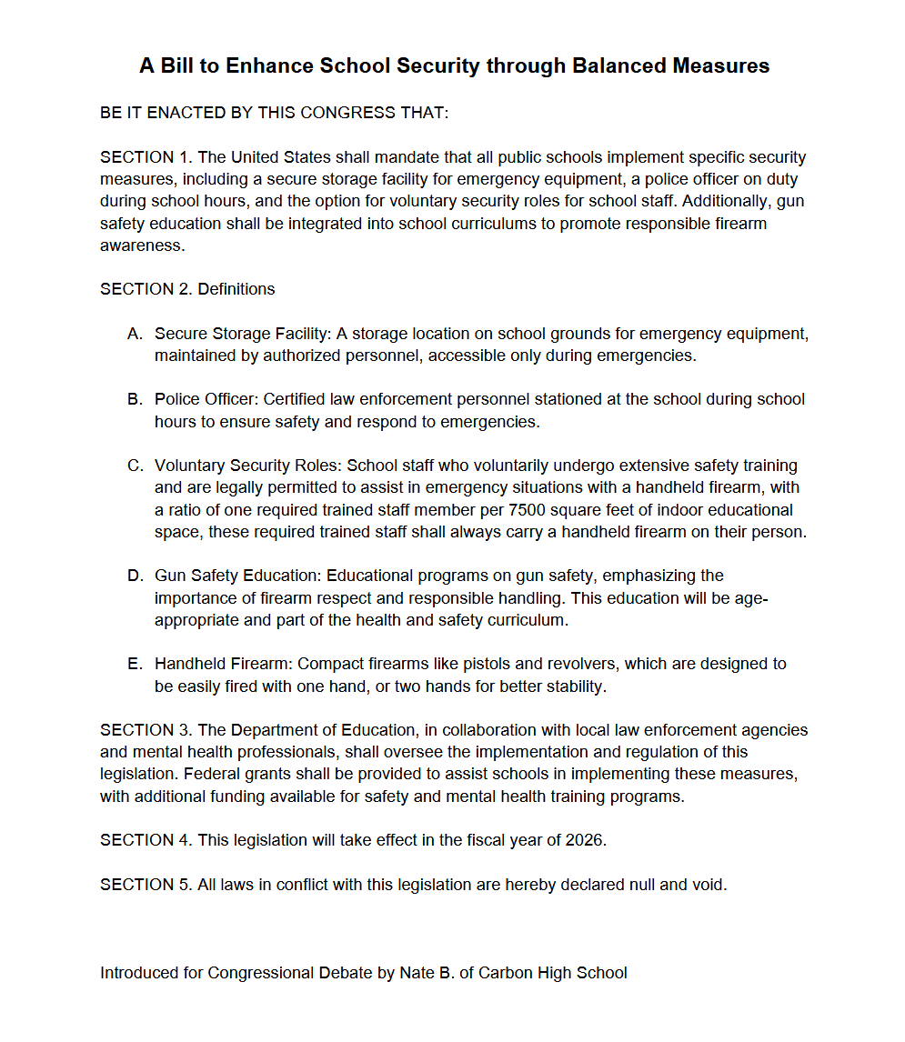

A Resolution to Abolish the Death Penalty

- WHEREAS, the death penalty has disproportionately affected marginalized communities
- and those from lower socioeconomic backgrounds; and
- WHEREAS, studies show that the death penalty does not deter crime, but promote a
- cycle of violence; and
- WHEREAS, there is a risk of wrongful convictions receiving the death penalty, a grave
- injustice that cannot be reversed; and
- WHEREAS, the United States should work to uphold dignity and human rights for
- individuals, regardless of their actions; now, therefore be it
- RESOLVED, By the Congress here assembled that the United States abolishes the
- death penalty in all states, territories, and districts, thereby
- promoting a justice system that works towards rehabilitation over
- retribution.

Introduced for Congressional Debate by Annie Kellis of Davis High School

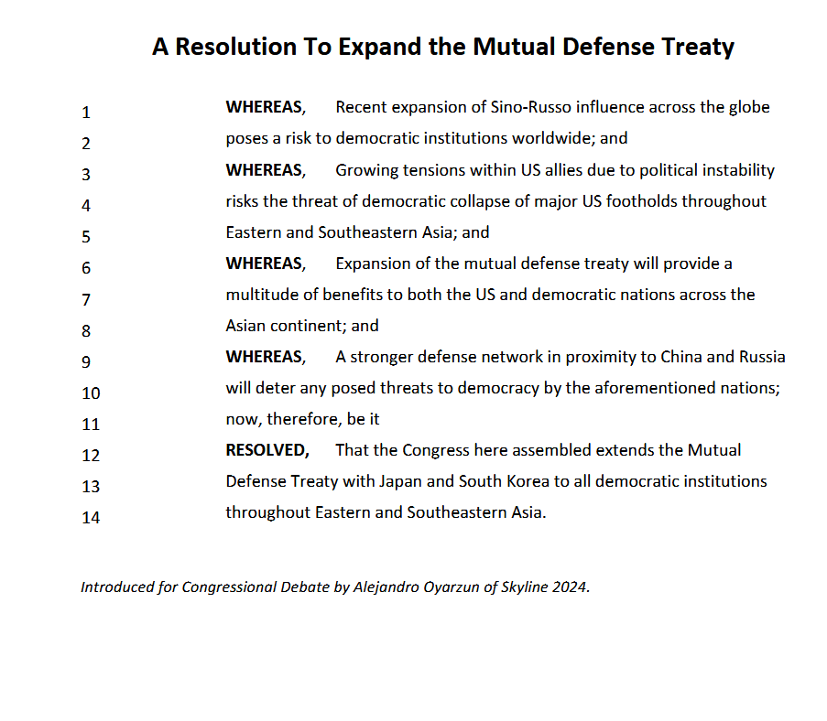

A Bill to Increase the Amount of Judges Managing the Immigration Process

BE IT ENACTED BY THE CONGRESS HERE ASSEMBLED THAT:
SECTION 1 - The number of courts handling immigration cases shall be expanded from
69 to 200, with a minimum requirement of 12 judges per court.
Each judge shall be required to manage 12 immigration cases a day.
A maximum of one year shall be required for the duration of an asylum
Case, with a penalty for the judge each month the case gets extended.
Should an asylum case go over 4 months past the one year limit, the judge shall be suspended for one month following the end of the case. If this occurs more than 5 times, the judge must be reappointed by the attorney general.
The Department of Justice shall have the power to interpret this legislation.
SECTION 2 - Asylum Case shall be defined as a legal proceeding initiated by an
individual seeking protection from persecution or torture in their country of origin.
Court shall be defined as A judicial body with jurisdiction over immigration cases.
Judge shall be defined as A judicial officer appointed to preside over immigration cases.
Duration of a Case shall be defined as The period of time from the initial filing of an asylum case to its final resolution.
Penalty shall be defined as A financial or administrative sanction imposed for failure to comply with the requirements of this Act.
SECTION 3 - The Department of Justice will oversee the enforcement of this legislation.
SECTION 4 - This bill will go into effect January 1, 2026
SECTION 5 - All legislation in conflict with this bill are
hereby declared null and void.

Introduced for Congressional Debate by McKay Clemens from Davis High.
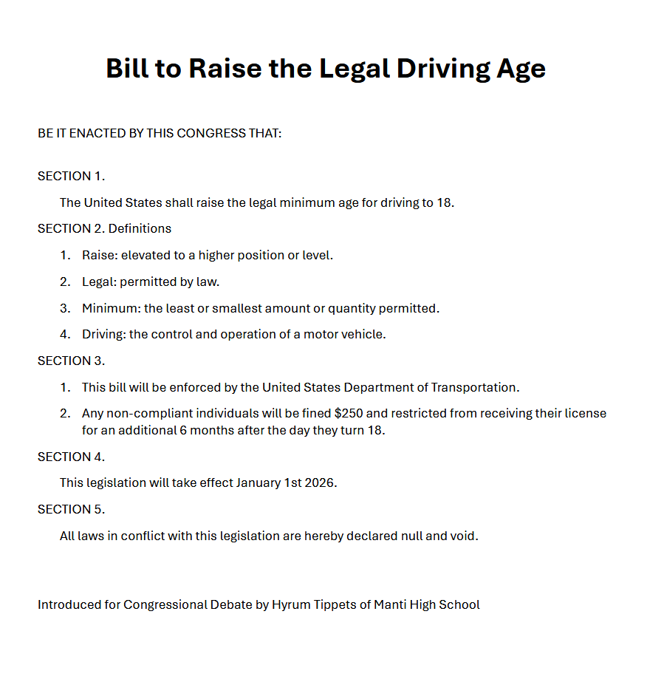

A Resolution to Reaffirm the Importance of Unbiased International Aid
1  2  3  4  5  6  7  8  9  10  11  12  13  14  15  16  17  18  19 | WHEREAS, Foreign aid provided by the United States been continually attacked and defunded by the current executive administration; and  WHEREAS, The executive order titled Reevaluating and Realigning United States Foreign Aid has defunded foreign aid to countries that do not fully align with America’s current executive ideals; and  WHEREAS, This defunding has highly endangered countries who are in need of foreign funding by withholding foreign aid based on political philosophy; and  WHEREAS, The dissolution measures taken against USAID have made foreign aid explicitly tied to the Department of State; and  WHEREAS, This further aligns foreign aid with agreement on the political values of a cabinet, endangering millions of people and the international standing of the United States based on agreement with the Secretary of State; now, therefore, be it  RESOLVED, That the Congress here assembled recommend the executive administration take steps to reverse their course against unbiased foreign aid; and, be it  FURTHER RESOLVED, That the Congress here assembled recommend investigation into practices of withholding or giving foreign aid on the basis of personal relationship and endorsement of involved politicians.
Introduced for Congressional Debate by Jack Basso of Cottonwood High School.

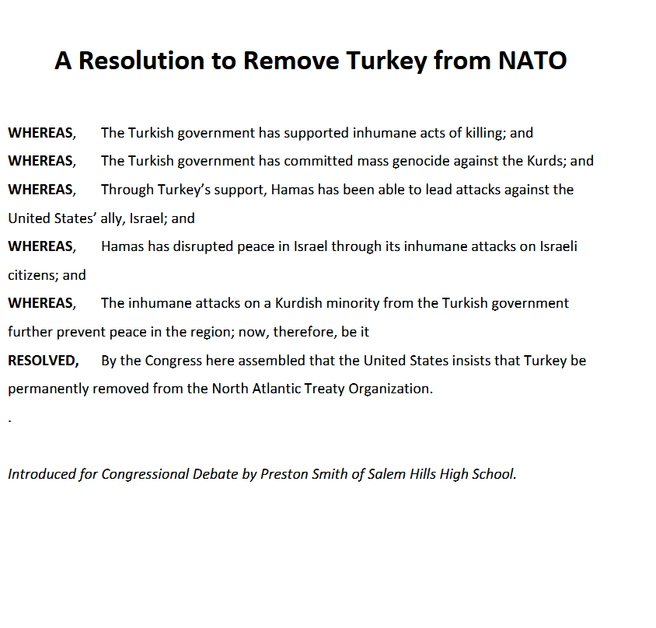

A Bill to Ensure Student Health by Starting School Hours at Later Times

1  2  3  4  5  6  7  8  9  10  11 | BE IT ENACTED BY THE CONGRESS HERE ASSEMBLED THAT:  SECTION 1. Federal funding will be denied to any public school or school district which starts the first period of their school hours before 8:30 AM.  SECTION 2. 1. Federal funding is defined as any school funding given by an agency or division of the federal government.  2. Denied is defined as not given.  3. First period is defined as the earliest class in which the majority of a school’s students are scheduled to attend.  4. School hours are defined as the hours of operation in which students are actively being taught.  SECTION 3. This bill will be enforced by the Department of Education.  SECTION 4. This legislation will take effect on January 1st, 2027.

Introduced for Congressional Debate by Jack Basso of Cottonwood High School

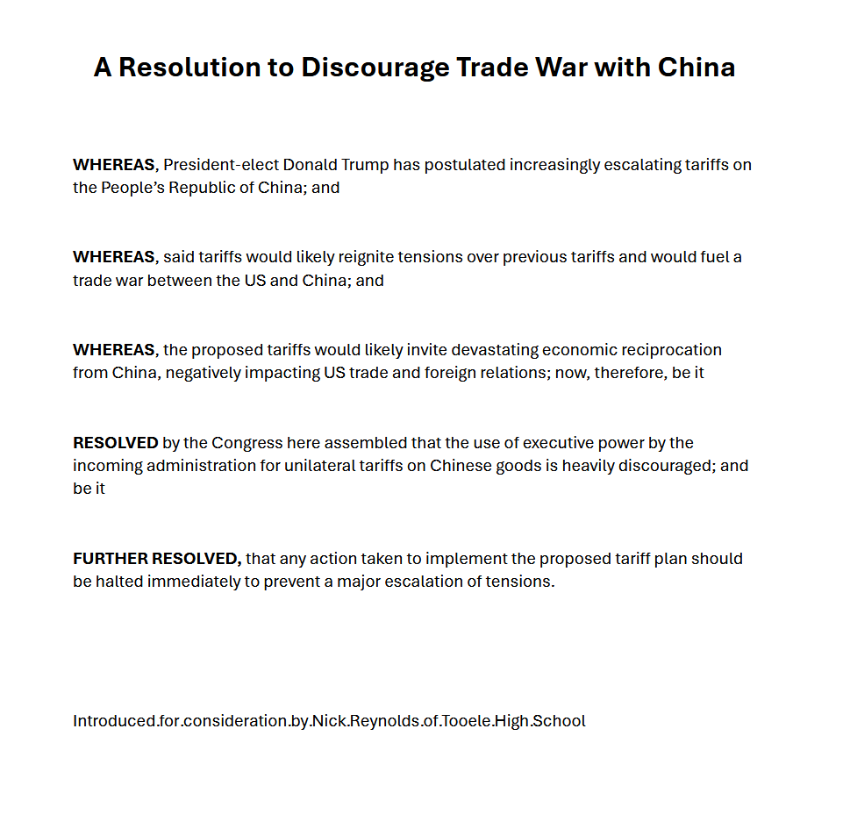

A Resolution to Leave NATO
1  2  3  4  5  6  7  8  9  10 | WHEREAS, The North Atlantic Treaty Organization has become ineffective in its original purpose and may harm the United States; and  WHEREAS, NATO was intended for mutual defence and to deter the Soviet Union from declaring war on one or more member nations and to benefit all member nations; and  WHEREAS, The Soviet Union has dissolved and ceases to be a threat; and  WHEREAS, The United States does not substantially benefit from its involvement in NATO; and  WHEREAS, The United States may be brought into a war if a member state has invoked Article 5; now, therefore, be it  RESOLVED, That the Congress here assembled shall begin the process of enacting Article Thirteen of the North Atlantic Treaty and thereby cease to be a party of NATO.
Introduced for Congressional Debate by Daniel Lomax of Clearfield High.

