

Feb 26, 2025

Dear Coach:

The Mulvane High School Forensics Team would like to invite you to attend the Mulvane “Battle for the Belt” Forensics Tournament on Saturday, March 15th. This year, we are a NIETOC Bid Tournament.

We will be offering the following 11 events: Humorous Interpretation, Dramatic Interpretation, Duet Acting, Duo Interpretation, Program of Oral Interpretation, Prose, Poetry, Informative (7/10 minute), Original Oration, Extemporaneous Speaking and Impromptu. KSHSAA rules will be followed. Informative will be combined 7 minute and 10 minute (I wish I had the room to run it separately), however judges will be informed that we are combining.

Schools will be limited to 16 entries with no more than 3 entries in an event. If space allows, I will allow schools to enter additional entries. Students will be limited to entering no more than 3 events. We will be scheduling 3 preliminary rounds and a final in each event. The top 6 finalists in each event will be awarded with medals. We are asking schools to provide a judge for every 6 entries or portion thereof.

**Marquis of Mulvane Rules**: Sweepstakes plaques will be awarded to the top 3 schools based on 16 entries. We will present our ***championship belt*** traveling award to the 1st place sweepstakes team who will retain it till our 2026 tournament where it will be up for grabs once again. In order to keep sweepstakes a fair competition, schools that enter more than 16 will be asked to declare which events will be counted toward sweepstakes prior to the end of round 1. This way, no school can run away with the belt just by bringing a huge entry.

Entries will be taken up until March 13th. Entry fees will be whatever you charge for your tournament. If you do not host a tournament, the entry fee is $6 per person per event. Schools can enter the tournament via <http://mulvanebelt.tabroom.com/>. If you have any questions, please contact me at [Jmitchell@usd263.org](mailto:Jmitchell@usd263.org)

Sincerely,

Jason Mitchell

Debate and Forensics Coach

Mulvane High School

1900 N. Rock Road

Mulvane, Ks. 67110

316-777-1183

[Jmitchell@usd263.org](mailto:Jmitchell@usd263.org)

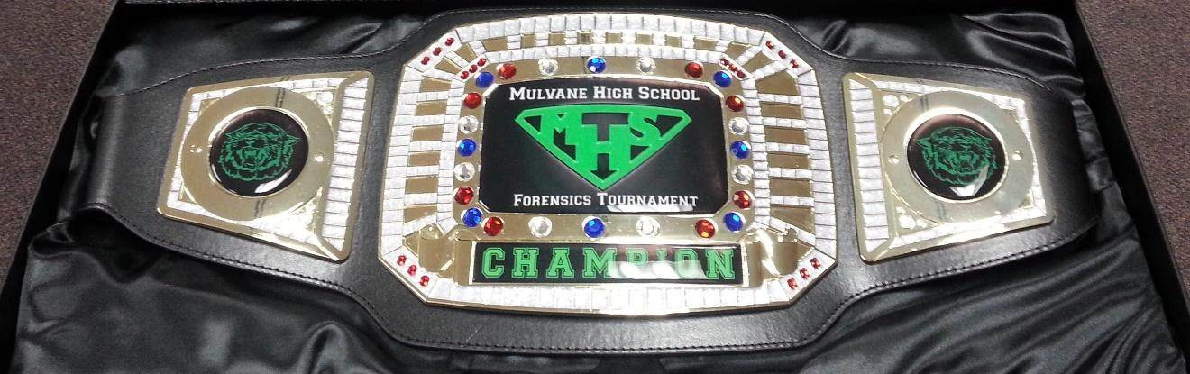

Mulvane “Battle for the Belt” Forensics Tournament

Entry Form

_________________________ High School would like to enter the following events in the Mulvane “Battle for the Belt” Forensics Tournament on March 15, 2025.

Extemp ______ x $6.00/your tourn price = _________

Impromptu ______ x $6.00/your tourn price = _________

Informative ______ x $6.00/your tourn price = _________

O. O. ______ x $6.00/your tourn price = _________

Prose ______ x $6.00/your tourn price = _________

Poetry ______ x $6.00/your tourn price = _________

HI ______ x $6.00/your tourn price = _________

DI ______ x $6.00/your tourn price = _________

POI ______ x $6.00/your tourn price = _________

Duet ______ x $12.00/your tourn price = _________

Duo ______ x $12.00/your tourn price = _________

Total Fees _________

# Schedule

Registration 7:15 AM

Rd 1 Extemp Draw 7:45 AM

Round 1 8:00 AM

Rd 2 Extemp Draw 9:15 AM

Round 2 9:30 AM

Rd 3 Extemp Draw 10:45 PM

Round 3 11:00 AM

Finals Draws 1:20 PM

Finals 1:30 PM

Awards ASAP

Coach: ______________________________________

Address:______________________________________________

Phone:______________________ Fax: ____________________

E-mail: _____________________________________________