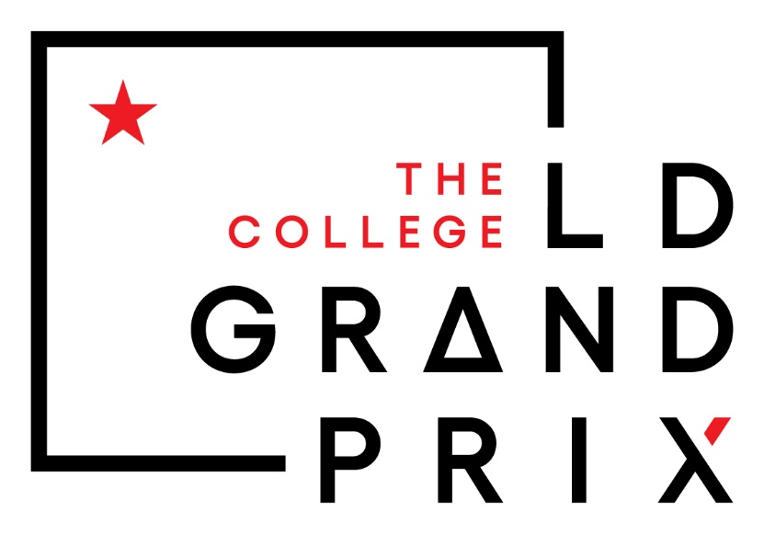

Date: March 15th-16th
Hosted by Kansas City Kansas Community College both on campus and online
Format: Hybrid. Classroom space provided for hybrid debates. Classroom and Common area space for judges. We cannot ensure AV technology access in every room.
Website: ldgrandprix.tabroom.com

KCKCC invites you to the 7th annual NFA-LD Grand Prix

Elimination Rounds
Up to 16 students will advance to the double elimination debates (whichever is closer)
If more than 16 students have winning records after 5 preliminary rounds, a run-off round will occur on Saturday Evening with pairing procedures like a partial double-octofinal round.

Schedule
All times Central Standard Time
March 15th
Round | Pairing | Disclosure | Report Deadline | Start Time | Decision Deadline
Round 1 | 9:00 AM | 9:15 AM | 9:20 AM | 9:30 AM | 11:00 AM
Round 2 | 11:00 AM | 11:15 AM | 11:20 AM | 11:30 AM | 1:00 PM
Lunch Break | - | - | - | 1:00 - 2:00 PM | -
Round 3 | 2:00 PM | 2:30 PM | 2:35 PM | 2:45 PM | 4:15 PM
Round 4 | 4:00 PM | 4:30 PM | 4:35 PM | 4:45 PM | 6:15 PM
Round 5 | 6:00 PM | 6:30 PM | 6:35 PM | 6:45 PM | 8:15 PM
Run-Off Round* | 8:00 PM | 8:30 PM | 8:35 PM | 8:45 PM | 10:15 PM
*Note: The Run-Off Round is optional and will only be held if there are more than 16 winning records.

March 16th
Round | Pairing | Disclosure | Report Deadline | Start Time | Decision Deadline
Elimination Round 1 | 9:00 AM | 9:15 AM | 9:20 AM | 9:30 AM | 11:00 AM
Elimination Round 2 | 11:00 AM | 11:15 AM | 11:20 AM | 11:30 AM | 1:00 PM
Elimination Round 3 | 1:00 PM | 1:15 PM | 1:20 PM | 1:30 PM | 3:00 PM
Elimination Round 4 | 3:00 PM | 3:15 PM | 3:20 PM | 3:30 PM | 5:00 PM
Elimination Round 5 | 5:00 PM | 5:15 PM | 5:20 PM | 5:30 PM | 7:00 PM
Elimination Round 6 | 7:00 PM | 7:15 PM | 7:20 PM | 7:30 PM | 9:00 PM
Final Round | 9:00 PM | 9:15 PM | 9:20 PM | 9:30 PM | 11:00 PM

Deadlines
March 10th 5 pm – Entry Deadline
March 12th 5 pm – Judge deadline
After March 12th any changes should be communicated to chad@ldgrandprix

Fees
Fees: 45 dollars per entry

Please make checks payable to:
Attn: WKU Forensics
1906 College Heights Blvd
Bowling Green KY 42101

We cannot currently accept credit card payment.

Judging
Each entry requires 3 rounds of judge coverage. A judge can cover 5 rounds.
All judges are obligated through the 2nd full elimination round. And then one round past their last eliminated debater.
Online judges should have cameras and keep them on for the duration of the debate. Judges should disclose their decisions and offer helpful/constructive feedback to students.
Judges should have a paradigm on the taproom website. Please ensure the content of your paradigm is something you would be fine being the subject of public interest, as publication of paradigms has become relatively common place.

Disclosure
The tournament expects students to disclose their affirmative and upload citations using the https://opencaselist.com/nfald24
Students should go to their rooms to disclose the affirmative by the arrival deadline.

Competition
The tournament will offer a Novice, JV, and Open division of National Forensics Association Lincoln-Douglas Debate. The topic will be the National Forensics Associations 2024-2025 topic: The United States federal government should substantially increase prohibitions on the development and/or use of artificial intelligence in one or more of the following areas: law enforcement, automation, and/or privacy.
Each debate will have one winner and loser.

Eligibility
Students competing at the LD-Grand Prix must be eligible to compete at the National Forensics Association national tournament.

Awards
Awards will be given to the 16 debaters who advance to the double elimination rounds of the Varsity division and the champion in JV and Novice.
The champion of the varsity division is awarded a traveling trophy, generously purchased by The Spicer Debate Forum at the first LD Grand Prix.
The LD Coaches Association will award trophies for the All-American Team, Coach of the Year, and Emerging Debater of the Year. LD Coach Association awards are donated by Chad Meadows.

Divisions
Any student may enter an open division. Junior division is open to students in their first four semesters of collegiate debate (of any kind). Novice division is open to students with less than two semesters of any debate at any level (high school or college).

Online Procedures
Zoom will be used for online/hybrid debates.

Coach Association Awards
All-American, Coach of the Year, and Emerging Debater of the Year Portals will be uploaded to the Tabroom page shortly.

