Hi Coaches!
Registration is now open in Tabroom for the Rapid City Stevens High School Penguin Classic!

RC Stevens Penguin Classic 2025
IE, Debate, Congress & Big Question
January 24 & 25, 2025 at Rapid City Stevens High School

The Stevens Speech & Debate Team invites you to join us Friday, January 24th and Saturday, January 25th for the 2025 Penguin Classic. We'll be at Stevens High School, 4215 Raider Rd, Rapid City, SD 57702. We welcome schools from Hole in the Wall, Northern District, Rushmore District and others in the area. We will offer IE, Debate, Congress & in-person Big Question. I expect we'll start Friday around 4pm and Saturday around 8am to accommodate for traveling schools.

Please do bring as many judges as you can! We are asking for 1 judge for every 2 debate entries, and 1 for every 5 Interp entries.

A few things to note:
- The “Classics” return: We will be offering Non-O, Story Telling and Poetry along with the typical IE & D events, in hopes that a few OI teams might join us.

- In-Person Big Question: We know there are other big tournaments going on in all 3 districts this particular weekend, and so we are also offering in-person Big Question in hopes that your school might send a suburban or two our way. Stevens Senior & Captain Olivia Boerger is our first 4-time National Qualifier (World Schools '22, 10th in BQ '23, 5th in BQ '24) and has auto-qual’d in Nationals BQ again for 2025. She will be available to watch rounds and offer her own critique for competitors, share a few ideas on this year's topic, and will host a "Q&A" session for Coaches and interested students.

- We will follow the D / HOPE pattern, During the D Round, students can pick 2 from POI, DI, DUO, and ST, or they can pick 1 from LD, PF, or Congress. During the HOPE Round, students can pick 2 from HI, OO, POE, Info, NonO or they can pick 1 from BQ, DX, IX or Congress. There will be 3 rounds of congress; each session will be 1 hour and we’ll use the NSDA January Docket. We will NOT break out Novice from Varsity.

D Pattern:
Pick 2: POI, DI, DUO, ST – or -
Pick 1: LD, PF Or D Congress

HOPE Pattern:
Pick 2: HI, OO, POE, Info, NonO, - or –
Pick 1: BQ or DX or IX or HOPE Congress

FOOD: We will feed our judges and coaches and will have light concession snacks for the students to purchase during the tournament (so please remind your students to bring cash). There should be time to have lunch delivered on Saturday (DorrDash, Uber Eats, or other delivery) or there are a number of options a short drive from the school (Qdoba, Jimmy Johns, Subway, Little Ceasars, and others).

UPON ARRIVAL Stevens excuses students for the day at 3:20pm, and then parking is a mad house. Please do not arrive before 3:40pm. Upon arrival, please drop off students at the front entrance and then park in the freshman parking lot (see below).
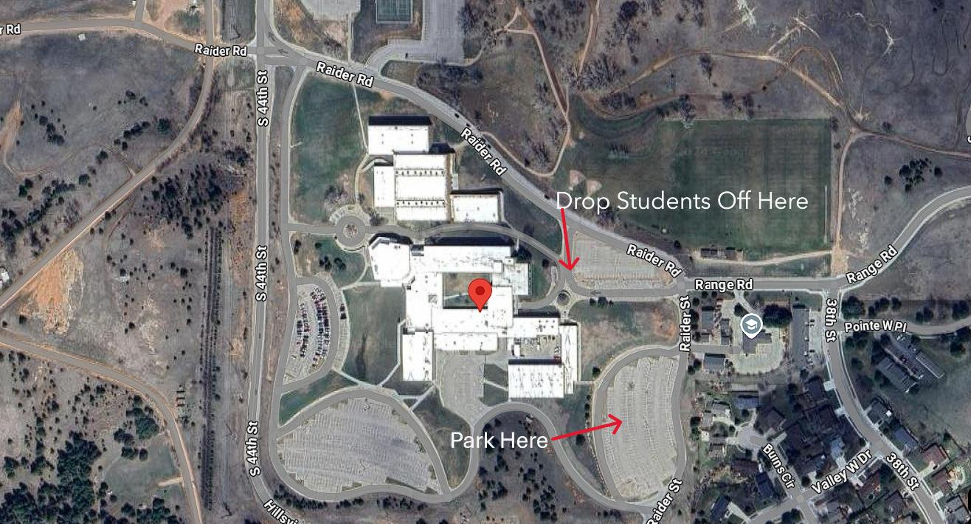
Registration will be in the Commons and students can find team tables in our 9th Grade Lunch Room.

Tentative Schedule:

Friday, 1/24/25
Please do not arrive before 3:40pm; drop students off at the front entrance off of Raider Road then park in Freshman Parking.

3:45p – 4:15p Arrival & Registration
4:15p - Welcome meeting
4:30p - Round 1 D pattern starts
5:30p - Round 1 Extemp Draw
5:45p - Round 1 HOPE pattern starts
6:45p - Round 2 D pattern starts
7:45p - Round 2 Extemp Draw
8:00p - Round 2 HOPE pattern starts.

Saturday, 1/25/25
7:30a - School is open, arrive between 7:30 – 8:30am
8:30a - Round 3 D pattern starts
9:30a - Round 3 Extemp Draw
9:45a - Round 3 HOPE pattern starts
10:45a - Round 4 for LD and PF only
11:45a - Break before finals (This is a great time for an early lunch!)
12:15p - Finals posted
12:30p - Finals Extemp Draw
12:45p - Finals HOPE Pattern & Penguin Congress!
2:00p - Finals D Pattern & Penguin Congress OR learn about Big Question
Awards will start as soon as Tabroom is calculated
4p? Awards

Please let us know if you plan to join us - registration is open now, and we’d love to have final entries in by Wednesday, 1/22/2025.

Thanks all and we'll see you in the coming weeks!

Best,
Ryan Harris, Head Coach
Sean Bradley, Assistant Debate Coach
Charalet VanderWall-Dunnigan, Assistant Speech Coach

