2025 Omaha Central Seth Rich Tournament
January 25th
CONGRESS DOCKET

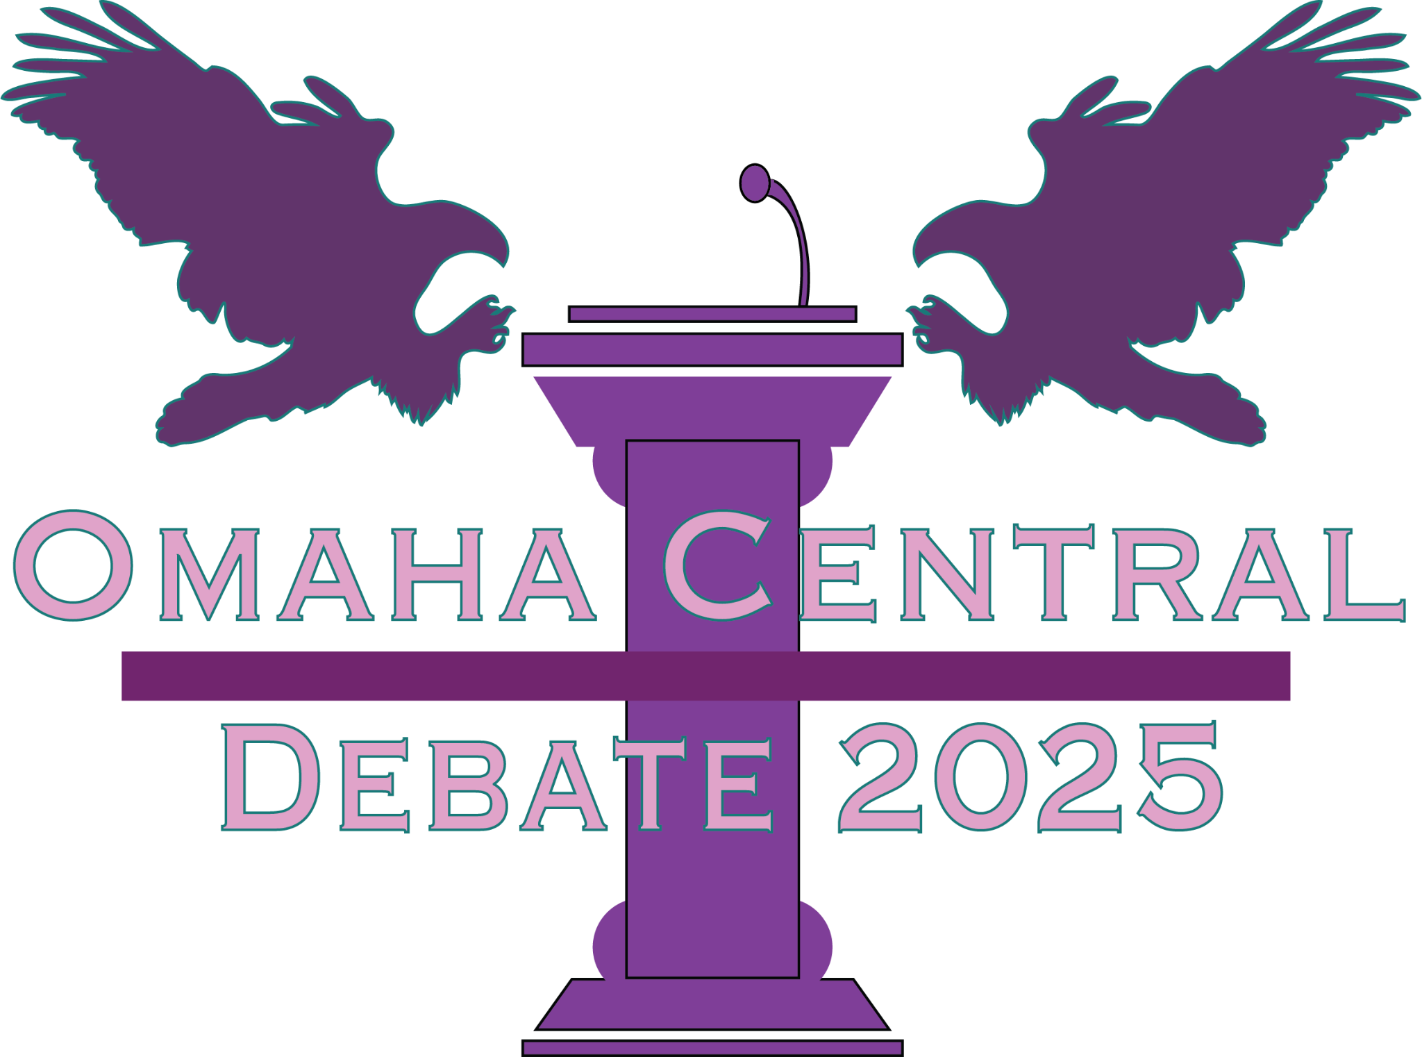

Table of Contents:
DOCKET ORDER:

1. A Bill to Eliminate Daily Savings Time - NF
2. A resolution to amend the Constitution to add a maximum age limit to run for president - MS
3. A Bill to Regulate Generative Artificial Intelligence Art - HS
4. A Bill to Put Stray Cats in Prison - LE
5. A Bill to Increase US Aid to Ukraine - LSE
6. A Resolution to Eliminate Unfunded Mandates in Education - NF
7. A Resolution to Promote Solar Punk Ideals - HS
8. A Bill to Defund For Profit Charter Schools - LSW
9. A Bill to Ban Hostile Architecture - LE
10. A Resolution to Leave the Quadrilateral Security Dialogue - MS
11. A Bill to Welcome Palestinian Refugees - MS
12. A Bill to Improve Assisted Living Facilities - MR

1. A Bill to Eliminate Daily Savings Time
1  2  3  4  5  6  7  8  9 | BE IT ENACTED BY THE CONGRESS HERE ASSEMBLED THAT:  SECTION 1. Daylight Savings Time in the United States will be abolished.  SECTION 2. Daylight Savings Time, as described in the Uniform Time Act of 1966 (15 U.S.C. §§ 260-64), is the practice of moving clocks forward one hour in the spring and back in the fall.  SECTION 3. The Department of Transportation shall continue to administer standard time as described in 15 USC CHAPTER 6, SUBCHAPTER IX.  SECTION 4. Daylight Savings time will end in the fall of 2025.  SECTION 5. All laws in conflict with this legislation are hereby declared null and void.

Introduced by Norfolk High School

2. A resolution to amend the Constitution to add a maximum age limit to run for president
1  2  3  4  5  6  7  8  9  10  11  12  13  14  15  16  17 | RESOLVED, By two-thirds of the Congress here assembled, that the following article is proposed as an amendment to the Constitution of the United States, which shall be valid to all intents and purposes as part of the Constitution when ratified by the legislatures of three-fourths of the several states within seven years from the date of its submission by the Congress:  ARTICLE --  SECTION 1: This resolution would enact a maximum age limit for anyone running for the position of President of the United States of America. Candidates would have to be below 50 years of age.  SECTION 2: Candidates are defined as anyone who is running for President of the United States of America.  SECTION 3: Candidates would have to be below the age of 50 years in order to run for President. Candidates could not turn 50 prior to the inauguration of their presidency if elected.  SECTION 4: This legislation will take effect immediately and all laws in conflict with this legislation are hereby null and void.
Introduced for Congressional Debate by Millard South High School.

3. A Bill to Regulate Generative Artificial Intelligence Art

- BE IT ENACTED BY THE CONGRESS HERE ASSEMBLED THAT:
- Section 1. The United States will regulate generative artificial intelligence art by
- establishing a set of guidelines that AI art generators must follow if they are
- headquartered within the 50 states or any U.S. territories.
- A. The companies behind the AI art generators must provide a database
- of all the art they have collected to generate new pieces from said art.
- The database needs to provide attribution data (e.g. name of artist,
- source) for each piece of art. This database must be easily
- accessible/navigable for the public to view in a designated area of their
- website.
- B. Copyright holders must be notified within a month of the art being
- acquired by the company and provide proof of notification.
- C. The companies behind AI art generators must remove any piece of art
- they have in the database if a copyright holder requests its removal
- through an official form the company must provide. The company has
- two weeks from receiving the form to remove the piece from its
- database. The company must also blacklist the art to prevent its
- addition to the generator.
- D. If the company fails to remove the piece of art from their database after
- two weeks, they will be fined $100 for every piece they failed to remove
- by the request of the copyright holder. If the same copyright holder
- requests additional removals after two weeks from their last request of
- removal, the fine will increase by $100 for each removal.
- E. The company must also document the method they use to receive the
- data and art for the generators and release quarterly reports through
- the website database. These reports must at least include the sources
- used for the data and the method of collecting the data.
- Section 2. AI art generators shall be defined as tools, software, or platforms that
- utilize artificial intelligence algorithms to analyze and synthesize visual or
- graphical outputs by referencing existing works, particularly those created by
- humans.
- Section 3. The United States Copyright Office will oversee this legislation. The
- annual budget of the Copyright Office will be increased by $125 million in order to
- hire and pay more employees.
- Section 4. This shall be fully implemented by the fiscal year October 1, 2026.
- Section 5. All laws in conflict with this legislation are hereby declared null and
- void.

Respectfully submitted by Hastings Senior High School

4. A Bill to Put Stray Cats in Prison
1  2  3  4  5  6  7  8  9  10  11  12  13  14  15  16  17  18  19  20  21  22  23  24  25  26  27  28  29  30 | BE IT ENACTED BY THE CONGRESS HERE ASSEMBLED THAT:  SECTION 1. The United States shall add a Feline Rehabilitation Program to its Correctional Facilities once this legislation is passed.  SECTION 2. The following definitions are important for this legislation:  A."Feline Rehabilitation Program" refers to a program established in correctional facilities  that involves the care and training of stray cats.  B. "Stray Cat" refers to a cat that is not microchipped and does not have a home or  owner.  SECTION 3. The Department of Justice shall establish a Feline Rehabilitation Program in each correctional facility that meets the following criteria:  A. The program must take in stray cats that are not microchipped and have no owner.  must also facilitate inmate participation in the care and training of the cats.  B. Cats must be extensively documented and photographed in the case that the cat is lost  and not a stray. The documentation will be added to a database.  SECTION 4. The Department of Justice (Bureau of Prisons) shall allocate $50 million annually to fund the Feline Rehabilitation Program. This will come out of the existing F-35 military budget.  A. $1,000 dollars shall be given to shelters that donate half of their stray cats. The rest of  the money allocated will be used for any vital infrastructure to make the correctional  facilities cat-friendly.  B. Congress will evaluate this funding annually to see if further allocation is needed to  keep the program intact.  SECTION 5. The following defines which prisoners are eligible for this program:  A. Inmates who have committed nonviolent crimes shall be eligible to participate in the  program.  B. Inmates who have committed violent crimes may be eligible to participate in the  program if they exhibit good behavior.  C. Inmates who exhibit any violent behavior towards the cats or other inmates shall be  immediately removed from the program.  SECTION 6. This legislation will take effect at the beginning of the 2025 FY. All laws in conflict with this legislation are hereby declared null and void.
Introduced for Congressional Debate by Lincoln East.

5. A Bill to Increase US Aid to Ukraine

1  2  3 | BE IT ENACTED BY THE CONGRESS HERE ASSEMBLED THAT:  SECTION 1. The Stand with Ukraine Act of 2024 is hereby passed.  SECTION 2. The aforementioned Act will take effect immediately upon passage.  SECTION 3. All laws in conflict with this legislation are hereby declared null and void.
Introduced for Congressional Debate by LIncoln Southeast High School.

6. A Resolution to Eliminate Unfunded Mandates in Education

1  2  3  4  5  6  7  8  9 | WHEREAS, the Unfunded Mandates Reform Act (UMRA) of 1995 has failed to reduce unfunded mandates on PK-12 schools; and  WHEREAS, unfunded mandates force school districts to increase local taxes to meet their federal requirements ; and  WHEREAS, the inequity in funding and mandates result in significantly different education opportunities; now, therefore, be it  RESOLVED, By this Congress that the state and federal government and their subsidiary agencies be prohibited from imposing unfunded mandates on local and independent school districts.

Introduced by Norfolk High School

7. A Resolution to Promote Solar Punk Ideals
- WHEREAS, Environmental unsustainability continues to harm ecosystems and
- public morale; and
- WHEREAS, This issue affects the well-being of current and future generations in
- myriad ways while discouraging collective environmental action, and it has
- caused people to develop a feeling of what is classified as doomerism because
- of things like psychological, economic, resource, and inevitably environmental
- collapses; and
- WHEREAS, Embracing Solar Punk ideals can inspire innovation and solutions
- that harmonize human society with nature and bring back a feeling of hope in
- society and humanity; now, therefore, be it
- RESOLVED, By this Congress that the United States government should adopt
- measures to advance Solar Punk principles and practices to promote
- sustainability and hope.
Submitted for Congressional Debate by Hastings Senior High School

8. A Bill to Defund For Profit Charter Schools

1  2  3  4  5  6  7  8  9  10  11  12  13  14  15  16 | BE IT ENACTED BY THE CONGRESS HERE ASSEMBLED THAT:  SECTION 1. This bill adds to the definition of a charter school in the Elementary and Secondary Education Act of 1965.  SECTION 2. Section 4310 will now include the following: “A charter school does not enter into a contract with a for-profit entity, or have a charter management organization or other nonprofit entity enter into such a contract on behalf of such school, under which the for-profit entity operates, oversees, manages, or otherwise carries out the administration of such school, which may include curriculum development, budget management, and faculty management (such as hiring, terminating, or supervising school-level staff).”  SECTION 3. Charter schools may still contract for food, payroll, facilities maintenance, transportation services, classroom supplies or other ancillary services.  SECTION 4. The Department of Education will oversee the implementation of this bill.  SECTION 5. Current funding for charter schools, who do not meet the amended definition, shall not be renewed beyond the 2024-2025 academic year.  SECTION 6. All laws in conflict with this legislation are hereby declared null and void.
Introduced for Congressional Debate by Lincoln Southwest High School

9. A Resolution to Encourage the Executive Branch to Recognize Taiwan as a Fully Sovereign State
1  2  3  4  5  6  7  8  9  10  11 | WHEREAS, The Republic of China has long been an ally in the South Pacific; and  WHEREAS, The Republic of China is not currently fully recognized by the United States Government; and  WHEREAS, The Republic of China is not fully diplomatically supported by the United States Government; and  WHEREAS, The People’s Republic of China has been increasingly hostile towards the United States; so be it  RESOLVED, That the Congress here assembled encourage the President to fully recognize The Republic of China as a Sovereign State; and, be it  FURTHER RESOLVED, That any informal arrangements with the Republic of China be seen as fully fledged agreements and treaties.
Introduced for Congressional Debate by Millard North High School

10. A Resolution to Leave the Quadrilateral Security Dialogue

- WHEREAS, The United States should promote global peace; and
- WHEREAS, The Quadrilateral Security Dialogue (also known as “The Quad”) is
- harming our chances of global peace in the Indo-Pacific Region; and
- WHEREAS, The United States should aim to drive global peace and decrease
- tensions; now, therefore, be it
- RESOLVED, By this Congress that the United States leave and denounce the
- Quad; and, be it
- FURTHER RESOLVED, That we seek to cooperate with China on matters in the
- Indo-Pacific region in a much more open and less hostile manner.

Introduced by Millard South High School

11. A Bill to Welcome Palestinian Refugees

BE IT ENACTED BY THE CONGRESS HERE ASSEMBLED THAT:
SECTION 1.
- There will be a new program modeled after the UNRWA (United Nations Relief and Works Agency for Palestinian Refugees in the Near East). The UNRWA provides resources, assistance, and protection for Palestine refugees in the countries surrounding Palestine and the Middle East region. Our program would be the USRAPR (Unites States Relief Agency for Palestinian Refugees) providing the same support but in the U.S.
- The program will get 150 million dollars every fiscal year.
SECTION 2. A refugee will be defined as a person who has been forced to leave their country to escape war, persecution, or a natural disaster.
SECTION 3. The United States Refugee Admissions Program (USRAP) will implement and enforce this legislation.
- Violation of this legislation will result in a 2A felony charge.
- Any U.S. Immigration agent who denies a Palestinian refugee based on race, religion, nationality, or without a valid reason will be charged a fine of up to 25,000 dollars or 2-5 years imprisonment.
SECTION 4. This legislation will take effect once the bill is passed.
SECTION 5. All laws in conflict with this legislation are hereby declared null and void.

Introduced for Congressional Debate by Millard South High School.

19. A Bill to Improve Assisted Living Facilities

- BE IT ENACTED BY THE CONGRESS HERE ASSEMBLED THAT:
- SECTION 1.
- A. All states are required to have state-funded assisted living facilities for elderly with disabilities.
- a. These facilities are required to have a psychologist and psychiatrist on staff.
- b. There will be a mandated ratio in these homes of 4 nurses to 1 resident.
- B. States will be given 100 million dollars per every 1 million people above the age of 60 in their
- state to fund the assisted living facilities.
- C. All requests to transfer to another facility must be reviewed by an independent review board,
- medical professionals, and social workers.
- a. If every other private facility is deemed unsafe, a state home is required to make a
- place accessible to said resident.
- i. Unsafe shall be defined as not having suitable or proper care available for said
- resident to ensure proper care.
- D. “Endangerment of others” in the Retirement Home Reform Act of 1987 will now be defined by
- a tier list based on frequency, containability, severity, and intent.
- E. Facilities will have the right to ban anyone from a section of the home if a patient jeopardizes
- the safety of staff or other residents.
- F. 1 billion dollars shall be allocated to pay for raises and hiring bonuses to encourage the
- acquisition of more nursing staff for homes.
- SECTION 2. Assisted living facilities shall be defined as any place housing and giving daily
- assistance to elderly people with disabilities.
- a. The elderly shall be defined as all people over the age of 65.
- SECTION 3. This bill shall be enforced by the Department of Justice and the Department of
- Health and Human Services. Any home in violation of this bill will be under investigation and will
- be shut down after 3 infractions. Each infraction will result in paying a tax of 1,000 dollars per
- resident. Any state in violation of this review will have its highway funding taken away.
- SECTION 4. This bill shall go into effect 5 years after the passage of this bill.
- SECTION 5. All laws in conflict with this legislation are hereby declared null and void.

Introduced by Marian High School

