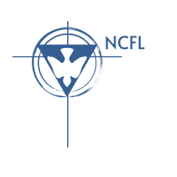
NCFL-Pensacola
Bruner Middle School
Thanksgiving Turkey Talk Tournament
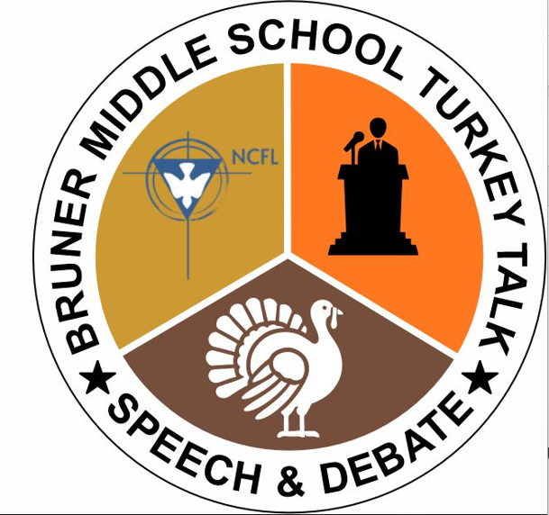
Legislative Docket
Tier 1 Legislation:
101. A Resolution to Amend the Constitution to Designate the Turkey as the National Bird
102. A Bill to Ban Tackling Football and Rugby
103. A Resolution to Recognize the first full week of November as Drowsy Driving Prevention Week
104. A Bill to Abolish the IRS and Establish a Flat Tax System
105. The National Railroad Support Act of 2024
106. A Bill to End Aid for Ukraine
107. A Bill to Limit Tourism in National Parks

- All Tier 1 Legislation must be debated before moving to Tier 2. Debate includes at least one speech in the affirmative and one in the negative before voting on the legislation.

A Resolution to Amend the Constitution to Designate the Turkey as the National Bird

RESOLVED, By two-thirds of the Congress here assembled, that the following article is proposed as an amendment to the Constitution of the United States, which shall be valid to all intents and purposes as part of the Constitution when ratified by the legislatures of three-fourths of the several states within seven years from the date of its submission by the Congress:
ARTICLE --
SECTION 1: The Turkey shall be designated as the National Bird of the United States.
SECTION 2: The Congress shall have power to enforce this article by appropriate legislation.

A Bill to Ban Tackling Football and Rugby

BE IT ENACTED BY THE CONGRESS HERE ASSEMBLED THAT:
Section 1. Tackling is hereby prohibited in public elementary, middle, and secondary education sports in football, rugby, and any other activities where tackling is standard practice within the sport. The use of flags as a stand-in for tackling shall remain legal, and public and private leagues at all levels are encouraged to embrace this humane adaptation.
Section 2. Tackling is defined as the intentional use of physical contact and force to arrest another 7 player’s movement, bring that player to the ground, and/or compel that player to lose 8 possession of the ball.
Section 3. This legislation shall be jointly overseen by the Department of Health and Human Services 12 and the Department of Education.
- Any public school found to be allowing tackling sports without penalty shall be fined $1,000 10 for each violation.
Section 4. This legislation will take effect on January 1st, 2026
All laws in conflict with this legislation are hereby declared null and void.

A Resolution to Recognize the First Full Week of November as “Drowsy Driving Prevention Week”

WHEREAS, Drowsy driving creates serious risk on the road by making drivers less attentive, slowing reaction times, and affecting his or her ability to make decision; and
WHEREAS, The National Safety Council considers drowsy driving to be a profound impairment that mimics alcohol-impaired driving in many ways, including impaired attention, mental processing, judgment, and decision making; and
WHEREAS, Studies show that being awake for 18 hours results in impairment equivalent or worse than a blood alcohol content (BAC) of 0.05 percent and being awake for 24 hours results in a BAC of 0.1 percent, higher than the legal limit of 0.08 percent BAC in all States; and
WHEREAS, The National Sleep Foundation found that 60 percent of adult drivers reported driving while drowsy in the past year and an estimated 1 in 25 adult drivers (aged 18 or older) reported having fallen asleep while driving in the previous 30 days; therefore, be it
WHEREAS, An estimated 328,000 crashes and 21 percent of all fatal crashes annually, 6,400 deaths per year, involve a drowsy driver: Now, therefore, be it;
RESOLVED, That the Congress here assembled:
- Supports the designation of the first full calendar week in November as “Drowsy Driving Prevention Week” to raise awareness about the dangers of drowsy driving; and
- encourages people across the United States to take preventable steps against drowsy driving.

A Bill to Abolish the IRS and Establish a Flat Tax System

BE IT ENACTED BY THE CONGRESS HERE ASSEMBLED THAT:
Section 1. The income tax code of the United States will be repealed and replaced by a flat tax on incomes of 15%. The Internal Revenue Service will be Abolished.
Section 2. Income Tax is defined as a tax on wages (hourly or salary) earned by workers.
Section 3. The United States Treasury will oversee the abolishment of the Internal Revenue Service, and the responsibilities of the IRS shall be shifted to relevant state agencies and the Social Security Administration.
SECTION 4. This legislation will take effect on FY 2024. All laws in conflict with this legislation are hereby declared null and void.

The National Railroad Support Act of 2024
BE IT ENACTED BY THE CONGRESS HERE ASSEMBLED THAT:
Section 1. Congress shall invest $100 billion into both creating new high-speed railroads as well as maintaining all pre-existing railroads.
Section 2. Railroads are defined as a track or set of tracks made of steel rails along which passenger and freight trains run. Traditional Railroads are defined as any railroads that are not high speed.
Section 3. The Federal Railway Administration (FRA) and the Federal Department of Transportation (DOT) will oversee enforcement.
A. Funding shall come from a 5% tax on diesel sales, a 5% tax on No.6 fuel oils, and a 5% tax on Airline ticket sales. Any additional funding required shall generously be provided by the U.S. Department of Defense.
B. The FRA and DOT must submit a plan of action detailing the location of railways they will construct as well as which sections of pre-existing railways they will maintain to Congress within 6 months of this legislation taking effect. The plan will emphasize maintaining high-speed and traditional railroads first and then constructing new railroads second.
C. Newly created railroads must be able to withstand high-speed passenger trains traveling above 180 miles/hour.
SECTION 4. This legislation will take effect on FY 2025. All laws in conflict with this legislation are hereby declared null and void.

A Bill to End Aid for Ukraine

BE IT ENACTED BY THE CONGRESS HERE ASSEMBLED THAT:
Section 1. The United States shall halt all forms of federal aid to Ukraine immediately and indefinitely.
Section 2. Federal Aid includes, but is not limited to: the providing, without cost of weapons, military and civilian supplies, technology, and monetary funds.
Section 3. The Department of Defense will oversee the enforcement of this legislation.
SECTION 4. This legislation will take effect on FY 2025. All laws in conflict with this legislation are hereby declared null and void.

A Bill to Limit Tourism in National Parks

BE IT ENACTED BY THE CONGRESS HERE ASSEMBLED THAT:
Section 1. The United States shall limit the number of visitors allowed to National Parks and National Park Areas.
Section 2. The National Park Service (NPS) is instructed to evaluate an environmentally and logistically sustainable capacity for each of its parks and park areas and to set limits accordingly.
Section 3. The National Park Service shall oversee this legislation.
- The NPS shall have full discretion over the parameters and details of visitor restrictions, but they are directed to keep matters of equity and accessibility in mind when determining which visitors gain access.
SECTION 4. This legislation will take effect on FY 2025. All laws in conflict with this legislation are hereby declared null and void

