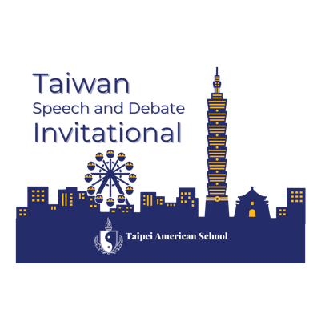

Dear Colleagues,

The Taipei American School Speech and Debate team is excited to invite you to attend the 2nd Annual Taiwan Speech & Debate Invitational on October 10-12, 2025, hosted at our campus in Taipei, Taiwan.

We are excited to offer you and your students not only an outstanding tournament experience, but also a unique cultural opportunity to explore parts of our beautiful island and engage with the growing international speech and debate community.

Please note some important tournament information:
- The inaugural Taiwan Speech and Debate Invitational will be an in-person tournament.
- Schools from around the world are invited to attend. In 2024, we hosted 20 schools from around the world, including six schools joining from the United States, two schools from Vietnam, and one school from mainland China. We look forward to growing these numbers in 2025!
- The tournament will run Friday through Sunday. We encourage teams to arrive by Wednesday evening to provide sufficient time to get settled and adjust to the time difference before the tour day on Thursday, October 9th.. We have selected this weekend as 10/10 is Taiwan’s National Day, a national holiday, and Monday, October 13th is a holiday in the United States, making return travel easier for visiting teams.
- Our current plan is to offer Congressional Debate, Policy Debate, Public Forum Debate, and World Schools Debate, as well as Extemp, Impromptu, Oratory, and Informative. We will also open registration for Lincoln-Douglas Debate and interp events, but do warn that these events are less popular in Asia and thus will be filled by primarily U.S. entries and/or TAS students.
- The tournament will offer six preliminary rounds in Public Forum, Policy, and LD, five or six preliminary rounds in World Schools Debate, four preliminary rounds in all speech events, and three preliminary sessions in Congressional Debate. In debate, we will break all winning records. In speech, we will advance the greatest number of students reasonable (around a third of the field).
- We will offer novice divisions in both Policy Debate and Public Forum Debate. If interest warrants it, we will add novice divisions in other categories.
- We have been designated by the Tournament of Champions as a finals bid tournament in Policy Debate and Public Forum Debate, and a Top-6 bid tournament in Congressional Debate.
- We plan to apply for NIETOC bid status for our 2025 tournament.

In recent years, international speech and debate has expanded significantly and we are excited to share that exciting growth with you at our tournament. In addition to teams from Taiwan, we anticipate hosting teams from China, Vietnam, and the United States at our 2025 Invitational and hope to add more tournaments to that list. In our increasingly globalized world, we believe there is great value in students making connections with their peers around the globe and look forward to fostering those connections with you in-person this fall in the beautiful city of Taipei, Taiwan.

Please do not hesitate to reach out with any questions. We can’t wait to welcome you to Taiwan!

All the best,
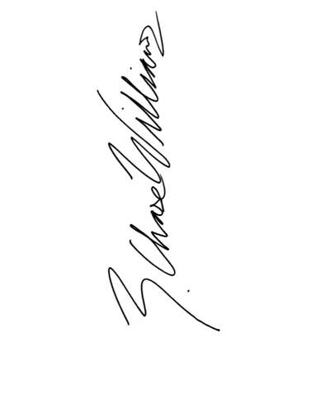
Chase Williams
Director of Speech and Debate
Taipei American School

