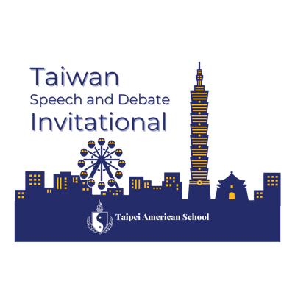

Frequently Asked Questions – Last Updated 10/29/24

- Schedule – Our 2024 schedule can be found here: https://docs.google.com/spreadsheets/d/1ph8iW0B7DvwqJDN4anjuE-WQGIavNG7VxUEe_LA0XLw/edit?usp=sharing. We will publish our 2025 schedule in Spring of 2025, but the tournament days will be Friday, October 10-Sunday, October 12 with the cultural tour day on Thursday, October 9.
- Cultural Tour Day – We recommend teams arrive by the evening of October 8, 2025 in Taipei in order to join us for our cultural day tour on October 9th. A final itinerary will be available in the Spring, but 2024’s itinerary included the National Palace Museum, Taipei 101, and Chiang Kai-shek Memorial Hall. Costs associated with the tour day are included for overseas schools in your tournament registration fee.
- Transportation – TAS will be providing bus transportation from Taoyuan International Airport (TPE) to your hotels upon your arrival. TAS will also provide transportation to/from our evening events each night. Outside of the transportation we’re providing, Ubers, Taxis, etc. are all very easy to manage in Taiwan.
- Hotels – There are two hotels that are within walking distance of TAS that we recommend. The Dandy (https://tianmu.dandyhotel.com.tw/en/ ) and The Mellowfields (https://mellowfields.com.tw/en/index.php). We work with these hotels often and can help you book/reserve the rooms you need. Please reach out to me at williamsc@tas.edu.tw with the number of rooms and room types that you will need and I can work with our activities office to reserve those rooms for you. We can also book the rooms through TAS and then just charge your school the amount if that is something that would work better for your program. If you choose to book at another hotel (for example, the Renaissance Shilin or Aloft Beitou if you’re a Marriot person) you would need to figure out your own transportation to/from TAS each day, but Uber, Taxis, etc. are all very easy in Taiwan.
- Meals – Lunch will be included during the Cultural Tour Day, as well as lunches during the tournament. During our evening outings, we will be taking the students to more public spaces where dinner will be more street food/individual affair, but there will be plenty of inexpensive options for students.
- Currency Exchange/Spending Money – Currently the currency exchange rate is about 1 USD to 32 NTD. This will likely fluctuate between 32 and 33 between now and the tournament. TAS can help with currency exchange if needed. Prices in Taipei are either comparable or cheaper than the US – depending on the items desired. Imported items are significantly more expensive than domestic goods – but the amount of spending money for your students will be based on how much they plan to buy as far as souvenirs, etc. While cash is required in some situations in Taipei, most restaurants, shops, businesses, and even some taxis will accept international credit cards.
- Language – Taiwan, and specifically Taipei, is very English friendly. Most public signage is in both languages and Google Translate is sufficient for any interactions where you may need additional language support. I would recommend that everyone on your team download Google Translate and the “Mandarin (Traditional)” language dictionary in the app before arriving.
- Flights – If you need help with finding flights or have questions about the flights you have found, please don’t hesitate to reach out. United Airlines has 2 flights a day to/from Taipei out of SFO and Delta has one flight a day to/from Taipei out of Seattle. Other airlines with flights direct to Taipei are EVA Airways, China Airlines, and Starlux Airlines. Another option that we have used over the years is ANA with a connection in Tokyo. I am here to help – and if I can’t help – I can connect you with our school travel agent who can try to work her magic.

