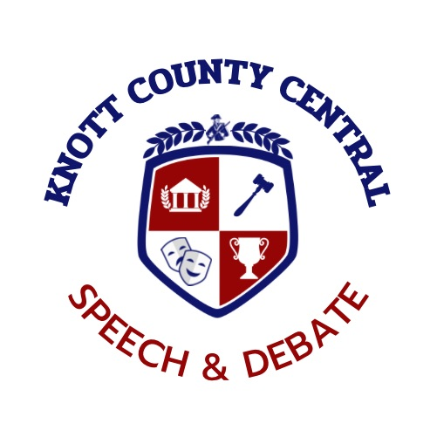

2024 PATRIOT WINTER CLASSIC

**Dear Coaches, Judges, and Speechies,**

It is with great pleasure that we invite you to the Patriot Winter Classic Junior High Speech Tournament held this year at the Hindman Elementary School located at; 875 W Main St, Hindman, KY 41822. Our tournament is scheduled for Saturday, December 14th, 2024.  We are certainly looking forward to seeing all of you, and your teams!

**Schedule**

8:00-8:30 Registration

8:30-9:00 Judges Meeting

8:30 –9:00 Extemp Draw Flight A: Rd I

9:00-10:30 Flight A: Rd I

10:30-12:00 Flight B: Rd 2

12:00-12:30 Extemp Draw Flight B: Rd II

12:30-2:00 Flight B: Rd II

2:00-3:30 Flight B: Rd II

3:30-4:00 Extemp Draw Finals

3:30-4:00 Broadcasting Draw Finals

4:00-5:30 Finals 6:00 Awards

**Entries:**

The Patriot Winter Classic will offer all junior high K.H.S.S.L. individual events. Students are permitted to do multiple events, **Students may enter up to two events in each flight.** There are no limits on the number of entries in each event, however, only the top three entries in each category from each school will be used to tabulate team sweeps. Substitutions may be made the morning of the competition.

**Tournament Fees:**

Entries for single are $6.00 and double entries are $12.00. Drops passed the deadline will incur a fee of $10 for single events and $20 for duo.

**Judges:**

Each school is asked to provide one judge for every six entries or the portion thereof. Example:(6 entries = 1 judge. 7 entries = 2 judges) Again, there will be a $40.00 fee assessed for every hired judge we must provide for you.; Dropped judges result in a $50.00 fee. (We would much rather have your judges than your money!)

**Rules:**

The Patriot Winter Classic will follow all K.H.S.S.L. rules for all events.

**Flighting**: The tournament will utilize the following division of events:

**Flight A**

Extemp

Humorous Interp

Prose

Declamation

Impromptu

Duo Acting

**Flight B**

Broadcasting

Dramatic Interp

Duo Improvisational

Storytelling

Poetry

Oratory

**Awards:**

First through sixth places will be given in all categories including sweepstakes at the PWC. Next -Out awards will be given for 7th places.

**Lunch:**

Concessions will be offered, hotdogs, nachos, chili in a bag and other goodies for student purchase. Concessions are cash only. As for judges, coaches, and bus drivers our hospitality room should keep you occupied!

**Deadline:**

All entry and deadline information may be found at www.tabroom.com. Entries will be due by 6:00 p.m. Wednesday, December 11th. With drops allowed until 6 pm on Thursday, December 12th. Again, we hope to enjoy your company at the Patriot Winter Classic.

Knott County Central High School 606-785-3166

Bria Stacy (Cell) 606-438-6500

Tournament Email: bria.stacy@knott.kyschools.us