Schedule of Events for McCallum Inaugural Invitational (Saturday February 1, 2025)

Pattern A - INFO, DI, PRO, DUO

Pattern B - OO, HI, POE, POI

Pattern A&B Verification from 2:45-3pm

Debate Congress Extemp Pattern A Pattern B

Doors will open at 7:15am.

Tabroom will be in the Front Office.

Hospitality will be in

Debate rounds will be held in rooms 101-130. This includes the English, Social Studies, CTE and Math Halls. Refer to the annotated image below for visual representation. Debate Rounds will have judge panels in Finals only. Possible novice-division finals will not have judge panels. **Impromptu rounds of WSD will meet for the “draw” in the Library.**

Congress will be held in our Foreign Languages Hall (rooms 163 and 168)

Extemp rounds will be held in our Academic Success Hall (rooms 133-138). **The Draw will take place in the Library**.

Pattern A and Pattern B events will be held in our Science Hall (rooms 139-146).

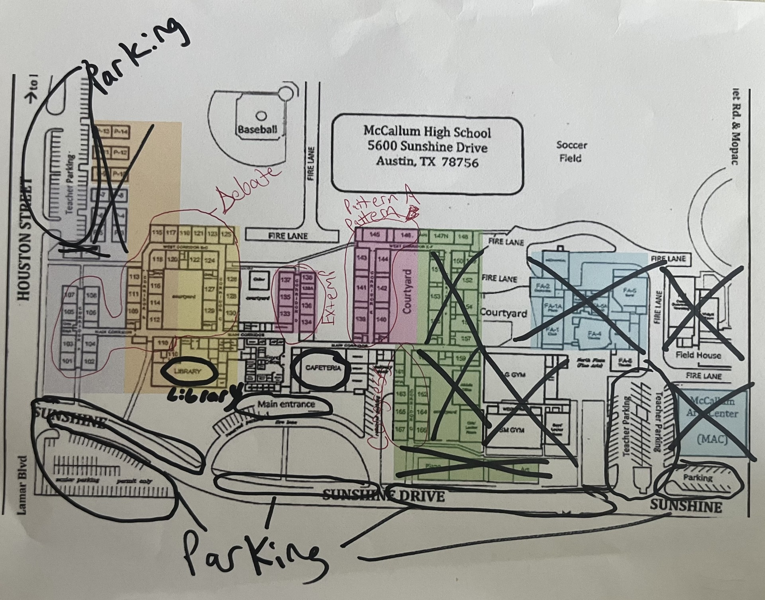

## Debate

8am - All Events Prelim Round 1

10am WSD Prelim Round 2 Draw

10:30am LD/PF/CX Prelim Round 2

11:00am WSD Prelim Round 2

1pm All Events Prelim Round 3

3:30pm LD/PF/CX Prelim Round 4

5:30-5:45pm All Events Verification Period

6pm All Events Elimination - Quarters/Semis

7pm LD/PF Elimination - Semis/Finals

7:30pm WSD Elimination - Finals

8pm CX Elimination - Semis/Finals

8pm LD/PF *(if necessary)* Finals

9:45pm CX *(if necessary)* Finals

## Congress

10am Prelims

1:45-2pm Verification Period

3:30pm Finals

## Extemp

8am Prelim Round 1 Draw

8:30am Prelim Round 1

1:30pm Prelim Round 2 Draw

2pm Prelim Round 2

3:45-4pm Verification

7pm Elimination - Semis/Finals Draw

7:30pm Elimination - Semis/Finals

8:30pm *(if necessary)* Finals Draw

9pm *(if necessary)* Finals

## Pattern A - INFO, DI, PRO, POI

9am Prelim Round 1

12pm Prelim Round 2

3pm Elimination - Semis/Finals

6pm *(if necessary)* Finals

## Pattern B - OO, HI, POE, DUO

10:30am Prelim Round 1

1:30pm Prelim Round 2

4:30pm Elimination - Semis/Finals

7:30pm *(if necessary)* Finals