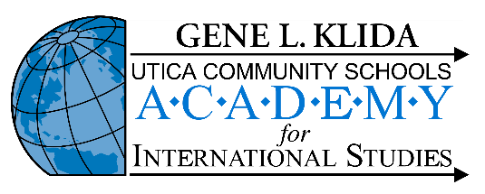
UAIS Phoenix Debate ONLINE Tournament
November 16, 2024

You and your team are invited to attend the UAIS Phoenix Debate Tournament on November 16, 2024. In a one-day online tournament, we will be offering both Congressional and Public Forum Debate.

Use this DOC LINK during the tournament for Schedule, Zoom Links, and Updates.

CONGRESSIONAL DEBATE:
Saturday-only tournament for Novice and Varsity—we will use MIFA invitational rules. There will be 2 preliminary sessions and a Super Session. Bills are due to christopher.kuhlman@uticak12.org no later than MONDAY, November 4, at 5:00 PM so that we can get the packets back to registered schools by Friday, Nov. 8. We will supplement the bills received with the NSDA November Congressional Legislation. Each school attending the tournament MUST submit at least one bill. Schools may enter up to 3 bills, but we can’t promise we’ll use all three of them. Please indicate whether or not the student has PO experience. One judge is required for every 8 entries. All judges are required to judge one round beyond the team’s elimination. We will give speaker awards in each division.

PUBLIC FORUM:
Saturday-only tournament for Varsity, Novice, and Middle-Level Divisions using MIFA rules. If we don’t have enough Middle-Level teams, they will be added to the Novice Division for prelims and have a breakout Final Round during the Semi-Final time slot. The topic will be the NSDA Nov/December topic:
Resolved: The United States should substantially reduce its military support of Taiwan.

We will offer 4 preliminary rounds with appropriate elimination rounds based on entries. One judge is required for every 4 debaters—lay judges are preferred. All judges are required to judge one round beyond the team’s elimination. We will give elimination and speaker awards based on entries.

Judges:
We will have minimal judges available for hire if necessary, so please ask early so we can accommodate you accodingly. One day hired judges will cost $100.

Fees:
Public Forum units will be $30 per 2 person team
Congressional/Legislative entries will be $10.00 per student.MAKE CHECKS PAYABLE TO Holt Public Schools or use PayPal to bcurrin@hpsk12.net

Entry:
The only way to enter is by using Tabroom. The deadline for entry is Tuesday, November 12th. All fees and judge commitments will be finalized by 5:00pm.

Forfeit:
We hope to run on time; if your students and/or your judges are not in their rounds by 15 minutes past the scheduled time for the round to begin, the students of the offending judge or team will be forfeited.

Saturday Congressional:
7:30-8:00 Registration in Commons
8:15 General Meeting in Commons
8:30-10:15 Round I
10:30-12:15 Round II
12:15-12:45 Lunch
1:00-2:30 Super Sessions Round
3:15 Awards

Saturday Public Forum
7:30-8:00 Registration Legislative/PF
8:15 General Meeting in Commons
8:45 Round 1
9:45 Round 2
11:00 Round 3
12:00 Lunch
12:45 Round 4
2:00 Award and Elimination Announcements
2:30 Semis (breakout final round for Middle Level if necessary)
4:00 Finals

