November 16-17 Viking Classic Debate Tournament
Hosted by Western Washington University, Bellingham WA.
Oct 1, 2024
Dear colleagues and friends,
We would like to cordially invite you to the Fall 2024 Viking Classic Debate Tournament, hosted by Western Washington University. Please join us in Bellingham, Washington for a weekend of debates and the beauty of the Salish Sea and North Cascades. Can’t travel? Join us on zoom!
This invite contains the key parameters for our schedule, the cost of the event, and how to register. More specific details will be provided to registered participants as the event draws closer, but we wanted to highlight the unique elements of our event and the key “need-to-knows” in this invite:
- Mode: This is a “hybrid” event that will accommodate online-participation for judges, students, and guests who cannot join in Bellingham. Tournament tabbing may seek to prioritize shared modality matchups depending on total entries.
- Tournament Structure: This is a CARD debate tournament and will use the activity’s standard format with 5 rounds of competition and a showcase debate in the junior and senior divisions.
- Awards: The event will conclude with an award ceremony that recognizes student performance in debate across CARD’s 3 areas of student performance, as well as awards for showcase participants.
- Fees: Fees will be charged to schools participating in the debate tournament to offset the costs of tabulation and contribute towards event costs, such as food and awards.
- COVID: All participants are considered guests of WWU and must comply with the university’s established COVID and public health policies during the event. Currently, the campus does not require that visitors are vaccinated, and the wearing of masks is optional. We ask that you abide by the CDC’s guidelines for isolation or quarantine if you are experiencing COVID-like symptoms or have tested positive.
If there are questions, do not hesitate to contact event organizer Dr. Travis Cram at Travis.Cram@wwu.edu.
Best wishes from the Western Debate Union,
Travis Cram (DoF, WWU) Korry Harvey (ADoF, WWU)
Tramanh Dao (Assistant, WWU) Carter Henman (Assistant, WWU)
Tournament Registration
Tournament entries: Debate programs can register for the tournament on Tabroom.com at the following link: http://westernpnw.tabroom.com
Deadline- initial entries and party size: November 11 (Monday), 5 pm PST.
Deadline- judging/entry adjustments (fees locked): November 14 (Thursday), 5pm PST.
Schedule for tournament fees:
School registration fee $55
Debate team fee $90
Uncovered judging fee $200
Fees can be paid via credit card at: https://commerce.cashnet.com/WWU_DebateX
We will work to find quality in-person judges, but please plan on covering your entries. Reach out to us if you anticipate a challenge.
Tentative Event Schedule
Saturday November 16 | Time (by time zone)
Event | PST | MST | CST | EST
Light Breakfast & Coffee | 8:00 | 9:00 | 10:00 | 11:00
Debates: Round 1 Pairing | 8:30 | 9:30 | 10:30 | 11:30
Debates: Round 2 Pairing | 10:30 | 11:30 | 12:30 | 1:30
Lunch break | 12:30 | 1:30 | 2:30 | 3:30
Debates: Round 3 Pairing | 1:30 | 2:30 | 3:30 | 4:30
Debates: Round 4 Pairing | 3:30 | 4:30 | 5:30 | 6:30
Sunday November 17 | Time (by time zone)
Event | PST | MST | CST | EST
Light Breakfast & Coffee | 8:00 | 9:00 | 10:00 | 11:00
Debates: Round 5 Pairing | 8:30 | 9:30 | 10:30 | 11:30
Snack break | 10:30 | 11:30 | 12:30 | 1:30
Showcase Debates | 10:45 | 11:45 | 12:45 | 1:45
Awards (15 minutes) | 12:45 | 1:45 | 2:45 | 3:45

Relevant Campus Details

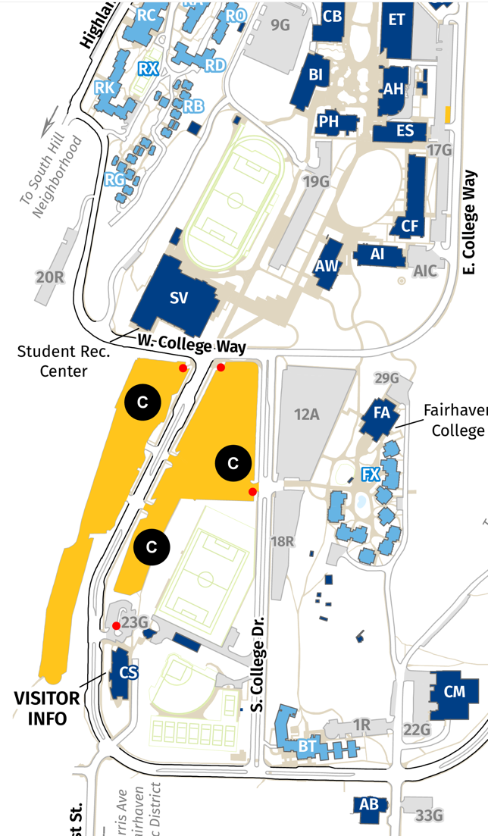
Event Location and Parking
Events will primarily occur on the south end of campus in the Communications (CF) and Academic West (AW) buildings. WWU does enforce restrictions on parking 24/7, but parking is free on the weekend in the C Lot (approximately 5-minute walk to events).

Wireless Access: WWU has fast, reliable guest internet access. It does not require a password. Connect your computer to “WWUwireless-Guest” and agree to the terms in the dialog box. More information on trouble-shooting a connection or how to contact our tech support office is here.

Campus common sense: Please communicate two important things to your participants: First, don’t touch technology or move anything in the classrooms other than seats. That includes unplugging things. Second, students, coaches, and judges need to constantly police each other in keeping campus clean! Make sure trash goes in trash cans, and recyclables and compostables go to their correct bins. Classroom seats should be placed back as they were found and all trash removed after each competition. We regard our participants as some of the finest students on campus, and that should also show up in how little work we create for custodial crews. Additionally, WWU Debate will be on the hook for thousands of dollars in custodial cleaning if we cannot abide by pretty basic common sense.

Lodging options: There will not be a central tournament hotel. There are a number of hotels within a 5-15 minute drive of campus. If this is your first time to Bellingham for the competition and you would like recommendations (or warnings of places to stay away from), contact us directly.

Campus Maps and Directions to Campus: We’d guess most of you will simply consult your GPS.

Debate Tournament Format and Details

Debate Tournament Event Description:

Collegiate Advocacy Research & Debate (CARD) uses a format that seeks to produce a student-centered debate experience that is rooted in evidence and rigor and yet accessible and realistic for students with increasing demands on their time, resources, and attention. There are four major goals the format hopes to achieve. First, it seeks to immerse students in scholarly literature related to pressing social and political controversies. Second, it seeks to develop student skill in building, testing, and critiquing arguments synthesized from that literature and honing their ability to do so in front of a diversity of educated audiences. Third, it seeks to develop skills related to critical and strategic thinking. Finally, the format emphasizes the educational and social benefits of forensics through community-building and a deemphasis on some traditional facets of tournament debating.

The event utilizes a collectively sourced article library of scholarship that has been cultivated by participating students and coaches, traditional policy debate speech sequences with shorter times, and a communicatively centered theory of argumentation to guide debates. A full description of the event and its theoretical norms are located here. It is worth nothing that the norms described therein are not intended as a set of exhaustive rules that speak to what students may or may not do, but rather a set of aspirational norms that reflect the goals of the activity.

Resolution:

The CARD 2024-2025 resolution focuses on the issue of national climate policy mechanisms to reduce greenhouse gas emissions in the United States. The Viking Classic will use the most recent topic and library at the time of the event, published at https://www.westerndebateunion.org/topics

Article Library Details & Guidelines:

CARD debates utilize a collectively built community library as the sole sources of quotable evidence. The library, including links to full-text articles, can be located at: https://www.westerndebateunion.org/cardlibrary

Participants can utilize any portion of any article listed in the established article library.

