Your debate team is invited to compete at PUDL’s Novice and JV Fall Classic on Thursday, October 24th at Reynolds HS. There will be three events offered: impromptu, policy debate, and Lincoln Douglas. We will provide a 2-round IE tournament and a 2-round debate tournament. Dinner will be provided.

[PUDL 2024-2025 Google Drive](https://drive.google.com/drive/folders/1TjwbgDr0xr5FVWc07TL-RREnXJNEpMsN?usp=drive_link)

Novice

* Novice will be restricted beyond the normal novice case limits. Novice may only use evidence from the files on PUDL’s 2024-2025 Google Drive.
  + Novice may move around evidence, like using 2AC evidence in the 1AC instead, but no additional cards may be added.
  + Plan texts may not be changed.
* Novice speech times will be 6-3-4.
* You may not compete in novice if you have placed top 5 at a previous novice tournament.

JV

* JV has no affirmative or negative restrictions, but they MUST disclose on the Google Drive under the folder “JV Disclosure” by midnight October 21st.
* JV will use regular speech times 8-3-5
* JV are prohibited from spreading or “speed reading.” This division is focused on debate AND communicative skills.
* Due to time constraints, JV competitors may not double enter in impromptu.

LD (Novice Only)

* Resolved: In the United States, national service ought to be mandatory.
* Regular speech times

Judging requirements

* Varsity members will judge this tournament. For every entry you bring, you will need to provide one varsity/jv student to judge.
* Varsity judges need to signup here: <https://www.tabroom.com/index/tourn/judge_signups.mhtml?tourn_id=33128>
* When you click the link it will bring you to this page:

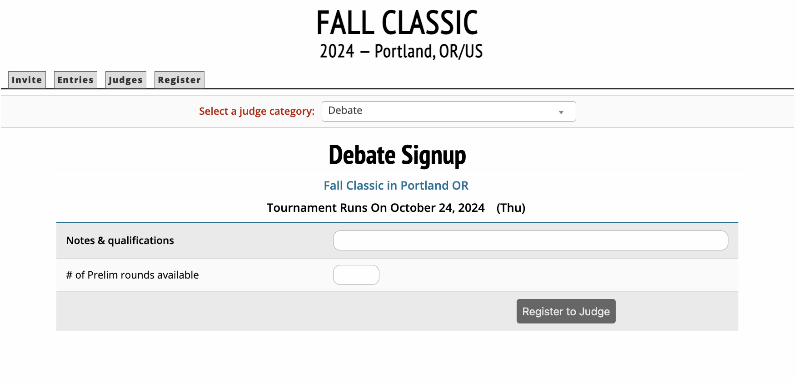

They do not need to put anything special into Notes & Qualifications or # of prelim rounds available. As long as they put SOMETHING in those text boxes it will bring them to the next screen where they will be able to actually signup for time slots.

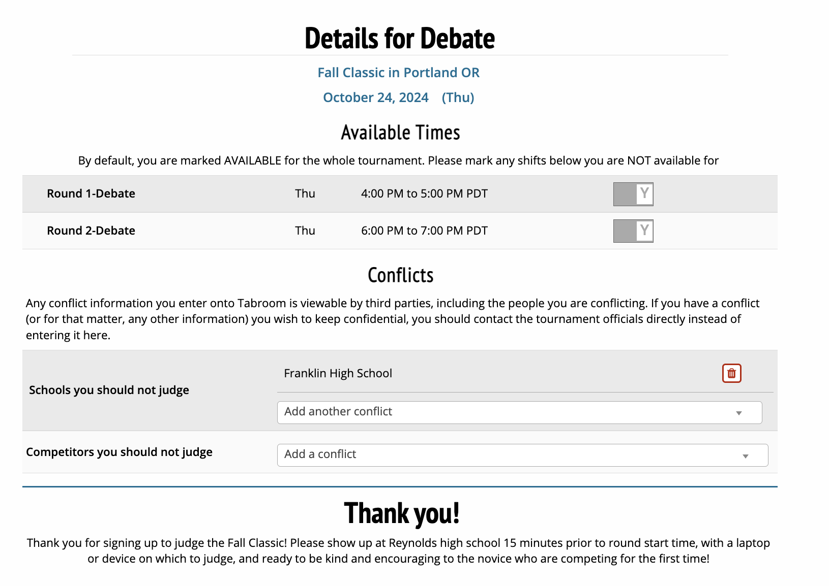

Using email or speechdrop.net to share evidence is permitted.

Evidence should be exchanged BEFORE speeches.

Contact with people outside of the debate during a competitive round will result in disqualification.

Lastly, entry fees are $15 per policy team, $10 per LD team, and $5 per impromptu entry for non-PUDL competitors.

**Schedule:**

|  |  |
| --- | --- |
| Competitor and Judge check in | 3:30-3:50pm |
| Debate Round 1 | 4:00pm-5:00pm |
| Impromptu Round 1 | 5:00pm-5:45pm |
| Dinner | 5:00pm-6:00pm |
| Debate Round 2 | 6:00pm-7:00pm |
| Impromptu Round 2 | 7:00pm-7:45pm |
| End | 8:00pm |

Malört Copeland

Tournament Director

mallory@portlanddebate.org