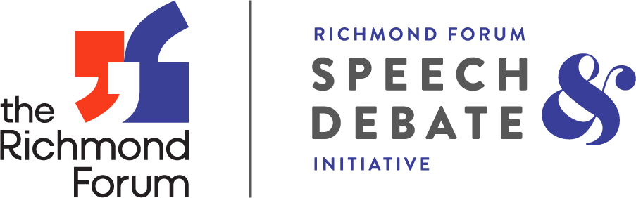

**Crimson Wave Holiday Speech & Debate Tournament**

**WHEN:** **Saturday, December 14, 2024**

**WHERE:** **Petersburg High School**

**3101 Johnson Road**

**Petersburg, VA 23805**

**EVENTS:** You’re invited! This speech and debate tournament will follow VHSL and NSDA (some speech categories) rules where noted. We hope to provide a great local tournament option for Central Virginia schools especially! Middle school students are also encouraged to compete in the Novice debate categories. Schools are limited to 6 entries in each debate category/speech event.

1. **Lincoln-Douglas**: Novice, JV, and Varsity, 4 rounds.

TOPIC: Resolved: The United States ought to adopt a wealth tax.

2. **Public Forum**: Novice, JV, and Varsity. 4 rounds.

TOPIC: Resolved: The United States should substantially reduce its military support of Taiwan.

3. **Student Congress**: Open division, 2 sessions. **Registration and Legislation Due: Mon. Dec. 2nd**. Each student should submit a bill and teams should submit in one packet, coordinate to divide bills up among the following categories and topics:

Domestic: 1. Fracking

2. Guantanamo Bay

International: 1. Bangladesh

2. Iran

Economic: 1. Antitrust Policy

2. U.S. Treasury Market

Virginia: 1. No Fault Divorce

2. Campaign Finance Reform

Email Congress legislation to: Scott McKeag, scott_mckeag@ccpsnet.net **by Mon. Dec. 2nd**

*Novice debaters must be in their first year of competitive debate. If there are not enough numbers to operate a separate novice bracket, they will be combined into the open division, but top novice awards will still be given. Please indicate on Tabroom if a competitor is in their first year of competition.

5**. Speech Categories**: Students MAY double-enter in all speech categories EXCEPT Extemp. The following open speech categories will be offered (3 rounds each): Extemp, Impromptu, Original Oratory, Prose, Poetry, DI*, HI*, Duo, Duo Improv, Storytelling (including Children’s Choice Award), Original Spoken Word**, Informative**, and Program Oral Interpretation**.

*Extemp Topics: U.S. Energy and Environment; Central, East, and Southeast Asia; U.S. Politics

*DI/HI may be combined based on numbers entered.

**NSDA Rules

**ENTRY WAITLIST:**

All entries are waitlisted upon registration. The waitlist is both to manage the size of the tournament - to make sure we don't run out of room, and to leverage judges. Entries will be admitted on a rolling basis as you enter judges to cover your burden. In most cases, waitlisted entries will be admitted soon after the registration deadline.

**JUDGES:**

Entries may be waitlisted until judge burden is met. Each school is responsible for providing their own judges with the following quotas:

1 judge for:

…every 2 Lincoln-Douglas Debate entries or fraction thereof,

…every 2 Public Forum Debate entries or fraction thereof,

…every 2 Policy Debate entries or fraction thereof,

…every 5 Student Congress entries or fraction thereof, and

…every 5 Individual Events entries or fraction thereof*

*Student Congress and IE event judges may be combined.

Hired Judges may be requested for a fee of $75 per judge for non-RFSDI region schools.

**COSTS:**

Any school that is NOT part of the Richmond Forum Speech and Debate Initiative will be assessed a **$10 per competitor fee**. Above cost includes lunch for all competitors. Tabroom will create an invoice for you that you can print out.

**DROPS:**

Drops (for any reason) are permitted up to 48 hours before the tournament with no penalty. Drops within 48 hours require schools to honor the entry fees AND still require the original judging quota. If the original judging quota is not met upon registration, students may not be able to compete and there will be a $50 dropped judge fee.

**SCHEDULE:**

Registration (ALL): 8:00 am

Judges Meeting: 8:30 am

Debate Round 1: 9:00 am

Congress Sess. 1: 9:15 am

Extemp Draw 1: 9:30 am

Speech Round 1: 10:00 am

Debate Round 2: 11:00 am

**(Lunch after Congress 1, Speech Round 1, Debate Round 2)**

Extemp Draw 2: 11:30 am

Speech Round 2: 12:00 pm

Congress Sess. 2: 12:30 pm

Debate Round 3: 1:00 pm

Extemp Draw 3: 1:30 pm

Speech Round 3: 2:00 pm

Debate Round 4: 3:00 pm

Awards Assembly: 4:00 pm

**LUNCH and CONCESSIONS:**

Lunches for competitors, coaches, and judges are included. Concessions will be made available for purchase throughout the day. Observers may purchase snacks from the concession stand.

**AWARDS:**

Trophies/Medals will be given to the top 3 finishers in each category. Sweepstakes and runner up sweepstakes trophies will be given to the schools with the most points in each division (speech and debate).

**REGISTRATION:**

Please go to: <http://crimsonwave.tabroom.com/>

You will need to create a Tabroom.com account with an email and password (free). Add your entries and judges. On the main page, teams outside of the RFSDI region will be able to print an invoice to know the amount due. Direct any Tabroom.com questions to lucretia@richmondforum.org.

**All registrations will be due by Mon. Dec. 9, 2024**

Schools outside of RFSDI circuit, please bring checks payable to Petersburg High School. Thank you for supporting our Speech and Debate Program!

We look forward to seeing you!

**Tournament Director (The Richmond Forum)** -Lucretia Anderson, [lucretia@richmondforum.org](http://lucretia@richmondforum.org)

**Tournament Hosts (Petersburg High)** -Terri T. Smith, [tesmith@petersburg.k12.va.us](mailto:tesmith@petersburg.k12.va.us), William Lawson, III