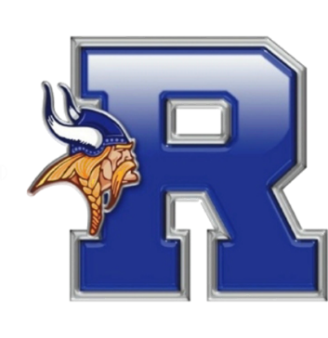

**Fortnir’s Challenge**

***Ripley High School***

***January 25, 2025***

Dear Associates:

I am pleased to invite you to Fortnir’s Challenge, our inaugural Speech and Debate Tournament, which we have named for Fortnir, the god of debate and compromise in Viking mythology.

**Where:** Ripley High School

**When:** Saturday, January 25, 2025

**Time:** Schedule and any updates will be posted on Tabroom

**Entries Due:** Tuesday, January 21, on Tabroom.com by 5:00 PM

Fortnir’s Challenge will feature three rounds of competition with awards being given based upon the number of entries in each event per WVSDA guidelines. Sweepstakes awards will be presented to the top 3 schools.

**Section A Events**

Impromptu, Prose, Informative Speaking, Humorous/Dramatic Interp (HI/DI), Broadcasting, Programmed Oral Interp, Public Forum Debate

**Section B Events**

Extemp, Poetry, Declamation, Original Oratory, Dramatic Duo, Lincoln-Douglas Debate, SPAR Debate

Students may enter two events in Section A and two events in Section B with the following exception: Debaters may not double enter in the same section as their debate event(s).

**Impromptu Topics**

Round 1 = Ordinary Things

Round 2 = Abstract

Round 3 = Quotations

**Broadcasting Rounds**

Round 1 = Prepared TV news (No preparation time)

Round 2 = TV news (15 minutes of preparation time)

Round 3 = Edited Radio news (30 minutes of preparation time)

**Debate Topics**

Public Forum Debate and Lincoln-Douglas Debate topics will be the NSDA topics for Jan/Feb 2025 and will be posted on Tabroom when available

We are looking forward to seeing you in Ripley!

Sincerely,

Kelley Adcock

Ripley High School Coach

[kadcock@boe.jack.k12.wv.us](mailto:kadcock@boe.jack.k12.wv.us)