Damien Campus Map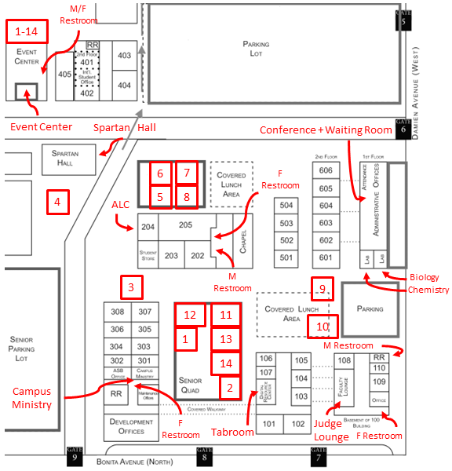
Gym Rooms 1-6 are all in the Athletic Center (south of the parking lot, outside of the map view)
108a and 108b are in the back of 108.
600 Conference and 600 Waiting Rooms are in the bottom floor of the 600 building.

