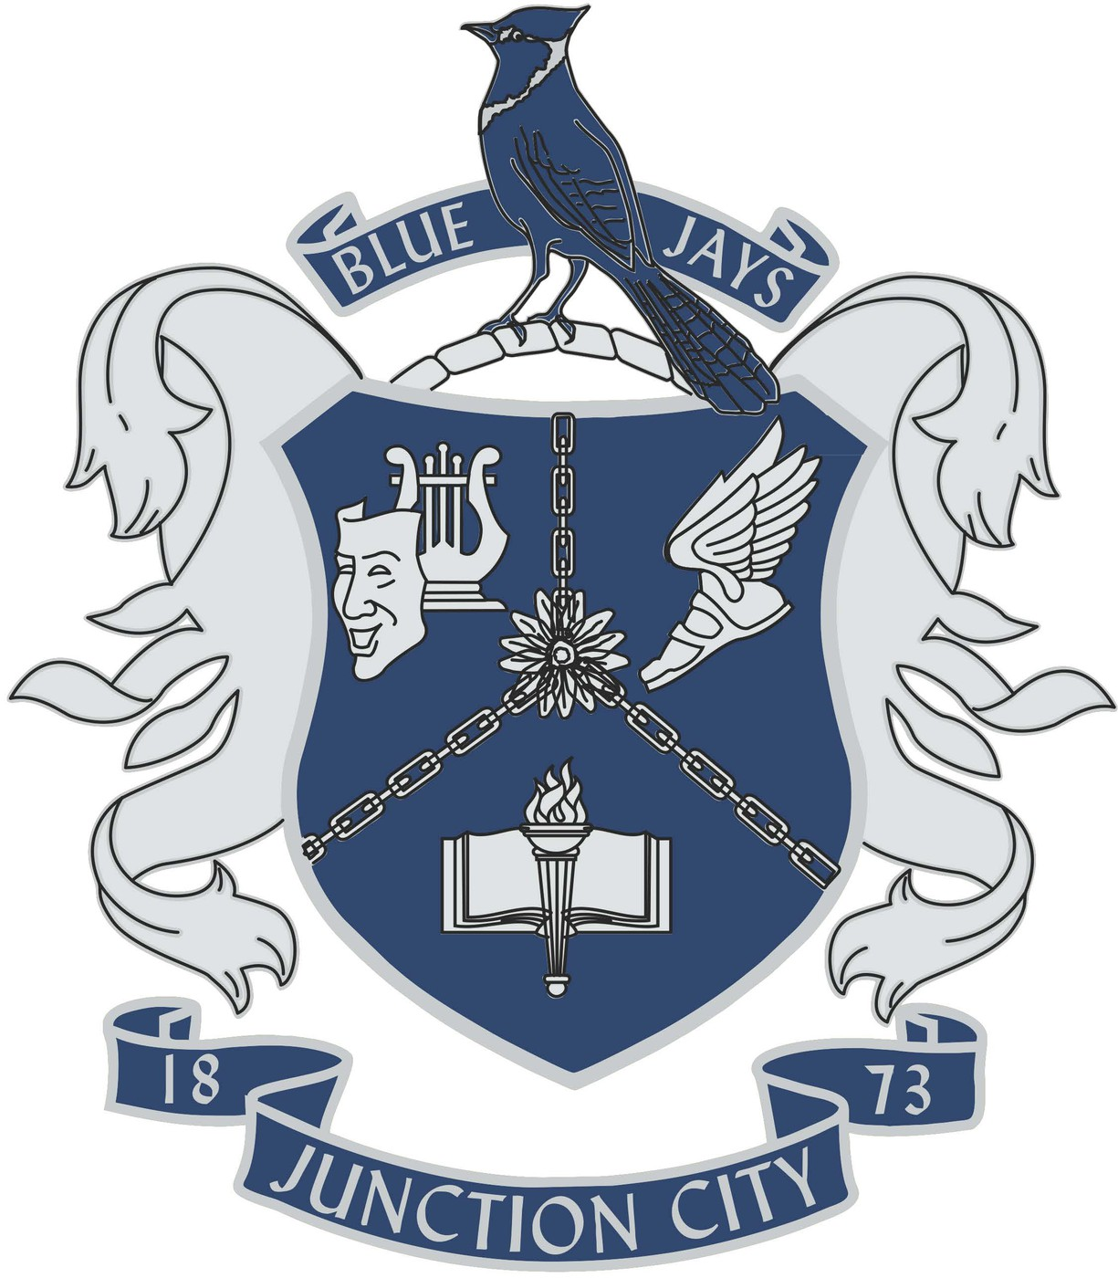
August 2024
Dear Coach,
You and your squad are cordially invited to attend Junction City High School’s “Battle In The Nest” Novice and Open Debate tournament—Saturday, September 21, 2024.
- We will operate on tabroom.com.
- We will accept entries for the first 44 teams. Each school may enter up to 4 teams in any combination. Please let us know if you would like to bring extras. We will accommodate this request on a first-come, first-serve basis.
- We will supply judges, and sponsors will be on standby for judging. Let us know if your sponsors like to judge. Also let us know if your 3rd/4th year debaters wish to judge novice. We welcome their expertise and will use them.
- Sweepstakes awards will be given to the top three squads based on a school’s best three entries. To qualify for sweeps, the school must have an entry in both Open and Novice divisions. Individual medals will be awarded through 6th place in each division.
- KSHSAA rules will be followed.
- The cost per team will be $6.
- The first two rounds will be preset, followed by power-matched rounds.
Schedule:
Registration: 7:30
Round One: 8:00-9:30
Round Two: 9:45-11:15
Round Three: 11:30-1:00
Lunch: 1:00-1:30
Round Four: 1:30-3:00
Round Five: 3:15-4:45
Awards ASAP
Looking forward to seeing many of you on September 21!

John Alfrey
Head Debate/ Assistant Forensics Coach
Junction City High School

