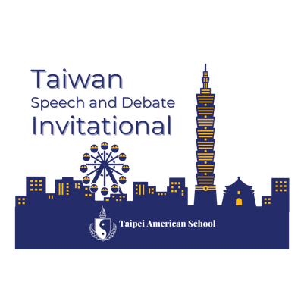

August 3, 2024
Dear Colleagues,

I hope that you have had a restful summer that has recharged you for the year ahead!

We are very excited to welcome so many of you to Taipei in October and hope that even more schools will be able to join us for the Inaugural Taiwan Speech and Debate Invitational from October 11-13, 2024!

With just over 2 months to go, I wanted to answer some FAQ:

- Bids – We have been designated as a finals bid in both Policy and Public Forum and a Top-6 bid in Congressional Debate by the TOC.
- Schedule – The most up to date schedule can be found here: https://docs.google.com/spreadsheets/d/1ph8iW0B7DvwqJDN4anjuE-WQGIavNG7VxUEe_LA0XLw/edit?usp=sharing
- Cultural Day – As a reminder, we recommend teams arrive by the evening of October 9, 2024 in Taipei in order to join us for our cultural day tour on October 10th. I am working with our PTA and Debate parents to finalize the itinerary for this day, but it’s going to be an exciting day of exploration around our beautiful city! Cultural day will be a no-cost experience for you and your students – we will provide transportation and will cover lunch and dinner for everyone joining us.
- Transportation – TAS will be providing bus transportation from Taoyuan International Airport (TPE) to your hotels upon your arrival. In early September, I will send a google form to collect your flight information to schedule those shuttles. TAS will also provide transportation to/from our evening events each night (Shilin Night Market on 10/11, TBD on 10/12, and either Xinyi or Ximending District on 10/13). Outside of the transportation we’re providing, Ubers, Taxis, etc. are all very easy to manage in Taiwan.
- Hotels – There are two hotels that are within walking distance of TAS that we recommend. The Dandy (https://tianmu.dandyhotel.com.tw/en/ ) and The Mellowfields (https://mellowfields.com.tw/en/index.php). We work with these hotels often and can help you book/reserve the rooms you need. Please reach out to me at williamsc@tas.edu.tw with the number of rooms and room types that you will need and I can work with our activities office to reserve those rooms for you. We can also book the rooms through TAS and then just charge your school the amount if that is something that would work better for your program. If you choose to book at another hotel (for example, the Renaissance Shilin or Aloft Beitou if you’re a Marriot person) you would need to figure out your own transportation to/from TAS each day, but Uber, Taxis, etc. are all very easy in Taiwan.
- Meals – TAS will cover both lunch and dinner on the cultural exchange day, as well as lunches on 10/11, 10/12, and 10/13. We will likely also cover a dinner on 10/12. On 10/11 and 10/13 for dinner, we will be taking the students to more public spaces where dinner will be more street food/individual affair, but there will be plenty of inexpensive options for students.
- Currency Exchange/Spending Money – Currently the currency exchange rate is about 1 USD to 32.5 NTD. This will likely fluctuate between 32 and 33 between now and the tournament. Personally, because I’m bad at math, I usually retreat to a 1 to 30 conversion. I am working with my business office to see if it is possible for visiting teams to order a certain amount of NTD that we can order from our school’s bank to ensure that you don’t have to go through currency exchange at the airport – and we can just provide you an envelope with the NTD you pay for in advance. I will have more information on this in a few weeks. Prices in Taipei are either comparable or cheaper than the US – depending on the items desired. Imported items are significantly more expensive than domestic goods – but the amount of spending money for your students will be based on how much they plan to buy as far as souvenirs, etc. While cash is required in some situations in Taipei, most restaurants, shops, businesses, and even taxis will accept international credit cards.

- Language – Taiwan, and specifically Taipei, is very English friendly. Most public signage is in both languages and in my six years living on the island, I can count on one hand the number of situations where I couldn’t communicate efficiently in English or by using Google Translate. I would recommend that everyone on your team download Google Translate and the “Mandarin (Traditional)” language dictionary in the app before arriving.
- Flights – If you need help with finding flights or have questions about the flights you have found, please don’t hesitate to reach out. United Airlines has 2 flights a day to/from Taipei out of SFO and Delta has one flight a day to/from Taipei out of Seattle. Other airlines with flights direct to Taipei are EVA Airways, China Airlines, and Starlux Airlines. Another option that we have used over the years is ANA with a connection in Tokyo. I am here to help – and if I can’t help – I can connect you with our school travel agent who can try to work her magic.

Please do not hesitate to reach out with any questions. We can’t wait to welcome you to Taiwan!

All the best,

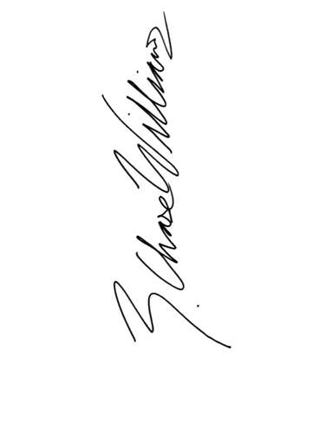

Chase Williams
Director of Speech and Debate
Taipei American School

