Date: Saturday, November 19th, in person at Golda Meir, 227 W Pleasant St, Milwaukee, WI 53212. Up the straight from the Fiserv Forum (Buck’s Stadium).
Topics:
LD and PF will use the November/December Topics
NCX Packet restrictions are lifted, teams but teams must follow all other restrictions.
Divisions: We’re offering all 6 WDCA divisions. If a division isn’t viable on it’s own, we will collapse divisions.
Deadlines: Registration closes at 5 PM on Thursday, November 17th. Judges are due at this time as well.
Judges: 1 for every two entries, or fraction thereof. LD, PF, NCX, and VCX pools will remain separate to the extent possible. We will move judges where necessary and logical. We don’t have any judges available for hire, so please make sure you can find some!
Fees: Policy and PF $30, LD $20. Make checks payable to Golda Meir Debate
Schedule:
Check in begins at 7:30 in Golda Library room 123
PF
Round 1 – 8:00
Round 2 – 9:15
Round 3 – 10:30
Lunch
Round 4 – 12:30
Round 5 – 1:45

LD
Round 1 – 8:00
Round 2 – 9:15
Round 3 – 10:30
Lunch
Round 4 – 12:30
Round 5 – 1:45

CX
Round 1 – 8:00
Round 2 – 10:00
Lunch
Round 3 – 1:00

Awards: to follow at the conclusion of the tournament.
Concessions: We will provide concessions. Please let me know if you have dietary restrictions and we will try to accommodate you.
Key Rooms: Tab room will be in the Library. Students should gather in cafeteria in the bottom level using stairwell 3 or 4. Judge’s lounge will be in second cafeteria. We will have maps available.

Parking and Entrance:
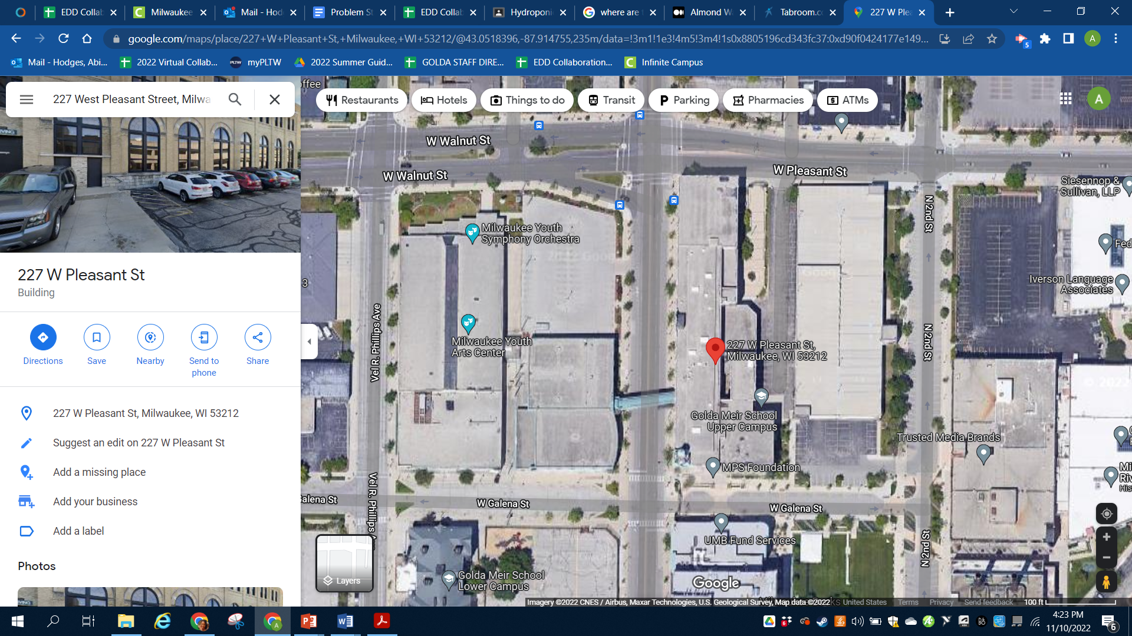  c.  b.  a. | - Street parking is available on MLK Blvd between Walnut St. and Galena.  - Parking Lot available on W. Galena between MLK Blvd and Vel R. Phillips Ave  - Use Front Entrance located in lot just east of MLK Blvd

Questions? Please ask. You can reach me at 414-874-5278 or 816-668-6393 after school hours.

