KCFL Tournament Information 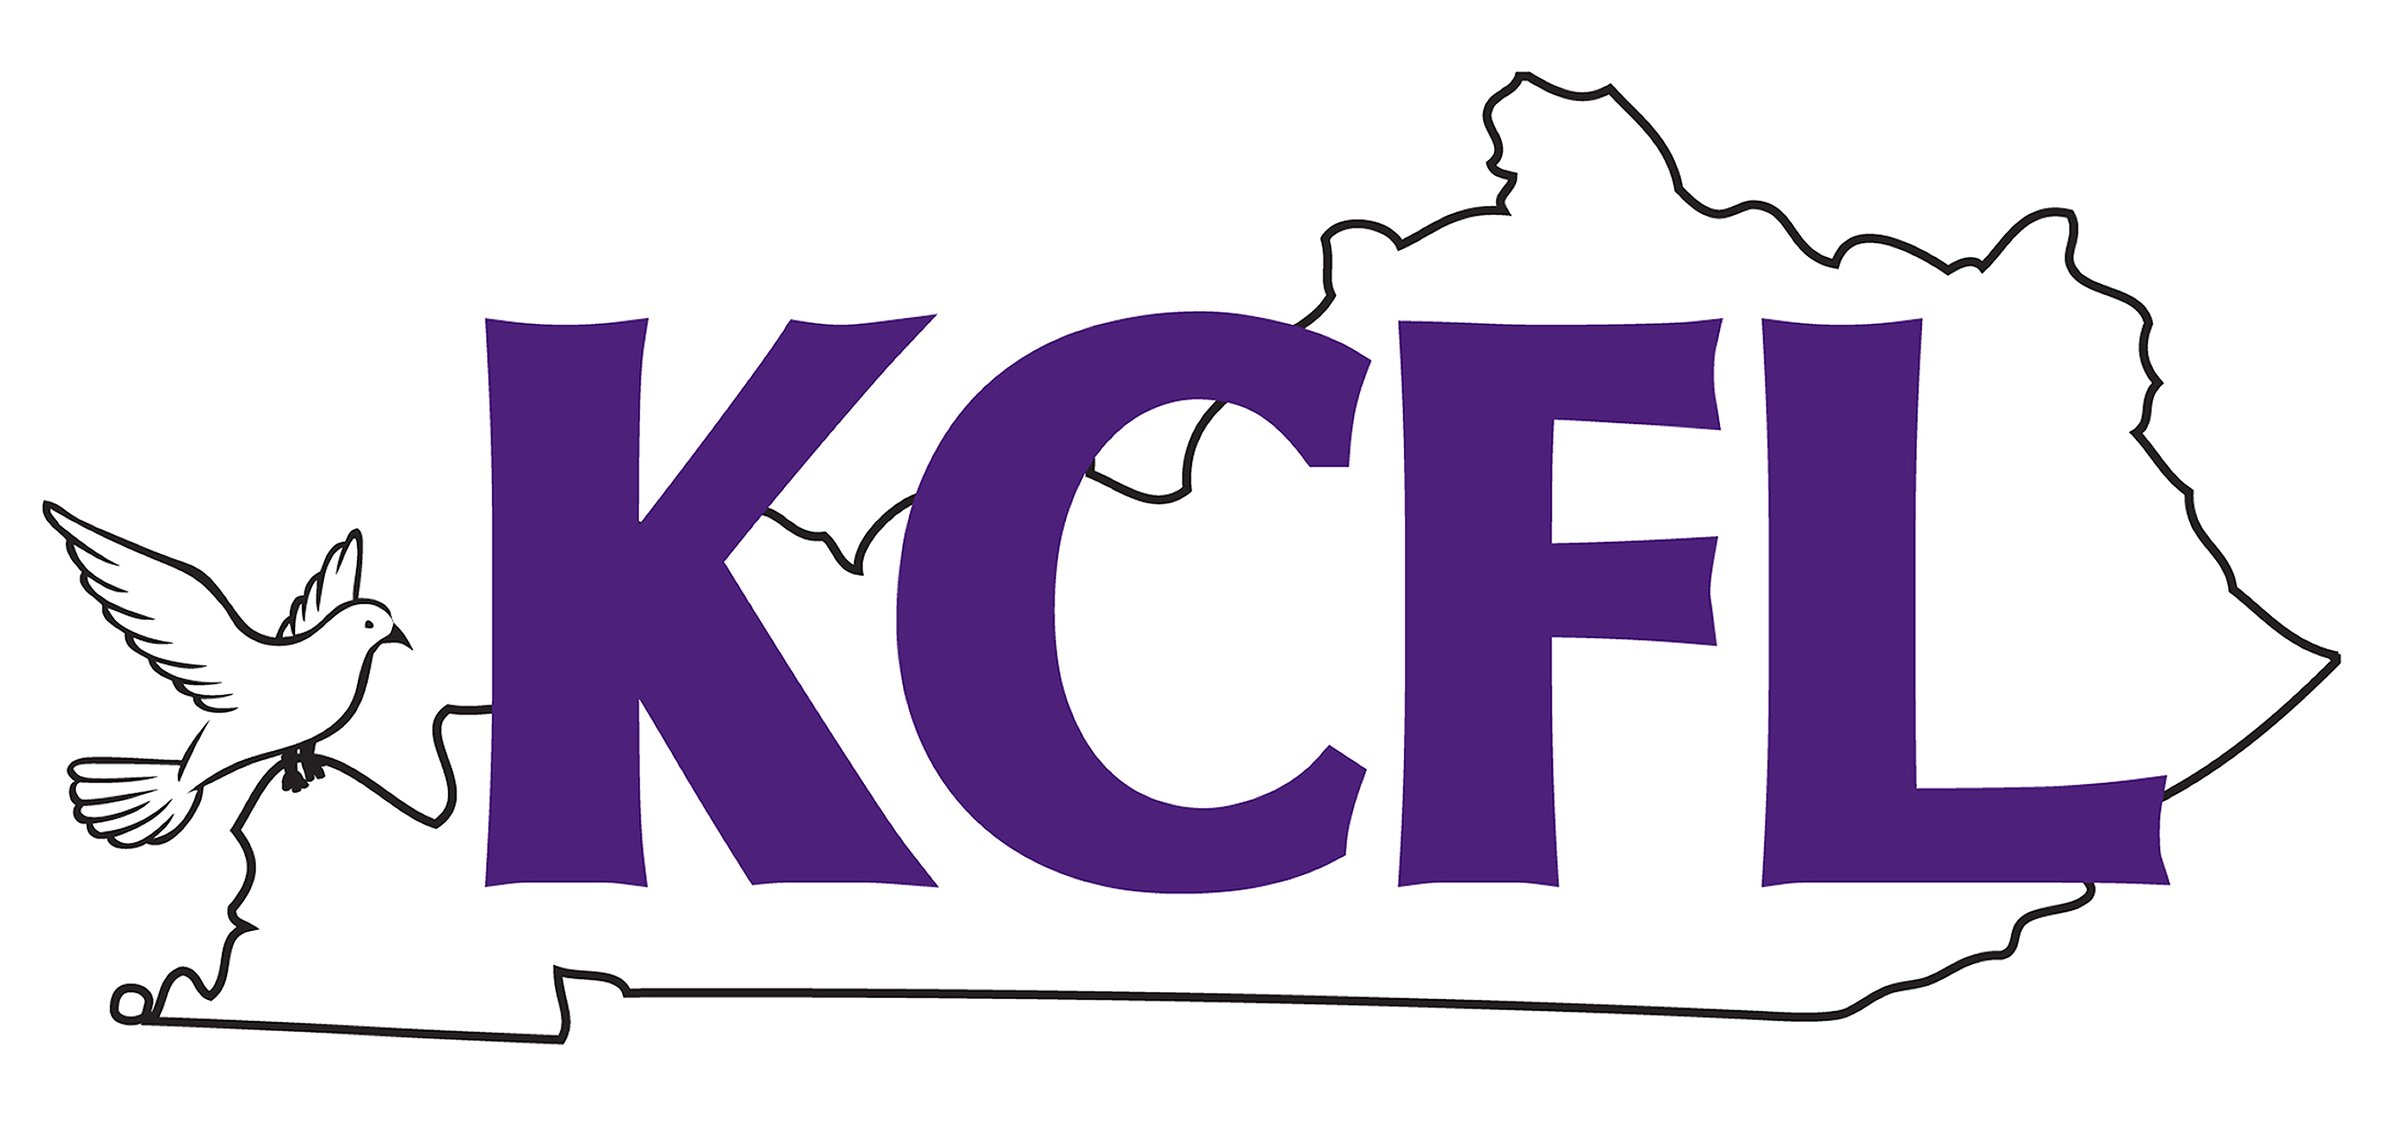

Date: KCFL Qualifier – March 5, 2022 at LaRue County High School
NCFL Grand Nationals – May 27-29, 2022 in Washington, DC

Entry Deadline: Tuesday, March 1, 2022.

Entries: You may bring up to 6 entries in each event. Each individual student entry is $10 (that means that team debate and duo are $20 per entry). Registration is open and available at www.tabroom.com – this is a one-time reduction in costs for KCFL because I know schools are struggling with funds.

Doubling: Students may enter up to two events, but may not double in debate events. For example, a student may enter Congress and Extemp, but may NOT enter Congress and LD. This is not negotiable given our time constraints.

Judges: You must provide
one (1) judge for every six (6) speech entries or fraction thereof
one (1) judge for every two (2) LD Debate entries or fraction thereof
one (1) judge for every two (2) PF entries or fraction thereof
one (1) judge for every two (2) Policy entries or fraction thereof
one (1) judge for every six (6) Congress entries or fraction thereof

Remember that for NCFL Grand Nationals your judge burdens are vastly different:
one (1) judge for every two (2) speech entries or fraction thereof
one (1) judge for every one (1) LD Debate entries or fraction thereof
one (1) judge for every one (1) PF entries or fraction thereof
one and a half (1.5) judge for every one (1) Policy entries or fraction thereof
one (1) judge for every two (2) Congress entries or fraction thereof

Congress Bills Deadline: Monday, February 28, 2022 at 5pm. I will post the complete packet on Tuesday. No bills will be accepted once the deadline has passed.

Fees: Entry Fees - $10 per student
Judge Fees – Hired Judge $50
Dropped Judge $100
Important Reminder: There is no doubling allowed at the national tournament, so a student can only QUALIFY one event; however, students may enter two events at the state qualifier and take the event he/she prefers to nationals (with the caveat that that preference will be indicated in writing before the tournament begins). The preference form is attached at the end of this invitation. Please print as many copies as you need and bring them with you filled out and signed on the morning of the tournament.

Drops: You will be permitted to drop students at no charge until 4:00 p.m. on Thursday, March 3, 2022. I prefer drops to be made via your online entry, but I would also ask that you send me an email to let me know you have made changes to your entry. After March 3, you will have to drop by emailing me, and I will assess a $10.00 drop fee and you will still be charged the original entry fee, as well.

Entries to the Grand National Tournament will be $75.00 per individual student. You may pay me at the conclusion of the tournament, or I can invoice you. Either way is acceptable.

Nationals Reminder: IF a student who qualifies chooses not to attend the national tournament for whatever reason, he/she will not be refunded the entry fee. The final deadline for notifying me that a student will not be attending the NCFL Grand National Tournament is May 10, 2022. There is no excuse for waiting. If you have to drop a student after the final deadline, you will be assessed a $50.00 drop fee in addition to forfeiting the original entry fee. If you drop a judge at the NCFL tournament, and you had better not, there will be a $500.00 drop fee. Students who qualify should go! If students can’t go to NCFL because of graduation or other conflicts, please don’t enter them in the state tournament.

Please visit the NCFL site (www.ncfl.org) as ballots for many of the events have been revised. There are many notable changes, and it is your responsibility to know the rules for your events.

I look forward to seeing you in March, and I strongly urge the new coaches in the league to review the bylaws, rules, and ballots for NCFL at the web site – www.ncfl.org. All coaches should make use of the site to get pertinent hotel information.

Schedule
KCFL State Qualifier
March 5, 2022

Debate Round 1 8:00
Extemp Draw 8:30
Speech Round 1 9:00
Congress Session 1 9:30
Debate Round 2 10:00
Extemp Draw 10:30
Speech Round 2 11:00
Congess Sesson 2 11:30
Debate Round 3 12:00
Extemp Draw 12:30
Speech Round 3 1:00
Congress Session 3 1:30
Debate Round 4 2:00
Extemp Draw 2:30
Speech Round 4 3:00
Congress Session 4 3:30
Awards 5:00or ASAP

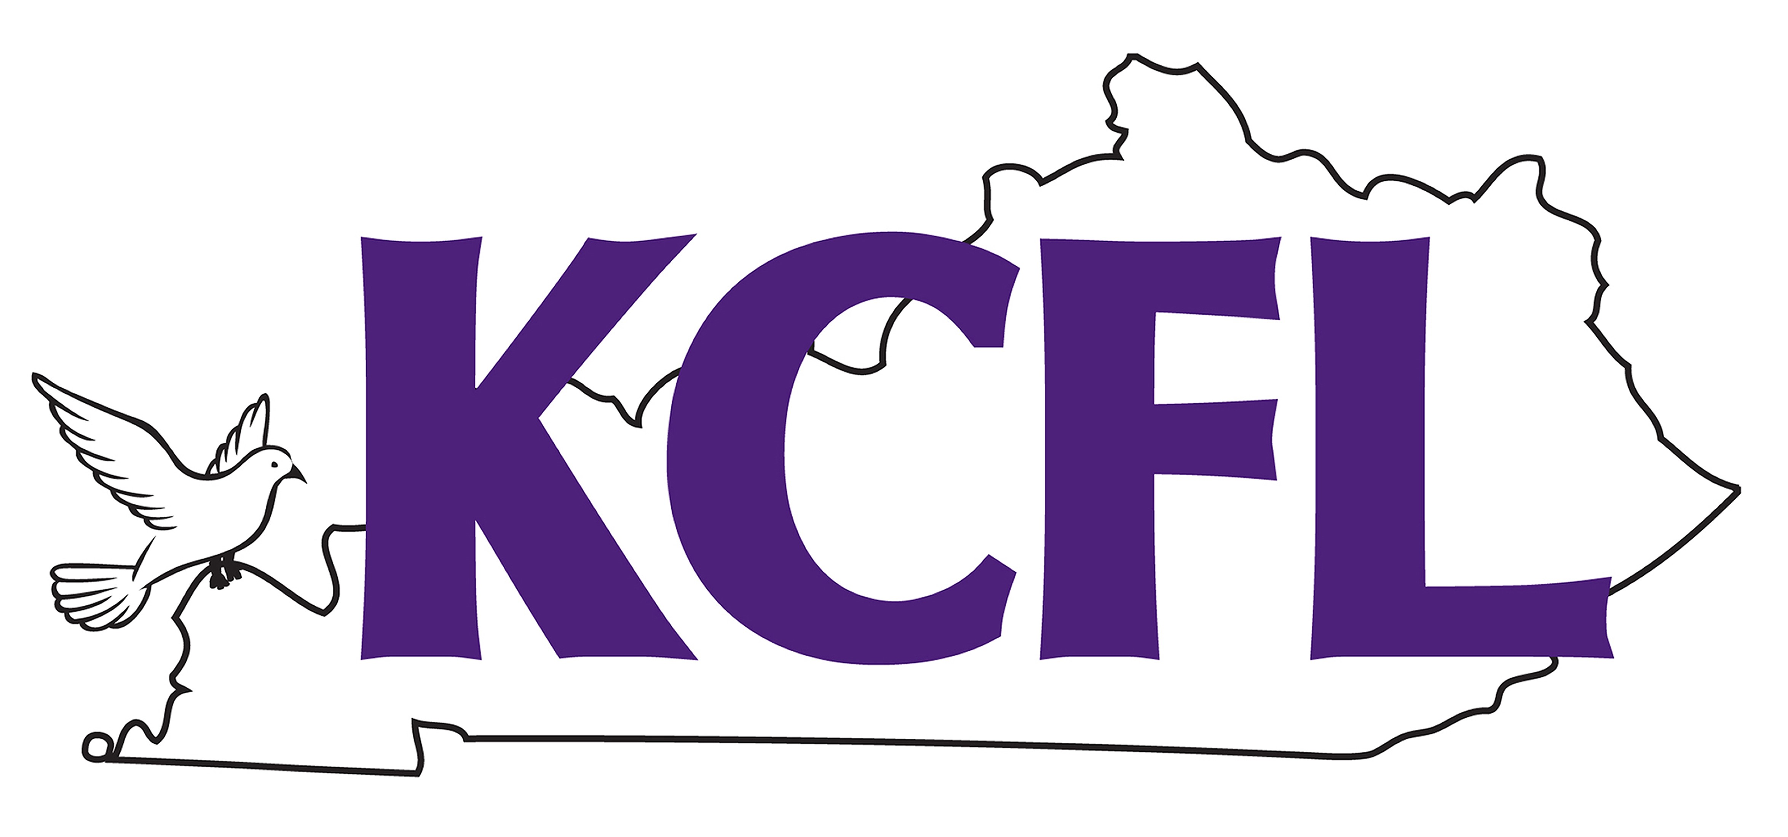
Kentucky Catholic Forensic League
LaRue County High School
925 S. Lincoln Blvd.
Hodgenville KY 42748
Phone 270-358-2210 Fax 270-358-9469
Katy Blair Cecil – Moderator
Rosemary Cundiff-Brown – Tournament Director

Event Preference Signature Page

March 5, 2020

Student Name ____________________________
(please print)

School ___________________________________

I prefer to attend nationals in the following event ______________.

________________________
Student Signature

________________________
Coach Signature

