6/2/2021
Collegiate Public Forum League Policies & Procedures – 6/2/2021
Policies & Procedures Manual
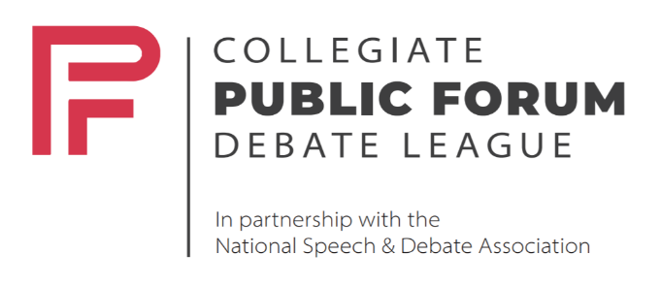
www.collegepublicforum.org
Table of Contents
1.0 Logistical Information 2
1.1 Dates 2
1.2 Topics 2
1.3 Tournament Schedule 3
1.4 Registration 4
1.5 Navigating Online Tournaments 4
2.0 Procedures 6
2.1 Format 6
2.2 Tournament Procedures 8
2.3 Pairing Process 9
2.4 Petitions and Ombuds 9
3.0 Evidence 11
3.1 Role of Coaching 11
3.2 Evidence and Ethics Challenges 11
3.3 Evidence Norms 12
3.4 Evidence Exchange Expectations 15
3.5 Eligibility 16
4.0 Judging 18
4.1 Procedures 18
4.2 Judge Philosophy 19
4.3 Training 20
5.0 Outside Assistance 21
6.0 Discrimination and Inclusion 23
6.0.1 Equity Policy 23

1.0 Logistical Information

1.1 Dates

1.1.1 Topics

Fall Topic Release | August 15, 2021
Spring Topic Release | December 15, 2021

1.1.2 Instruction

Novice Classes | Registration: August 1, 2021; Classes Begin the First Week of September
Student Ambassador Program | Rolling Registration; Meetings Begin the First Week of September

1.1.3 Tournament Schedule

Season Opener | October 9-10, 2021
Mid-Fall | November 13-14, 2021
Fall Championship | December 11-12, 2021
Spring Opener | February 5-6, 2022
Mid-Spring | March 13-14, 2022
National Championship | April 10-11, 2022

1.2 Topics

The College Public Forum League will release two topics for the 2021-2022 season. The CPFL will use a domestic and international topic area rotation.

The first topic will be used for tournaments in October, November, and December. The second topic will be used for February, March, and the National Championship in April.

The first-semester topic will be released on August 15th and the second-semester topic will be released on December 15th.

1.3 Tournament Schedule

Each tournament will use the following template, subject to modification based on entry size:

1.3.1 Open Division

2 day

Saturday | Sunday
Round 1 - 11:00AM EDT | Elim 1 - 11:00AM EDT
Round 2 - 12:30PM EDT | Elim 2 - 1:00PM EDT
Lunch - 1:45PM EDT | Elim 3 - 3:00PM EDT
Round 3 - 2:15PM EDT | Elim 4 - 5:00PM EDT
Round 4 - 3:45PM EDT | Elim 5 - 7:00PM EDT
Break - 5:00PM EDT
Round 5 - 5:15PM EDT
Awards/Breaks Announcement - 7:30PM EDT
(All 4-1’s and better clear)

1.3.2 Classroom and Novice Division

1 day

Saturday
Round 1 - 11:00AM EDT
Round 2 - 12:30PM EDT
Lunch - 1:45PM EDT
Round 3 - 2:15PM EDT
Round 4 - 3:45PM EDT
Exhibition Breaks Announcement - 6:00PM EDT
Exhibition Debate(s) - 6:30PM EDT
*Open Debaters and Coaches are encouraged to Attend*
Awards/Assembly - 7:30PM EDT

1.4 Registration

Full invitations and schedules will be posted on Tabroom.com.

For more information on how to use Tabroom, please visit https://docs.tabroom.com/Main_Page.

1.5 Navigating Online Tournaments

Online tournaments will occur via NSDA’s Campus platform.

Training materials for using Campus are available for review before the tournament.

An instructional video is available to introduce beginners to online debating.

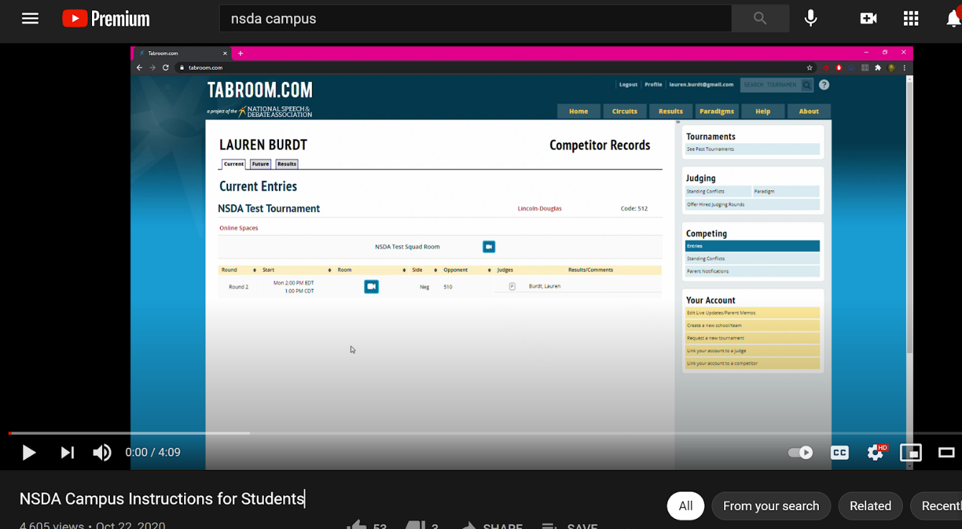

Another instructional video is available for beginners to online judging.

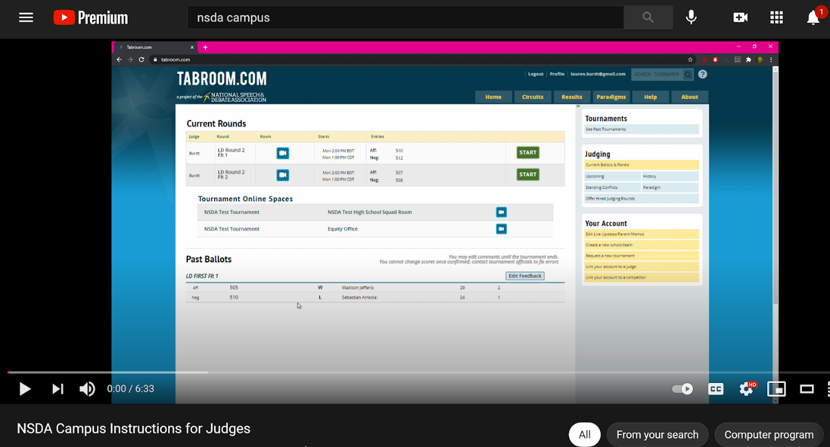

2.0 Procedures

2.1 Format

Except where indicated, the College Public Forum League will follow NSDA format and procedures. The CPFL is committed to the spirit of innovation and in consultation with the National Speech and Debate Association may experiment with reforms to format and procedures throughout the inaugural slate of tournaments. Any modifications to format will be announced at the beginning of each semester with the new topic.

As adapted from the National Speech and Debate Association unified manual:

2.1.1 Resolution

Specific resolutions for tournaments held during the season, including the National Tournament Topic, are available online at https://www.collegepublicforum.org/topics.

2.1.2 Entries

An entry consists of two students from the same school (or hybrid teams from two schools in limited circumstances) each debating both sides of the resolution and advancing on its record. No substitution of debaters is permitted once the tournament has begun.

2.1.3 Procedure

Teams will be notified within 5 minutes after the release of pairing as to which team has won the Tabroom coin flip. The team that wins the flip may choose one of two options: Either the side of the topic they wish to defend (pro or con) or the speaking position they wish to have (beginning or ending the debate). The remaining option (side or speaking position) is the choice of the team that loses the flip. The team winning the flip will have 5 minutes to choose and report their choice to Tabroom, and the team that loses the flip will then be able to report their choice. If the winner does not report their choice within 5 minutes, the first team to report will get their choice, leaving the other option choice to the latter reporter. If one or neither team reports within 10 minutes of the result of the flip, then Tabroom will assign outstanding sides and/or speaking positions for the debate.

Once speaking positions and sides have been determined, the debate begins. The con team may lead, depending on the coin flip results. Following the first two constructive speeches, the two debaters who have given speeches immediately prior will participate in a three-minute "crossfire". In "crossfire" both debaters "hold the floor." However, the speaker who spoke first must ask the first question. After that question, either debater may question or answer at will. After the summary speeches, all four debaters will participate in a three-minute "Grand Crossfire” in which all four debaters are allowed to cross-examine one another. The speaker who gave the first summary speech must ask the first question. The speakers from each team will continue to ask and answer questions. Teams should alternate asking and answering questions, so a balance between teams is achieved. All speakers are encouraged to participate in the Grand Crossfire. Speakers should listen respectfully to opponents’ questions and answers.

2.1.4 Order of Speeches

Team A, First Speaker---4 minutes
Team B, First Speaker---4 minutes

Crossfire---3 minutes

Team A, Second Speaker---4 minutes
Team B, Second Speaker---4 minutes

Crossfire---3 minutes

Team A, First Speaker, Summary---3 minutes
Team B, First Speaker, Summary---3 minutes

Grand Crossfire---3 minutes

Team A, Second Speaker, Final Focus---2 minutes
Team B, Second Speaker, Final Focus---2 minutes

2.1.5 Other Debate Time

Each team is allotted a total of three minutes of prep time, which can be used before any speech in the debate.

If debates occur utilizing an online platform, each team shall be allotted ten total minutes of tech time. This time is exclusively for resolving uniquely online tech-related problems (e.g., internet connection, audio/video issues). Tech time should not be used as additional standard prep time. If the time elapses before the team can resolve the issue within the official tournament platform, they will forfeit the debate. In the event a speech needs to be redelivered entirely or in part, the time for that should count as tech time for the team experiencing the problem. If their tech time runs out while giving the speech, the remaining time should be deducted from prep time. Judges should notify tab staff immediately if Tech Time is invoked.

2.1.6 Plans/Counterplans

In Public Forum Debate, the Association defines a plan or counterplan as a formalized, comprehensive proposal for implementation. Neither the pro or con side is permitted to offer a plan or counterplan; rather, they should offer reasoning to support a position of advocacy. Debaters may offer generalized, practical solutions.

2.1.7 Prompting

Oral prompting, except time signals, either by the speaker's colleague or by any other person while the debater has the floor, is discouraged though not prohibited and may be penalized by some judges. Debaters may, however, refer to their notes and materials and may consult with their teammate while they do not have the floor and during the Grand Crossfire.

2.1.8 Timing

Timekeepers are an option but not required. If no timekeeper is used, debaters may time for their partners or the judge may keep time. Prep time for each team is three minutes.

2.2 Tournament Procedures

2.2.1 Start Times

Teams will be allowed at least 20 minutes of prep time from the release of the pairings until the official start time of the debate. Coaches should conclude their coaching 10 minutes before the debate. Judges should report to their rooms no later than 10 minutes before start time.

2.2.2 Forfeit Times

Any team arriving later than 15 minutes after the posted start time will be at the risk of forfeit by the tab room. Any team experiencing what they believe to be a legitimate delay should make every attempt to communicate with the tab room if they are going to be late.

2.2.3 Seeding Tiebreakers
Wins
High low points
Double high low points
Total points
Judge Variance

2.2.4 Mavericks

Teams must consist of two partners prior to the start of the tournament. Singleton debaters are not allowed to enter. If a team becomes maverick due to an illness of a partner during the tournament, the ill debater may miss no more than 2 debates to be able to return and continue debating. Mavericks will not be permitted to clear to elimination rounds.

2.2.5 Strike Policy

Each team may ‘strike’ up to five judges in the pool. A strike prevents a team from being paired with that judge.

2.2.6 Speaker Point Scale

The CPFL will use a 30-point speaker point scale with tenths of a point allowed.

2.3 Pairing Process

2.3.1 Preliminary Rounds

The presets will be random.

All power-matched rounds will be paired high-low within brackets as possible.

2.3.2 Elimination Rounds

Tournaments will utilize a single-elimination format.
After the Preliminary Rounds, teams will be seeded according to tiebreakers. The tournament will pair high-low and continue until there is one winner.

Brackets will not be ‘broken’ (if two teams from one school meet, one team from the school will be selected by that school to advance) or utilize ‘side equalization’ (each Elimination Round will include a coin flip for sides and speaking position, as in Preliminary Rounds).

2.4 Petitions and Ombuds

2.4.1 Types of petitions

Any party seeking to petition regarding an infraction of the rules or procedures outlined in this document should follow these procedures, depending on the subject matter of the petition/appeal:
- Most evidence and ethics challenges during a debate are handled by the judge in the round. See the Evidence and Ethics Section below.

- Harassment, bullying, or discrimination complaints are to be brought to the attention of the Tournament Director and then will be handled by an assigned equity officer or committee.

- Procedures for resolving all other complaints, including outside assistance, and challenges or appeals not explicitly set out in this document will be conducted by the Tournament Director, Ombudsperson (or committee of Ombudspersons) appointed by the Director of the Tournament or CPFL executive committee.

2.4.2 Procedure

The Ombud (in consultation with the Director when deemed necessary and feasible) will strive to make fair and transparent decisions to expeditiously resolve conflicts and avoid tournament delays that might jeopardize a timely tournament conclusion.

Petitions must follow the following procedure:

Petitions are filed via form and directed to an ombudsperson on duty appointed by the Tournament Director. The tournament will provide a link to a form to be completed by a coach or team captain.

In filing a petition, the coach should be prepared to provide, at minimum, the following information:
- Name of coach or team captain filing the petition (a coach of record must file the protest) and school, city, state, as well as their contact information.
- Name of students/parties petitioning.
- Name of person(s) alleged to have violated rules.
- Details about the round (what round, room, persons involved).
- room and speaker number of person/team being protested.
- Specific relevant procedure and the infraction alleged, described with supporting detail.
- A requested remedy.

After the infraction has been observed/discovered, the petition must be filed in a timely manner. The Ombuds Committee may speak with additional witnesses, including the accused party. Decisions of the Ombuds Committee are final. If a potential violation occurs in a subsequent round, another protest may be filed.

3.0 Evidence

3.1 Role of Coaching

Because students differ in talent, experience, motivation and purpose, forensic educators should adapt pedagogical methods to student needs. In all cases, however, coaching efforts should supplement, not substitute for, student efforts. The primary creation of argument and the primary research effort in debate must be the students. Forensics educators may engage in limited research designed to teach students research techniques, demonstrate model evidence, or case construction, or identify key areas of argument while teaching scholarly techniques in debate, but the fundamental arguments, cases, and research must be the students' own.

3.2 Evidence and Ethics Challenges

3.2.1 Most Evidence & Ethics Challenges
Challenges to evidence or ethics will be determined by a committee of three to be appointed by the tournament administrators.

In the case where a team believes their opponent to have committed an evidence or other ethics violation (except in the cases of prohibited outside assistance – see end of this section), the accusing team should stop the debate, and ask the judge to refer the challenge to the tournament committee. This needs to occur immediately during the debate or immediately after the debate before a judge offers a decision. This is an ethics challenge and so the challenging team will win or lose based upon the challenge.

This includes the following situations:
- a team reads evidence is that fabricated
- a team reads evidence that has added or deleted words from a quote.

The accusing team will write up the challenge and present it to the committee.

If the committee does in fact find an ethics or violation, the offending team will be assigned a loss and zero speaker points for the round.

Any decision to challenge evidence or ethical behavior must be made during the round where the infraction occurred, or before the judge submits their decision to the tab room. No challenge can be made to a previous round after the next has commenced.

3.2.2 Outside Assistance Situation
The above type of challenge does not include an outside assistance situation (in which a team receives argument assistance or reads or responds to communications from a coach or other person after the debate has commenced, whether verbal or electronic, including the transfer of evidence after the round starts).

In the event of an outside assistance situation, the provisions on Prohibitions on Outside Assistance and Appeals and Ombuds Procedure will be invoked. The outcome of the process will also determine the outcome of the debate.

In the event of this type of challenge, the accusing team should explain the alleged violation. The judge should inform the accusing team that invoking this process means it will go to the Ombuds, and it will also result in a binding outcome for the debate (i.e., if the accuser is found to be wrong or has not provided sufficient proof, they lose). The accusing team may have a moment to determine whether or not they wish to proceed. If they choose to do so, it gets directed to the event’s tab room, which will begin the Ombuds process. If they choose not to, and withdraw the challenge, the round should promptly continue.

3.3 Evidence Norms

Debaters may request evidence from the opposing team. Debaters reading evidence must present full carded evidence with full citations immediately to the requesting team. In instances where evidence is stored on an electronic device, students must hand over the electronic device to the requesting team and cannot try to withhold the electronic device for purposes of personal preparation. Prep time for the requesting team will not start until evidence has been handed over to the debater requesting said cards. Teams may prep during this evidence request time, this should encourage teams to have their evidence ready and available to present immediately. Judges should discourage teams from attempting to “game the system” if evidence requests become overly burdensome or create excessive delays in the debate.

For evidence used in Public Forum debates, we recommend as a best practice that all evidence be cited using one of the prominent citation styles (MLA, Chicago, APA, or the standard Policy debate citation style).

The CPFL will utilize NSDA rules for evidence paraphrasing:

3.3.1 Evidence Defined
Debaters are responsible for the validity of all evidence they introduce in the debate. Evidence includes, but is not limited to: facts, statistics, or examples attributable to a specific, identifiable, authoritative source used to support a claim. Unattributed ideas are the opinion of the student competitor and are not evidence.

The following criteria are required for evidence:
- Evidence should be provided in the form of a ‘card’. A card consists of a brief selection of original source material, a summary of that evidence in the form of a ‘tag’, and a citation providing information about the source.
- Should debaters choose to read selections of a card, those portions should be denoted with underlining or highlighting. Portions read should be made clear and unambiguous to all debate participants.
- Source material should be original and unedited. Evidence modification to manipulate information is strictly prohibited. There may be instances where minor modifications (e.g. gendered language, etc.) are appropriate, but must be denoted in the citation (e.g. ‘Language modified’).
- Evidence should be in proper context and represent the author’s true opinion about a subject. Straw person arguments or claims out of context of the author’s full argument are prohibited.
- Evidence should be, at a minimum, one full paragraph from the original source. Evidence should not be cut mid-paragraph or end mid-sentence.
- Evidence should be a complete selection from the original source without in-line cuts (‘author continues…’) or elements omitted.
- Evidence should be from a publicly accessible and retrievable location.

3.3.2 Oral Source Citation
In all debate events, contestants are expected to, at a minimum, orally deliver the following when introducing evidence in a debate round: primary author(s)’name (last) and year of publication. Any other information such as source, author’s qualifications, etc., may be given, but is not required. Oral citations do not substitute for the written source citation. The full written citation must be provided if requested by an opponent or judge.

3.3.3 Written Source Citation
To the extent provided by the original source, a written source citation should include:
1. Full name of primary author and/or editor
2. Publication date
3. Source
4. Title of article
5. Full URL, if applicable
6. Author qualifications
7. Page number(s)

3.3.4 Paraphrasing, Authoritative Source Versus General Understanding
If paraphrasing is used in a debate, the debater will be held to the same standard of citation and accuracy as if the entire text of the evidence were read. Paraphrasing may be used to shorten or clarify one specific portion of an original source. It should not be confused with the general summary of an entire book, chapter, study, etc., which may only be used for information that is widely considered to be common knowledge. Paraphrasing focuses on a single idea, while summary focuses on a general concept. For example, if a debater references a specific theory by a specific author, the debater must also be able to provide an original source as well as the specific text from the original source which is being paraphrased. If a debater were to reference social contract theory in general, that would not be an authoritative source that would require citation. However, if the debater references “John Locke’s Social Contract,” evidence would need to be available.

3.3.5 Ellipses Prohibited
In all debate events, the use of internal ellipsis (…) is prohibited unless it is a replication of the original document. Debaters may omit the reading of certain words; however, the text that is verbally omitted must be present in the text of what was read for opposing debaters and/or judges to examine. The portions of the evidence read including where the debater begins and ends must be clearly marked.

3.3.6 Availability of evidence
1. In all debate events, for reference, any material (evidence, cases, written citations, etc.) that is presented during the round must be made available to the opponent and/or judge during the round if requested.

2. Debaters, even if they have acquired the evidence other than by original research, are responsible for the content and accuracy of all evidence they present and/or read.

3.3.7 Distinguishing Parts of Evidence Read
In all debate events, debaters must mark their evidence in two ways:

1. Oral delivery of each piece of evidence must be identified by a clear oral pause or by saying phrases such as “quote/unquote” or “mark the card.” The use of a phrase is definitive and may be preferable to debaters. Clear, oral pauses are left solely to the discretion of the judge.

2. The written text must be marked to clearly indicate the portions read or paraphrased in the debate. In the written text, the standard practices of underlining what is read, or highlighting what is read, and/or minimizing what is unread, is definitive and may be preferable to debaters. The clarity of other means of marking evidence is left to the discretion of the judge.

3.3.8 Private Communication Prohibited
Private, personal correspondence or communication between an author and the debater is inadmissible as evidence.

For more details see the HS Unified Manual 2020-2021 (https://www.speechanddebate.org/high-school-unified-manual/).

3.4 Evidence Exchange Expectations

During a debate, it is common for teams to exchange evidence with their opponents or share evidence with the judge.

1) Evidence should be exchanged in Speech Docs, Google Documents, or other appropriate platforms. Speech docs are Microsoft Word documents that have been formatted for use in debate with the Verbatim template.

2) Verbatim can be downloaded for free from https://paperlessdebate.com/verbatim/. Instructions for using Verbatim can be found in this video from the Digital Speech and Debate Initiative.

3) Evidence in speech docs should take the form of ‘cards’: selected pieces of source material, along with an abbreviated summary (a ‘tag’) and attributing information (the ‘citation’ or ‘cite’). Evidence should not be transferred merely as links or in full text forms (e.g. entire PDFs).

The following is an example of a piece of evidence:

NATO is strong and resilient
Kevin Baron 18, Founding Executive Editor of Defense One, M.A. in Media and Public Affairs from George Washington University, B.A. in International Studies from the University of Richmond, “NATO Will Outlive Trump (and Putin), Don’t Worry”, Defense One, 6/27/2018, https://www.defenseone.com/politics/2018/06/nato-will-outlive-trump-and-putin-dont-worry/149348/
That’s how some of the political press in DC sound already, both giddy and worried about what President Donald Trump is going to say at the NATO Summit in two weeks. More seriously, many Americans and Europeans are worried about what Trump is going to say and do in Brussels, and how much further Trump may sink U.S. relations in general with European and North American allies.
You can’t blame them. The G-7 meeting in Canada last month was a diplomatic disaster that left foreign policy pundit circles aghast yet again at how the American president treated the leaders of his nation’s closest allies. (Trump supporters loved every minute of it.) Even before that meeting, Foreign Policy had run an article headlined “Can the U.S.-Europe Alliance Survive Trump?” (They were talking about Trump pulling the U.S. out of the Iran deal.) After Vancouver, other headlines proclaimed U.S.-European relations at an all-time low. Germany’s Chancellor Angela Merkel said Europe could no longer “completely rely” on American protection, leading many to question the future of the alliance.
There’s only one problem, or perhaps ray of hope. Relations between G-7 leaders are not the same as relations between their countries. And the G-7 is not NATO. NATO is not political Twitter or a TV roundtable. It’s not an economic club. NATO is a military alliance of treaty-bound governments with troops trained to kill, fight, and die to protect one another from foreign attack. NATO is a 70-year-old alliance that has withstood political winds and Cold War nuclear showdowns. It is a pact between democratic nations that their military men and women will stand that post. It outlasted Kennedy and Kruschev, Brezhnev and Reagan. It will outlast Trump and Putin and Merkel.

4. Evidence exchange should occur via email chains, a group email thread created that includes the judge and all team members from both teams. Alternatively teams may use the card drop function on NSDA Campus.

5. Speech docs should be sent after speeches, but before the start of crossfire.

3.5 Eligibility

3.5.1Student Eligibility

To be eligible for CPFL debate, students must be current undergraduates in good standing with their institution.

A student must represent a recognized degree granting institution and participate with the full knowledge and approval of that institution.

Ordinarily, a team will consist of two persons from the same school.

As a pilot program in 2021-2022, a narrow exception may be made for hybrid teams (with one member from each of two different schools). Hybrids are permitted under certain conditions:
- No school is permitted to have more than one debater participating as a member of a hybrid team.
- Hybrid partnerships must demonstrate significant program building efforts at their respective institutions to be eligible for the CPFL National Championship. Examples include achieving club or team status, recruitment of new members, developing active links with faculty or administration, receiving university funding, etc.
- Hybrid teams will not meet teams from either of the students’ two schools in preliminary or elimination rounds.

A competitor who judges in the Open division shall forfeit any remaining eligibility to compete in future CPFL tournaments.

3.5.2 Division Eligibility

Novice: to be eligible for novice a student should have no more than two semesters of high school debate experience and be in their first two semesters of collegiate debate.

Open: any otherwise eligible student may debate in the open division.

4.0 Judging

4.1 Procedures

4.1.1 Obligation

One judge can cover the judging obligation for two teams by being available to judge all preliminary debates.

All judges are obligated to judge one round past the school’s elimination in elimination rounds. For example, if your school’s last team is eliminated in quarterfinals, your judges must be available to judge the semifinal round. Judging at the end of a tournament is always in short supply, so volunteers are always appreciated.

Failing to meet the judging obligation may result in the removal of a school from the tournament.

4.1.2 Eligibility

The CPFL has no requirement for specialized judging credentials nor a requirement of prior judging experience. The clash of ideas in Public Forum Debate should be communicated in a manner persuasive to the non-specialist or “citizen judge”, e.g. a member of the American jury.

The CPFL welcomes ‘lay’ judges, without prior forensics experience and strives to provide training and continuing learning opportunities for judges. Generally, the league should adopt a welcoming approach toward new judges. The judge pool should be diverse and inclusive.

4.1.3 Preclusions

Judges should preclude themselves from judging any debater who they have previously coached, had a close, personal relationship with, or for any other reason the judge believes they cannot be objective towards them if assigned. This includes any judge who has done any paid or volunteer coaching, even if conducted digitally or otherwise-remotely. Judges should preclude themselves from judging their alma matter within four years of attending that school.

4.1.4 Entourage Rule

All qualified individuals at the tournament contributing to any school’s competitive effort must be in the judge pool for a minimum of 2 rounds. Schools in violation of this policy may be removed from the tournament.

4.1.5 One Winner

Judges must vote for one and only one team within the allotted decision time.

4.2 Judge Philosophy

All judges should post a philosophy on Tabroom.com before the start of the tournament.

To do so, go to Tabroom.com. Then, click on your email address, which appears near the top-right corner of the page. Then, under the “Judging” section, click on “Paradigm”. There will be a text box that you can enter your philosophy into. Then, click “Save Paradigm”.

4.2.1 Template

This template is intended as a starting point for items to address in your judge philosophy. If you already have a philosophy, this is not required, but it is advised that you review your philosophy as there may be template items you would like to address.

Name:
School Affiliation:
Number of Years Judging Public Forum:
Number of Years Competing in Public Forum:
Number of Years Judging Other Forensic Activities:
Number of Years Competing in Other Forensic Activities:
If you are a coach, what events do you coach?
What is your current occupation?

Please share your opinions or beliefs about how the following play into a debate round:

Speed of Delivery

Flowing/Note-Taking

Do you value Argument over Style, Style over Argument or Argument and Style equally?

If you have anything else you'd like to add to better inform students of your expectations and/or experience, please do so here.

4.3 Training

All judges will be required to take a CPFL diagnostic prior to the start of the tournament. Judges are also encouraged to complete the NSDA Judge Training prior to the start of the tournament. Judges are encouraged to consider the following suggestions to produce a welcoming and effective tournament environment:

a) Familiarize with the technology required to judge debates. This includes NSDA Campus, Tabroom ballot entry, as well as basic video conference equipment such as webcams and microphones.

b) Judges should be respectful and professional when interacting with others. They should review the NSDA’s training on Cultural Competency.

c) Judges should set aside any prior biases toward arguments discussed in the debate. Judges should attempt to evaluate debates on their own merits, as examples of argumentative practice.

d) Judges should refrain from spoken interventions during the course of the debate round. Oral decisions at the conclusion of the debate are, however, appropriate and encouraged.

5.0 Outside Assistance

5.0.1 Overview
The Collegiate Public Forum League appreciates concerns about potential misuse of the online format to facilitate cheating that might be more easily observed and deterred in a traditional brick and mortar context. The CPFL takes those concerns very seriously and is establishing these safeguards to promote the integrity of competition in an online venue.

This includes:
- Reinforcing prohibitions on outside assistance during rounds.
- Substantial penalties for participants and their schools for cheating.
- All participants will be expected to adhere to the honor code.

Coaches and Team captains should review that code of conduct, these rules, and their own school’s honor and integrity policies with all their participants – coaches, judges, and squads.

The tournament operates with an expectation that teams entering and participating have the requisite level of respect for debate as an institution that will deter them from undermining the integrity of that institution.

We are asking all competitors, judges, and coaches to participate and act in good faith to preserve the competitive integrity of the tournament.

5.0.2 Prohibitions
Students are prohibited from seeking outside assistance during competition rounds, whether in-person or electronically.

Coaches, including a school’s judges as well as private coaches, and teammates are prohibited from providing outside assistance during competition rounds, whether in-person or electronically.

Once a round starts, students should only be communicating with their partners, opponents, and/or judges, as appropriate to their event.

A limited exception will be allowed for communications with tournament officials or tech assistance in situations that require such (for example, an in-round emergency, missing judge, and the like).

5.0.3 Process
Infractions will be evaluated through the Petitions and Ombuds Procedures in this document.

5.0.4 Penalties
Students found to have violated the above prohibitions will be removed from the tournament.

Coaches, including a school’s judges, as well as private coaches, found to have violated the above prohibitions will have their entire school removed from the tournament.

6.0 Discrimination and Inclusion

6.0.1 Equity Policy

The Collegiate Public Forum League adheres to the Equity Statement of the NSDA:

The National Speech & Debate Association is committed to modeling and fostering diversity, equity, and inclusion for all speech and debate communities.

We are continuously transforming our organization to reflect and operationalize the values of equity, integrity, respect, leadership, and service.

We will take responsibility.
We will heed, learn, and evolve.
We will work conscientiously to model and foster an inclusive and equitable speech and debate experience for all.

The College Public Forum League is committed to providing its participants, judges, coaches, and staff the opportunity to pursue excellence in their endeavors. This opportunity can exist only when each member of our community is assured an atmosphere of mutual respect.

The CPFL prohibits all forms of harassment and discrimination. Accordingly, all forms of harassment and discrimination, whether written or oral, based on race, color, religion, sex, gender identity or expression, sexual orientation, marital status, citizenship, national origin, age, disability, genetic information, or any other characteristic protected by any applicable federal, state, or local law are prohibited, whether committed by participants, judges, coaches, or observers.
Coaches and program directors are encouraged to discuss this Policy with all their school’s participants prior to the start of the tournament and are expected to take any reasonable and necessary actions to ensure compliance by participants who are affiliated with their respective schools, including hired judges. By participating in a CPFL tournament, each individual shall be deemed to have agreed to comport themselves in accordance with this Policy.
Harassment, bullying, or discrimination complaints should be brought to the attention of an assigned Equity officer and will be resolved in consultation with appropriate host institutional offices.

