Custer County District High School

CCDHS Kyle Dunfee
20 S. Center Activities Director
Miles City, MT 59301
Phone: (406) 234-4920
FAX: (406)234-4923 December 14, 2020

TO: ACTIVITY DIRECTORS AND COACHES
SPEECH, DRAMA, AND DEBATE

FROM: HEATHER SCHMITZ, TOURNAMENT DIRECTOR
KYLE DUNFEE, ACTIVITIES DIRECTOR

RE: MILES CITY INVITATIONAL SPEECH, DRAMA, AND DEBATE TOURNAMENT

Custer County District High School cordially invites you to attend the Custer County District High School Speech, Drama and Debate Virtual (One Day) Tournament on Saturday, January 9, 2020.

REGISTRATION:
An entry fee of $5.00 will be charged for each participant. Registration will be through the Forensic Tournament website at: https://www.tabroom.com/index/tourn/index.mhtml?tourn_id=18753. All entries (including adds and drops) must be finalized by Monday, January 4th at 11:59 PM. After that, email drops to jw.mcclintic@gmail.com . Students cannot be added once the deadline has passed. You will be charged for any students dropped after this point because rooms for the tournament will be purchased based on your entry as of 11:59 PM on January 4th.

Each school may enter up to three entries in each event. Double entry is allowed. This year, teams will be asked to provide judges in order to cover your entries. You may assign multiple people to cover one judge bond requirement, but you must have a person available to cover every round that judge owes. All judge entries must be submitted via Tabroom by no later than Monday, Dec. 7th (the registration deadline). All coaches, judges, and competitors will need a tabroom.com account.

If you need any help with registering judges or students, please review the Online Master Resource Document for more information and video/information tutorials.

Also, tab/tech staff will be selected from participating schools by the Tournament Manager. If you have preference for assignments, please email Dubbz at jw.mcclintic@gmail.com .I will get assignments out a few days before so coaches know their assignments.

Judge Bond Requirements:

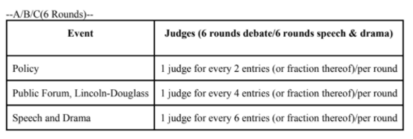

Day | Round | Round Begins | Extemp Draw
Saturday | Rd. 1 | 8:00 AM | 7:30
 | Rd. 2 | 10:00 AM | 9:30
 | Rd. 3 | 12:00 | 11:30
 | Semis | 2:00 PM | 1:30
 | Finals | 4:00 PM | 3:30

An awards video will be recorded the following Sunday and emailed to schools for viewing.

All events will be conducted in accordance to the MHSA Handbook.

Policy Debate:
Resolved: The United States federal government should enact substantial criminal justice reform in the United States in one or more of the following: forensic science, policing, sentencing.

Lincoln-Douglas Debate, January/February topic.
Resolved: States ought to ban lethal autonomous weapons.

Public Forum Debate, January Topic Area:
Resolved: The National Security Agency should end its surveillance of U.S. citizens and lawful permanent residents.

If you have any questions, contact Heather at hschmitz@milescity.k12.mt.us 406-234-4920 ext. 244 during the day, or 406-853-0055 in the evening. Voicemail will be available if I am out.

